Abstract Title: Nuclear synthesis of nano-carbon during supersonic plasma supercompression.
Kholmurad Khasanov
Moscow State M.V.Lomonosov University, Gas and Wave Dynamics Department, Moscow, Russia.
Samarkand State University, Nuclear Physics Department, Samarkand, Uzbekistan.

Abstract
A dynamic emitter has been created in which, when a supersonic gas jet elapses in the quantum field of space, a super compression of the plasma is observed and a nuclear fusion reaction takes place. A nozzle with a central cone is a dynamic emitter into which the inert gas (helium, argon or nitrogen) is fed. The gas expands adiabatically to form spiral double structures. The quantum structure of space is visually demonstrated. In free space, when a supersonic jet outflows from a dynamic emitter, a supercompression of a gas plasma occurs; this is observed near the exit at ten calibres of a nozzle that propagate over long distances without energy losses and without destroying the quantum structure of the plasma. Nuclear reactions and the synthesis of nano-carbon are taking place in a supersonic super-compressed plasma of helium. In fig. 1,2,3,4 presents the results of nuclear synthesis of nano-carbon on a silicon substrate of helium obtained from supersonic plasma, made with the help of an X-ray spectral microscope.
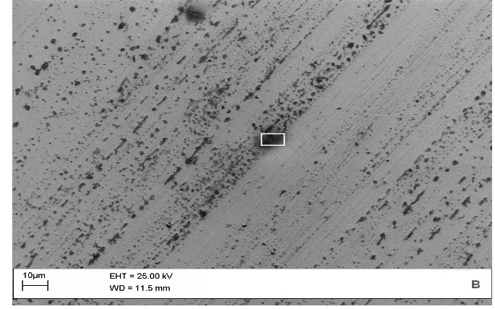
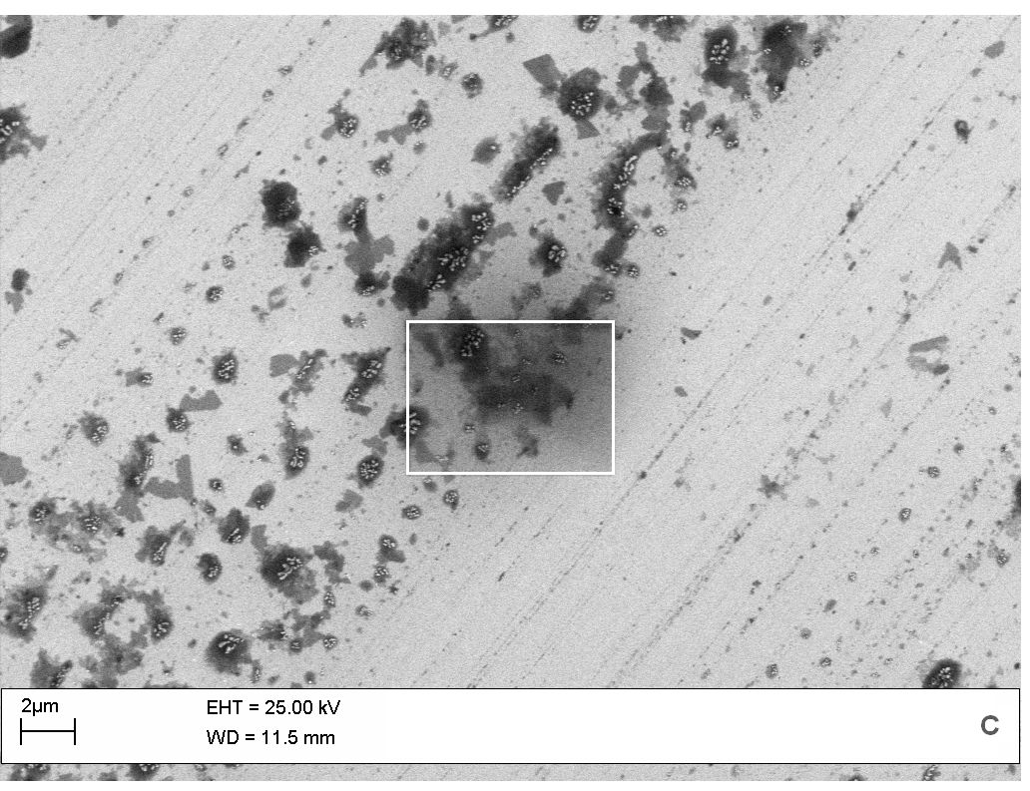
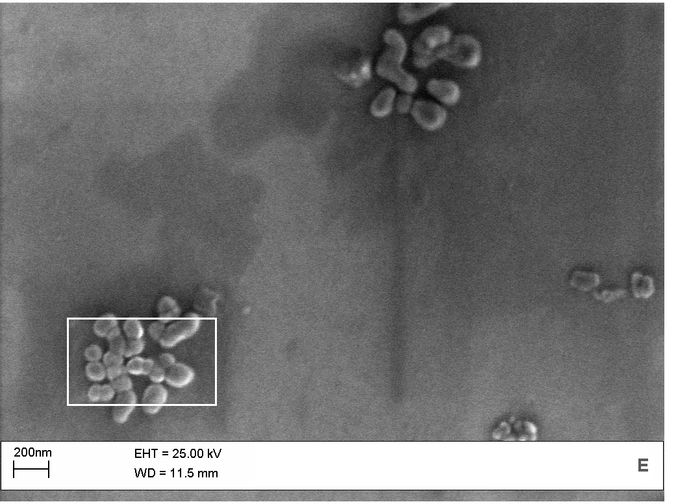
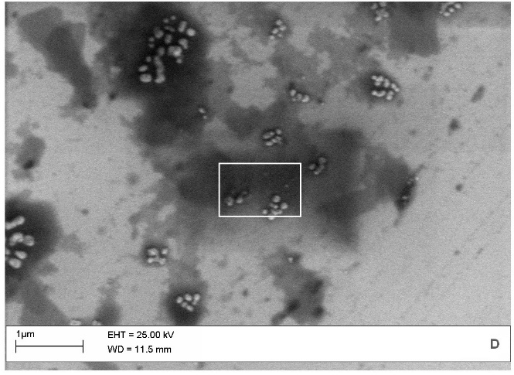
Fig 1 Synthesis of carbon from the gaseous helium during nuclear supercompression of plasma Sample - C
Fig 3 Synthesis of carbon from the gaseous helium during nuclear supercompression of plasma Sample - D
Fig 4 Synthesis of carbon from the gaseous helium during nuclear supercompression of plasma Sample - E
Fig 2 Synthesis of carbon from the gaseous helium during nuclear supercompression of plasma
Table 1. The weight content of the elements in percentage
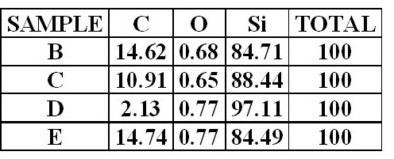

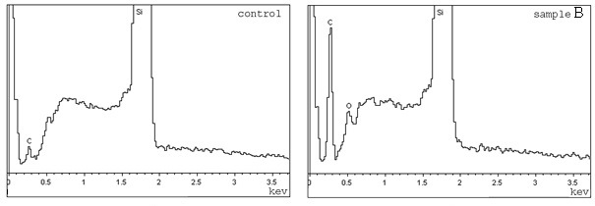
Graph 2. Spectrum of surface of the silicon substrate. Sample - B
Graph 1. Spectrum of the reference surface of the silicon substrate

Table 1 presents the results of X-ray spectral analysis of the synthesis of nano-carbon from helium plasma. From these results, it can be seen that over-compressing helium plasma and a supersonic plasma jet synthesize a nano-carbon synthesized on a silicon substrate.
Graphs 1.2 show the results of the analysis of the control surface of silicon and the synthesized nano-carbon from helium gas.

Professional Biography:
I am Dr. Sc. Prof. Kholmurad Khasanov currently work with the Mikhail Lomonosov, Moscow State University, in Russia; at the “Gas and Wave Dynamics Department” on the Faculty of Mathematical Mechanics and Samarkand State University, Nuclear Physics Department, Samarkand, Uzbekistan. I have been working as a prime investigator in the physics area for almost 40 years, and achieved one of my most iconic discoveries in 2011 when I designed and started experimenting with my dynamic emitter. I am actively doing researches and processing the data that I have collected over the past 6 years. My discoveries have shown great advances in the understanding of nanophysics, energy production and the bases of physic theories. I worked in the experimental and practical applications of the phenomena energy of photon-gravitational interaction. At present, I am working on experimental and practical applications of phenomena, supercompression of plasma in a supersonic jet and the technology of obtaining smart materials. I have released and shared my discoveries in several renowned scientific journals such as "Journal of Modern Physics" and "Physics Letters A" in Europe and America, I have done collaborations as a member of the “American Physics Society” and have done different related presentations in many countries including USA, Egypt, France and Russia. I have collaborated with several international organizations including NASA and "The Smithsonian"; my works can be found in the "Astrophysics Data System" under the Fluid Dynamics section. My experiments show great results in the production of nano-structures, and the applications.
