Finite element method of the internal friction angle and saturation degree with the groundwater levels variations

Thy Truc Doan, Technology and Engineering Department, Kien Giang University, Viet Nam

Abstract (300 word limit)
In recent years, research on the internal friction angle was done by previous researchers. The research objective shows the relationship between water content, porosity, saturation, internal friction angle, and the vertical displacement of the ground with depth variations. The experiment and numerical model were used for comparison by Viet Nam’s standard “TCVN 4196: 2012” and the finite Element Method (PLAXIS 3D software). Results show remarkably water content (W%) and porosity (P%) at the maximum value of 94.35% at 4.8m depth, whereas the minimum value is 18.22% at 39.3m depth; which compared with porosity (P%) of 71.9% at 4.8m depth and 40.4%. On the other hand, saturation results presented 88.09% and 86.79% at the center of the grounds. The increase of 23% and 75.42% (from 18.3m to 39.3m). Moreover, the vertical displacement maximum value of 0.01975 m (z = -36.9m) depth with ϕ0 = 290); whereas the minimum value is 0.002844 m (z = 0m) depth with ϕ0 = 20. The mean value at the center of the Clay layer was obtained at 0.0577m, and 0.0156 m at the Sand layer. From these research results, civil and geology researchers, scientists, and so on can use the best references for their works.

Image
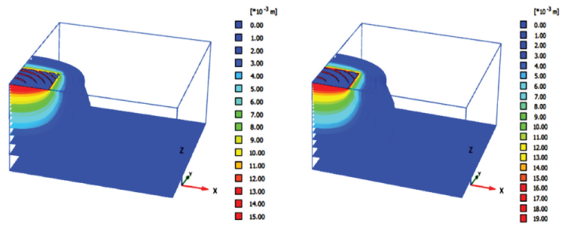
Recent Publications (minimum 5)
- Thy T D (2022) The Application of Geo-Statistical Software (SGeMS), Ilwis Software and Kriging Interpolation to simulate 3D Stratigraphic Structure Model Urban Rach Gia town, Kien Giang Province, Viet Nam. E3S Web of Conferences 347:2022.
- Thy T D (2022) Three (3d) Dimension Model of Settlement Differences of the Clay Ground Under Rigid Foundation by The Affection of the Groundwater Variations – A Comparison. E3S Web of Conferences 347:2022.
- Thy T D (2022) Evaluation of the Vertical Displacement of the Circular Foundation on the over-consolidation Ground in Phu Quoc Island, Kien Giang Province, Viet Nam. The 6th International Conference on Civil Engineering for Sustainable Development (ICCEE 2022) 2713:2022.
- Thy T D (2023) Simulation and Evaluation of the Pore Water Pressure Variations with Groundwater Levels Variations at The Depths. Earth & Environmental Science Research & Reviews 6 (2):2023.
- Thy T D (2023) Finite element method of the internal friction angle and saturation degree with the groundwater levels variations. Geology, Ecology, and Landscapes, 1:2023.
- Thy T D (2023) Experiment measurement of the Dry Density Variations and Shear Stress with the different Depth Variations. Earth & Environmental Science Research & Reviews 6 (2):438-450.
- Thy T D (2023) Finite Element Method of the Influence Evaluation of the Percentage of Fine Particles of Marine Clay at the Different Depth Variations to the Total Volumetric Strain of the Soft Clay Ground. Earth & Environmental Science Research & Reviews 7 (1):2023.

Photograph


Biography (150 word limit)

Dr Thy Truc Doan has expertise in evaluation and research for behaviors of the soft ground which include soft clay and sand. She researched many different soft soil behaviors with different loading, displacement, deformation, and conditions of the groundwater level variations by the experimental method in the laboratory and simulation by the PLAXIS software. She has built these results after years of experience in research, evaluation, and teaching in educational institutions. The foundation is based on the previous research results, then she builds, analyzes, evaluates, calculates, designs, and so on to obtain the best results for references to the readers in the future. It allows for the relative and reliable values for Geology engineers, civil engineering, scientists, and researchers… used for their work reference about the soft ground improvement technologies. This approach is responsive to the advanced development of soft ground behavior methods under changing groundwater levels in the future.

Email: drdoantructhy@gmail.com

Notes/Comments:

