Abstract Title: Clinical and Molecular Genetic Analysis of a Large Cohort of Saudi Arabian Patients with Hearing loss
Khushnooda Ramzan^{*,1}, Mohammed Al-Owain², Selwa Alhazzaa³, Faiqa Imtiaz¹

1 Department of Genetics, King Faisal Specialist Hospital and Research Centre, Riyadh, Saudi Arabia
2 Department of Medical Genetics, King Faisal Specialist Hospital and Research Centre, Riyadh, Saudi Arabia
3 Department of Opthalmomolgy, King Faisal Specialist Hospital and Research Centre, Riyadh, Saudi Arabia

Abstract

Hearing loss is one of the most common sensory disorders in humans with both genetic and environmental etiologies. Genetic causes of hearing loss are extremely heterogeneous; more than 100 genomic loci for hearing loss have been mapped so far. Usher syndrome (USH) is the most common cause of combined blindness and deafness inherited in an autosomal recessive mode. Molecular diagnosis is of great significance in revealing the molecular pathogenesis and aiding the clinical diagnosis of this disease. Our study aims to comprehensively delineate the genetic basis of hearing loss in the individuals of Saudi Arabian origin.

The identification of the causative gene in affected families with hearing loss is difficult due to extreme genetic heterogeneity and lack of phenotypic variability. Consanguineous families are a powerful resource for genetic linkage studies/homozygosity mapping for recessively inherited hearing impairment. Homozygosity mapping, linkage analysis and next generation sequencing Deafness Gene-panel and Whole Exome sequencing were conducted. Using the combined approaches, so far mutations in 32 different deafness genes have been identified in 150 familial/sporadic cases.

Using these innovative molecular approaches, we were able to document the most common forms of hereditary hearing loss, their incidence and distribution in the Saudi population. The overall results of this study are highly suggestive that the underlying molecular basis of hearing loss in Saudi Arabia is very genetically heterogeneous. The benefit of this study will hopefully provide the foundation for knowledge and awareness through screening of carrier status and genetic counselling, thereby having a major impact upon early intervention for and prevention of hereditary hearing loss.

Keywords: Hearing Loss, Consanguineous families, Mutations, Genetic counselling, Saudi Arabia

Professional Biography (100-150 words)

Dr. Khushnooda Ramzan, PhD in molecular biology works as Scientist in the Department of Genetics, King Faisal Specialist Hospital and Research Centre, Riyadh. She got her PhD from the Punjab University; during which she discovered new genes for hearing loss. After her PhD, Dr. Ramzan joined the department of genetics at KFSHRC, and continued working mainly on the genetics of deafness in the Saudi population. Her research focus was to investigate the role of different genes in hearing loss within the Saudi families. So far, she has characterized and documented genetic basis of deafness in families of Saudi Arabian origin; their incidence and distribution were also documented.

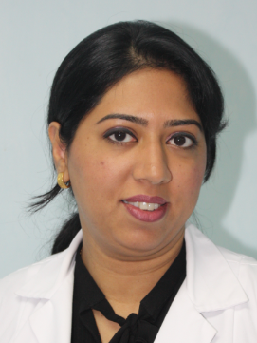

Email Id: khushnooda@gmail.com; Kramzan@kfshrc.edu.sa

