Abstract Template
Abstract Title: Comparative analysis of karyotyping and chromosomal microarray analysis for products of conception obtained with miscarriage

Abstract (not more than 300 words)

The goal of our study was to compare the results of chromosomal micro-matrix analysis (СMA) and karyotyping in the analysis of abortive material from women with miscarriage.
The study included 885 women - 632 women whose abortive material was sent to the СMA (group 1) and 253 women, whose material was sent for cytogenetic research (group 2).
Reliable differences between the studied groups in the number of samples with normal and pathological chromosome sets were not detected. However, the structure of chromosomal abnormalities in the studied groups differed. In both groups, in most cases, trisomy of autosomes occurred: in the first group 33.5% and in the second group 28.5% among all samples. Structural abnormalities were revealed significantly more frequently with the use of СMA - 4.4% of all effective studies in group 1, and only 0.8% (2 cases) in group 2. A higher frequency of polyploidy was revealed during the cytogenetic research. In group 1, triploidy was found in 5.8% of cases and tetraploidy - in 0.5%. In group 2, triploidy was detected in 10.0% and tetraploidy in 5.2% of cases.
Thus, traditional karyotyping and СMA have specific advantages and disadvantages. In the present study the СMA revealed a greater number of structural rearrangements, whereas during karyotyping more multiple anomalies and polyploidies were detected. The identification of structural abnormalities is of greater clinical significance, since they may indicate an imbalanced translocation that is hereditary. The impossibility of detecting a balanced chromosomal abnormality with the help of СMA is one of the drawbacks of this method, but it is not of great clinical significance.
Keywords— chromosomal micro-matrix analysis, chromosomal abnormalities, karyotyping
Professional Biography (100-150 words)
2005 – graduated the Ural State Medical academy, Ekaterinburg, Russia.
2006-2010 – medical doctor, 2010-2013 – geneticist in the Research Institute of Maternity and Infancy Protection (Ekaterinburg).
In 2013 I received a PhD degree and began to work as scientific worker at the Department of Obstetrics and Gynecology, Faculty of Postgraduate Training, USMU.
Since 2017 – assoсiated professor
I regularly take part in Russian and international conferences and congresses.
Scientific interests: reproductive genetics, prenatal diagnosis, hereditary thrombophilia
https://orcid.org/0000-0003-2797-1926

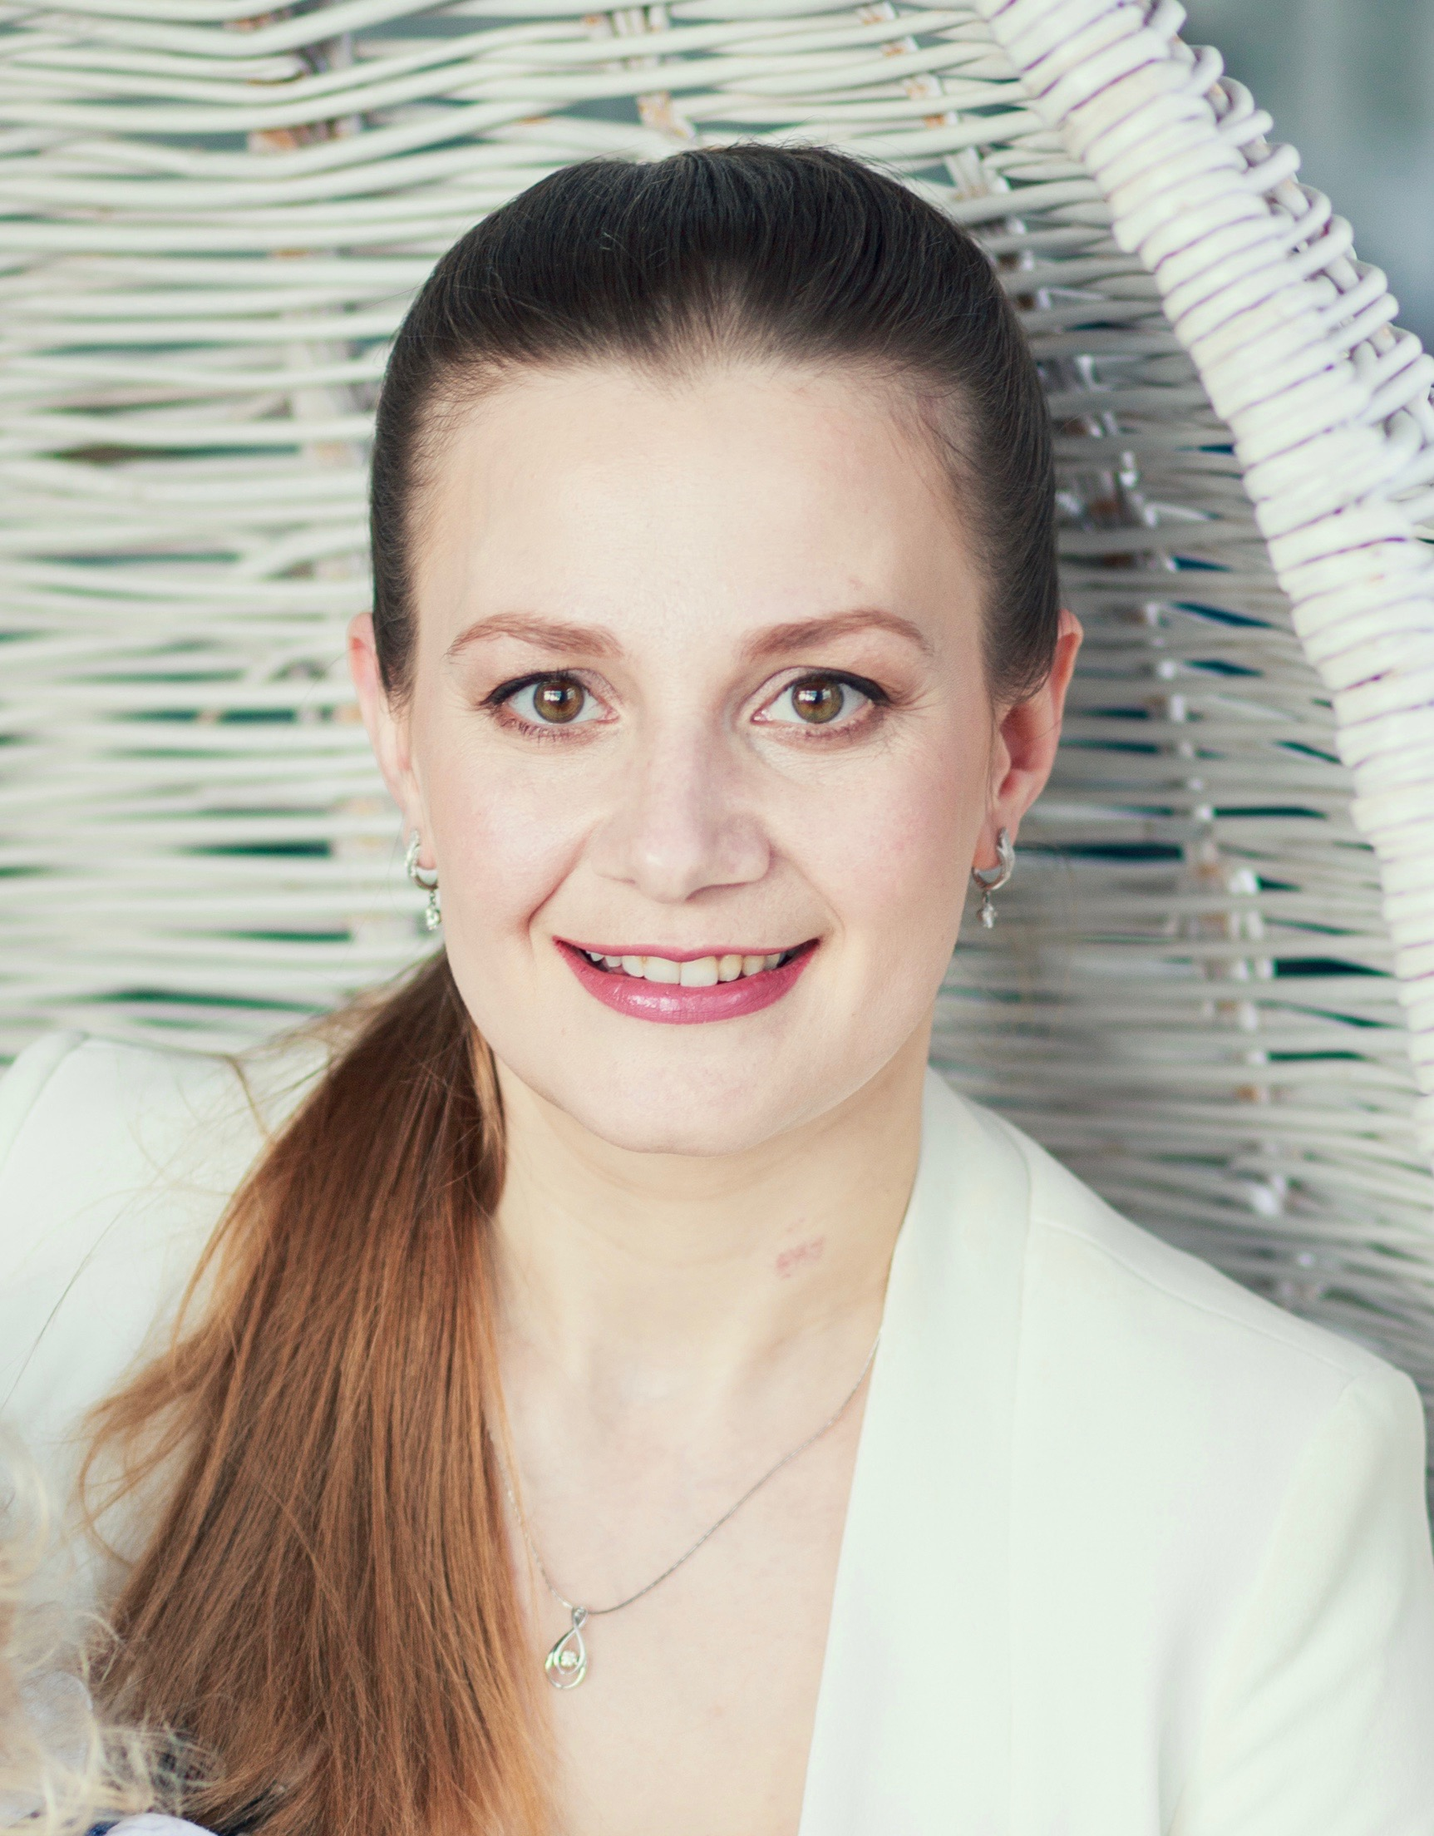

Paste your Photograph here
Email Id: elenavladpopova@yandex.ru

