Abstract Title: Catching Cancer; Carcinogenic Infectious Agents
Jorma A Jyrkkanen, BSc, PDP. whatsmymicrobiome.net

Jorma Jyrkkanen, whatsmymicrobiome.net

Abstract (not more than 300 words)

- . Catching cancer is really about our microbiome when it has unwelcome visitors or gets out of balance for a variety of reasons. I review the known list of infectious agents IARC and I and others have identified and list the cancers they cause. I then discuss different mechanisms of a variety of cancers to elaborate at what stage infectious agents might operate. I also share a broad survey of potentially synergistic residues that might operate through diet, air, drink and dermal absorption. I elaborate on each carcinogenic microbial vectors story and what we know about associations with cancers followed by identified strategies for stopping infections, prevention of contagion which I hope will stimulate discussion on preventing those cancers by education, public health policy, personal hygiene, clinical practice improvement and regulatory addendum. Among these Addenda I propose are assessment of antibiotics, chemical pesticides and biologicals including GMO for carcinogenicity, epigenetic profiles, impact on mitochondria which are symbiotic bacteria essentially and vulnerable, lateral gene transfer potential of introduced genes, effects on tumor suppressor genes and microRNA up or down regulation. As pathogenic microbes become antibiotic resistant it is possible to find a way to use this to give resistance to mitochondria as well. Sadly prolonged antibiotic use can increase cancer risk and damage to that critical organelle the mitochondria so the fight to save a person from infection might predispose them to cancers later in life. This needs to be added to the equation in evaluation of treatments and hopefully lead to antibiotics that are less genotoxic to microbiota.

Keywords—Infectious agents, carcinogenic, microbiome, prevention

I have Investigative Journalism type works on both that are more for thought provocation and stimulation of preventative strategies than academic works, based though on scientific publications. Prevention is the essence of both my investigations. I am a university trained zoologist/biologist with experience in carcinogens and mutagens from activism and personal inquiry and examination. I have no Academic Affiliation and am a retired Naturalist/Writer for the most part though I regularly attend graduate seminars at UBC as an Alumnus. I do have a large presence online that can be queried by google.

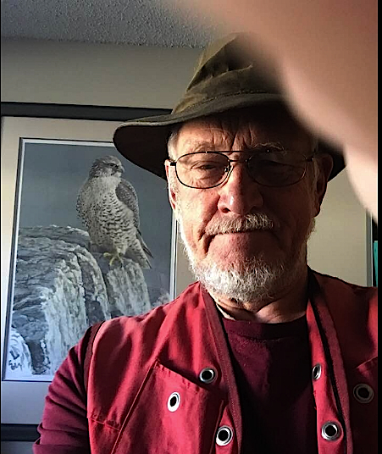
Paste your Photograph here

jormabio@hotmail.com
Any Comments: Looking forward to visiting the land of my birth, Finland since 1951.

