Rs2084881 and rs8170 and risk of ovarian cancer

Faeze Ghasemi¹, Farzaneh Sabouni PhD², Fatemeh Shahi³, Bahareh Abbasi MD⁴, Massoud Houshmand PhD*⁵

^{1,3}National Institute of Genetic Engineering and Biotechnology, MSc. (University of Iran, Tehran)
²Department of Molecular Medicine, National Institute of Genetic Engineering and Biotechnology.(University of Iran, Tehran)
^{4,5}Department of Medical Genetics, National Institute of Genetic Engineering and Biotechnology.

Abstract
Ovarian cancer is one of the most common cancers in women and the mortality rate of this cancer is increasing. Given the importance of early diagnosis in the treatment of ovarian cancer, finding biomarkers associated with this disease is essential. other countries have shown that rs2084881 on the SKAP1 gene and rs8170 on the BABAM1 gene are risk factors for ovarian cancer. Our main goal in this study is to investigate the association between the two polymorphisms and ovarian cancer susceptibility. 162 peripheral blood samples were collected from 100 controls and 62 patients and after extraction of DNA with Tetra-ARMS PCR, the genes SKAP1 and BABAM1 were studied. The tetra ARMS-PCR method is a valuable method because it has a simpler analysis, in addition to its high speed and low cost. So far 120 samples have been analysed, SKAP1 and BABAM1 genes were observed heterozygote in most of them. Checking on patient samples is ongoing. Expected to contrary to previous studies in other countries, there is no significant association between these genes and ovarian cancer so, rs2084881 and rs8170 can’t be used as potential biomarkers for ovarian cancer in Iranian populations. These findings lead us to find suitable biomarkers for the population with respect to personalized medicine, should be made an appropriate treatment according to the individual genotype.
Keywords: Ovarian cancer, Biomarker, polymorphism, Personalized Medicine

Professional Biography
Massoud Houshmand was born in Iran in 1962. he has completed his BSc, MSc and PhD in Medical Molecular Genetic from Gothenburg University. He is head of the Genetic Diagnostic Lab Special Medical Center and Houshmand Medical Molecular Genetic Lab in Tehran, Iran. He was member of Biology department, Astra Hassle, Gothenburg, Sweden in 1989-1989, And member of Botanic Institution, Physiology department, Gothenburg, Sweden in 1990-1991, and member of Botanic Institution, Genetic department, Gothenburg, Sweden in 1991-1992. He was Head of the Genetic Diagnostic Lab, Mendel Genetic Center, Erbil, Iraq in 2013. Also he has published more than 100 papers in various journals.

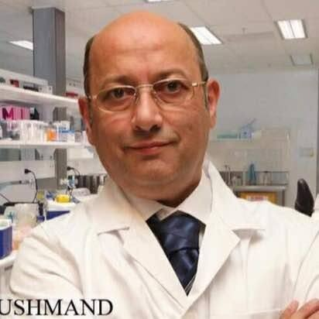

Email Id: massoudh@nigeb.ac.ir

