Rs9303542 and rs2363956 and risk of ovarian cancer
Fatemeh Shahi¹, Bahareh Abbasi MD², Faeze Ghasemi³, Massoud Houshmand PhD*⁴

^{1,3}National Institute of Genetic Engineering and Biotechnology, MSc (University of Iran, Tehran)
^{2,4}Department of Medical Genetics, National Institute of Genetic Engineering and Biotechnology (University of Iran, Tehran)
Abstract

Ovarian cancer is the fifth most common cancer in women. So, it's essential to find reliable biomarkers for prognosis and early diagnosis. According to previous studies in other countries, rs9303542 on SKAP1 and rs2363956 on ANKLE1 genes have strongly associated with ovarian cancer, so it is likely that we can use them as biomarkers in Iran. In our research, using the Tetra ARMS PCR technique, the frequency of rs2363956 and rs9303542 is evaluated on 162 sample. The tetra ARMS-PCR method is a valuable method because it has a simpler analysis, in addition to its high speed and low cost. So far, 100 control samples and 20 patient samples have been investigated, most of them are observed in heterozygote in both polymorphisms. Study on patient samples is ongoing. According to the results so far, it is expected that the frequency of these polymorphisms in patient and control samples will not be much different. So probably, unlike previous studies in other countries, there is no association between rs2363956 and rs9303542 and ovarian cancer in Iranian population. These findings lead us to further research for finding reliable biomarker with respect to personalized medicine we can achieve the best prognosis and diagnosis method according to the individual genotype.
Keywords: Ovarian Cancer, Biomarker, Personalized Medicine, polymorphism

Professional Biography

Massoud Houshmand was born in Iran in 1962. he has completed his BSc, MSc and PhD in Medical Molecular Genetic from Gothenburg University. He is head of the Genetic Diagnostic Lab Special Medical Center and Houshmand Medical Molecular Genetic Lab in Tehran, Iran. He was member of Biology department, Astra Hassle, Gothenburg, Sweden in 1989-1989, And member of Botanic Institution, Physiology department, Gothenburg, Sweden in 1990-1991, and member of Botanic Institution, Genetic department, Gothenburg, Sweden in 1991-1992. He was Head of the Genetic Diagnostic Lab, Mendel Genetic Center, Erbil, Iraq in 2013. Also he has published more than 100 papers in various journals.

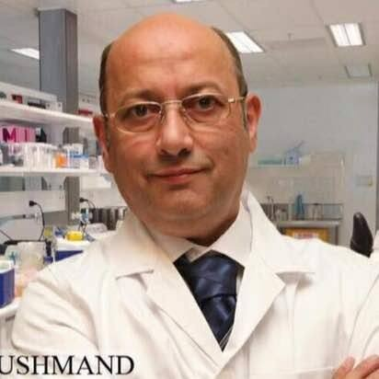

Email Id: massoudh@nigeb.ac.ir

