Bioaerosol identification and air quality analysis in Hyderabad city
Sujatha Uram
Research Scholar, Dept of Biotechnology ,JNTU Hyderabad.
Corresponding Author: sujathauram@gmail.com

ABSTRACT
The bioaerosol may consist of bacteria, fungi, algae, viruses, microbialtoxins³, insects, pollen, insect wings & scales etc. Hyderabad, the capital of newly formed Telangana State is all set to cross 10 million (1 crore) population.With the continuous increase in the population and migration⁴ of people from rural from urban settlement’s, puts tremendous pressure on the quality of living of the people living in urban environment (cities).pressure will be Access to good quality air for healthy Living is a fundamental right of citizens of every country. India with a population of 1.27 billion people (2013) must ensure good quality air for healthy living of citizens. Outdoor air pollution is the 5th leading cause of death in India. Environmental Pollution¹ Control Authority of India believes that the air pollution has reached such severe levels that it is cause of 3000 child deaths a year in Delhi alone.
A bioaerosol² by definition is a suspension of airborne particles that contains living organisms or was released from living organisms. These particles are very small less than1 micrometre to 100 micrometre in terms of space, availability of water both for drinking and other uses, housing ,employment and various other related necessities. So far central and state pollution control boards have come up with technologies required for measuring the pollution levels in the cities. Therefore, present topic is selected to estimate the bio aerosol concentration at various major junctions in the greater Hyderabad area. The results of experiments would be of immense value in making Hyderabad a clean and green city for healthy living. Various air sampling⁵ methods employed in the proposed investigations.
Keywords: Pollution¹ bioaerosol² microbialtoxins³ migration⁴ sampling⁵
- INTRODUCTION :
Air is a mixture of various components which includes myriad gases and several microbes. An average human being can live for two weeks without food, two days without water, but hardly for a minute without air. Air is very much essential for a human being to survive and this valuable air is being polluted day by day. Air pollution has become an area of concern as consists of various minute particle called microbes which may cause several problems in humans. The air without the pollutants released by the human, itself is very much polluted. Imagine the air we inhale after all the pollutants in the form of various emissions getting mixed up with it. Air we inhale may contain various pollutants, gases, and pollen, bacterial and fungal spores etc., which may be released by plants, fungal molds, bacteria and various other pollution emitters. This air we breathe may cause allergies in various people who are susceptible to the pollutants.
List of plants whose pollens are the source of pollen allergy:
Trees: Ash, birch, acacia, cottonwood, walnut, oak, maple, elm, cypress, box elder and hickory in the US. In India, common sources of pollen allergy in this category are Ailanthus excelsa (tree of heaven or Mahanimb), Azadirachtaindica (neem),
Madhucaindica (mahua), Mimusopselengi (bakula), Morus alba (white mulberry), Eucalyptus spp, Cassia spp. and Murrayapaniculata (orange jasmine, kamini).
Grass: Bermuda grass, rye, wild oat, orchard, Sorghum (Johnson grass, fodder grass), Pennisetum
Weeds: Parthenium, Amaranthus, Argemonemexicana (prickly poppy), Prosopis juliflora (kikar), ragweed, pigweed, cocklebur, sagebrush, marsh elder and tumbleweed.
Allergy to pollen:
Nasal allergy to pollen is called pollinosis, and allergy specifically to grass pollen is called hay fever. Generally pollens that cause allergies are those of anemophilous plants (pollen is dispersed by air currents). Such plants produce large quantities of lightweight pollen (because wind dispersal is random and the likelihood of one pollen grain landing on another flower is small), which can be carried for great distances and are easily inhaled, bringing it into contact with the sensitive nasal passages.
In the US, people often mistakenly blame the conspicuous goldenrod flower for allergies. Since this plant is entomophilous (its pollen is dispersed by animals), its heavy, sticky pollen does not become independently airborne. Most late summer and fall pollen allergies are probably caused by ragweed, a widespread anemophilous plant.
Arizona was once regarded as a haven for people with pollen allergies, although several ragweed species grow in the desert. However, as suburbs grew and people began establishing irrigated lawns and gardens, more irritating species of ragweed gained a foothold and Arizona lost its claim of freedom from hay fever.
Anemophilous spring blooming plants such as oak, birch, hickory, pecan, and early summer grasses may also induce pollen allergies. Most cultivated plants with showy flowers are entomophilous and do not cause pollen allergies.
The percentage of people in the United States affected by hay fever varies between 10% and 20%, and such allergy has proven to be the most frequent allergic response in the nation. There are certain evidential suggestions pointing out hay fever and similar allergies to be of hereditary origin. Individuals who suffer from eczema or are asthmatic tend to be more susceptible to developing long-term hay fever.
The most efficient way to handle a pollen allergy is by preventing contact with the material. Individuals carrying the ailment may at first believe that they have a simple summer cold, but hay fever becomes more evident when the apparent cold does not disappear. The confirmation of hay fever can be obtained after examination by a general physician.
- MATERIALS AND METHODS:
To trap the bioaerosols, the following methods are usually employed -
Rotorod air sampler
Culture plate exposure
Tape lift sampling
Rotorod air sampler:
Perkins (1957) developed a battery operated Rotorod sampler sampling at constant rotational speed since the efficiency of stationary impactor sampler is low and highly variable, the rotating impactor has been advantageously used. The collecting arms of this model are made up of brass having 0.159cm cross sectional area. It is in square shape and slightly bent inwards. The vertical arms are 6cm long and 4cm wide from the axis. According to Gregory (1951), this width should give more than 60-70% efficiency of deposition for 20um diameter spores at wind speed about 4m.p.h. The model employs miniature D.C motor with controlled speed of the type used for recorders. With the rods n proper position, the motor gives about 23,000rpm.
COLLECTION EFFECIENCY:
The model has been tested for efficiency and it shows 85% efficiency. The sampling efficiency for particles greater than 15µm is 100%. Wind speed has little effect in the efficiency drag and load on the motor. The Rotorod tested by carter (1965) showed 60-90% efficiency. The Rotorod sampler is used for short period sampling up to 2 hours. The sampler is volumetric and highly efficient. The efficiency is not affected at even high wind speed.
MOUNTANT MEDIUM USED AND ITS PREPERATION:
Glycerine jelly was used as the mountant, which has the best optical properties in visual examination. The composition and preparation of this are as follows
Table1: Composition of Glycerine jelly
INGREDIENTS | QUANTITY
Gelatin | 40gm
Glycerin | 120gm
Distilled water | 140ml
Phenol crystals | 0.5gm

SCANNING:
The scanning of slides was done regularly after the preparation of slides. The conversion factor of the sampler is 5. For example, if the total number of fungal spores types are 20 for the total catch, the n the total number of fungal spores/m³ of air= 5*20=100/m³ of air. Assuming the taping efficiency to be 75% with the help of conversion factor, we can easily estimate the fungal spore concentration per meter cube of air. The constant factor is irrespective of locality, season and weather. All the time described in the work is given in Indian Standard Time (IST).

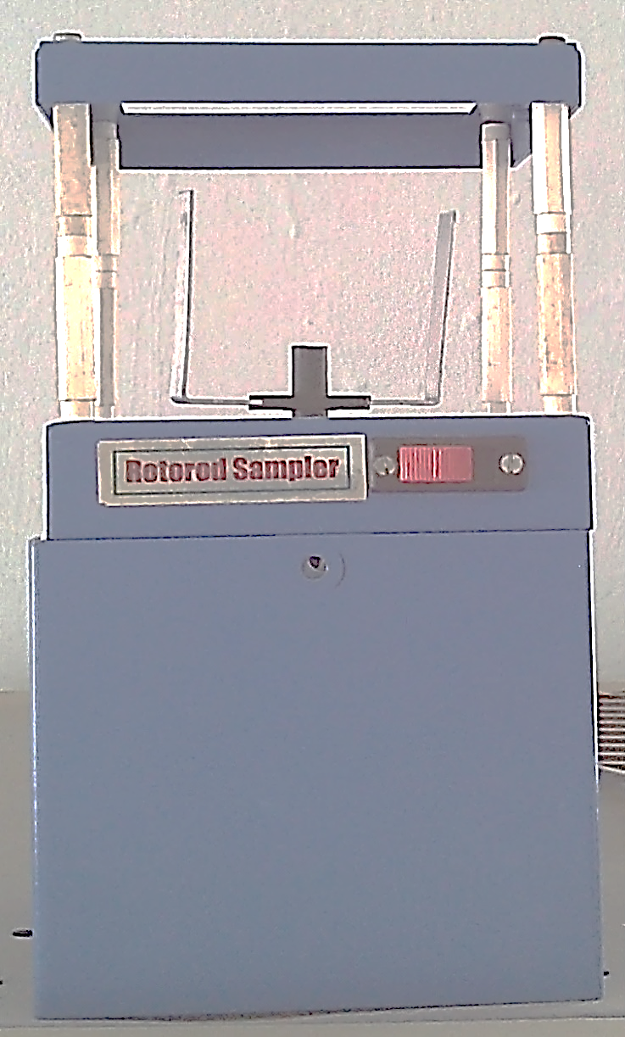
- RESULTS:
In the present investigation we have selected indoor and outdoor habitat for analysing the various bio aerosol concentration. An attempt has been made in the present investigation to find out the role of airspora in causing various allergies.
Ten sites (named S1 to S10)have been as they have been suffering from various allergies and the cause was yet to be known even selected for conducting outdoor aerobiological survey to ascertain the role of outdoor fungi and pollen in and around Hyderabad(LakkarajuAparna,K.Mythili,Mr.VenkataRatnam,Mrs.SujathaUram-Air Quality Analysis in the city of Hyderabad 2015 International Journal of Research and Innovation(IJRI)).25 Persons were selected after they have consulted the doctor. Depending on their problem they have been divided into 5 types which includes a control group also. 5 Types have been selected for conducting indoor aero biological survey to ascertain the role of indoor pollutants in causing allergic disorders in and around Hyderabad.
Type1: Patients living in Independent house, surrounded with gardening and non cultivated flowering plants.
Type2: Patients living in Independent house, surrounded with gardening and non cultivated flowering plants near agricultural fields.
Type3: Patients living in Apartments, with good ventilation near main road.
Type4: Patients living in Apartments, near by to sewage treatment plant domestic waste water pond.
Type5 : Control- Random samples from normal people .
Table-: Date and time of sample collection along with weather conditions
S.NO | Date of Sample collected | Time of Sample collected | Temperature(C) | Humidity (%) | Rainfall | Sky condition | Air condition
1 | 18-04-2016 | 09:15 AM | 29 | 41 | No | Clear | Windy
2 | 23-04-2016 | 01:15 PM | 33 | 29 | No | Clear | Windy
3 | 14-05-2016 | 12:20 PM | 39 | 42 | No | Clear | Windy
4 | 16-05-2016 | 01:40 PM | 37 | 37 | No | Clear | Windy
5 | 21-05-2016 | 11:03 AM | 33 | 36 | No | Clear | Windy
6 | 24-05-2016 | 11:50 AM | 37 | 30 | No | Clear | Calm
7 | 11-06-2016 | 11:43 AM | 34 | 38 | No | Clear | Windy
8 | 21-06-2016 | 12:35 PM | 38 | 25 | No | Clear | Windy
9 | 25-06-2016 | 11:04 AM | 33 | 37 | No | Clear | Calm
10 | 29-06-2016 | 12:40 PM | 39 | 35 | No | Clear | Windy
11 | 04-07-2016 | 10:30 AM | 33 | 39 | No | Clear | Calm
12 | 07-07-2016 | 10:40 AM | 36 | 46 | No | Clear | Windy
13 | 15-08-2016 | 11:10 AM | 35 | 49 | Yes | Cloudy | Windy
14 | 22-08-2016 | 11:30 AM | 37 | 57 | Yes | Cloudy | Windy
15 | 27-08-2016 | 10:25 AM | 32 | 63 | No | Clear | Windy
16 | 31-08-2016 | 11:50 AM | 38 | 71 | Yes | Cloudy | Windy
17 | 13-09-2016 | 10:55 AM | 34 | 65 | No | Clear | Windy
18 | 16-09-2016 | 10.32 AM | 32 | 67 | No | clear | windy

Month wise variation in the concentration of fungal spores/$m^{3}$ of air from April to September 2016.
S.No | Fungal Spore Name | April | May | June | July | August | Sept | Total | %
 | Ascomycotina
1 | Ascospores | 0 | 0 | 0 | 0 | 0 | 200 | 200 | 2.2
2 | Didymosphaeria | 0 | 0 | 0 | 0 | 130 | 90 | 220 | 2.4
3 | Otthia | 0 | 0 | 0 | 0 | 15 | 15 | 30 | 0.3
4 | Melanospora | 0 | 0 | 0 | 0 | 80 | 30 | 110 | 1.2
5 | Parodiella | 0 | 0 | 0 | 0 | 45 | 20 | 65 | 0.7
6 | Pleospora | 15 | 15 | 0 | 20 | 100 | 135 | 285 | 3.1
7 | Sordaria | 0 | 0 | 0 | 0 | 0 | 55 | 55 | 0.5
Basidiomycotina
8 | Rust spore | 35 | 15 | 35 | 45 | 85 | 20 | 235 | 2.6
9 | Smut spore | 25 | 85 | 75 | 30 | 20 | 0 | 235 | 2.6
Deuteromycotina
10 | Alternaria | 150 | 205 | 225 | 135 | 155 | 345 | 1215 | 13.4
11 | Bispora | 50 | 40 | 45 | 10 | 135 | 50 | 330 | 3.6
12 | Cladosporium | 0 | 0 | 0 | 140 | 245 | 315 | 700 | 7.7
13 | Curvularia | 20 | 45 | 30 | 35 | 105 | 155 | 390 | 4.3
14 | Diplodia | 15 | 15 | 0 | 10 | 65 | 205 | 310 | 3.4
15 | Epicoccum | 25 | 5 | 40 | 15 | 45 | 50 | 180 | 1.9
16 | Haplosporella | 0 | 0 | 0 | 0 | 0 | 175 | 175 | 1.9
17 | Helminthosporium | 15 | 5 | 5 | 80 | 135 | 205 | 445 | 4.9
18 | Heterosporium | 0 | 0 | 0 | 0 | 0 | 35 | 35 | 0.3
19 | Humicola | 0 | 20 | 30 | 25 | 0 | 95 | 170 | 1.8
20 | Nigrospora | 15 | 45 | 65 | 30 | 80 | 90 | 325 | 3.6
21 | Papularia | 35 | 55 | 20 | 0 | 85 | 105 | 300 | 3.3
22 | Periconia | 0 | 30 | 45 | 10 | 85 | 160 | 330 | 3.6
23 | Pithomyces | 0 | 0 | 0 | 20 | 85 | 155 | 260 | 2.8
24 | Tetracoccosporium | 0 | 0 | 0 | 0 | 25 | 110 | 135 | 1.4
25 | Torula | 0 | 0 | 0 | 10 | 35 | 105 | 150 | 1.6
Others
26 | Hyphal fragment | 125 | 100 | 120 | 30 | 155 | 95 | 625 | 6.9
27 | Insect scale | 50 | 50 | 85 | 100 | 170 | 210 | 665 | 7.3
28 | Planttrichome | 95 | 125 | 75 | 70 | 145 | 225 | 735 | 8.1
29 | Grass pollen | 20 | 15 | 10 | 5 | 10 | 35 | 95 | 1
 | Total | 690 | 870 | 905 | 820 | 2235 | 3485 | 9005
 | % | 7.6 | 9.6 | 10 | 9.1 | 24.8 | 38.7 |  | 100%

- CONCLUSION:
There is a huge variation in predominance of allergens from region to region in allergic disorders with the fact that there are topographical variations in nature. In our present study air samples were obtained by using Rotorod sampler. Alternaria and Cladosporiumwas the most dominant spore types trapped in the air of the major junction of Hyderabad, Outdoor fungal concentrations were highest in Mahatma Gandhi bus stand, Charminar, Uppal, Dilsukhnagarwhile the lowest value was detected in kukatpally. From April to June, Cladosporium spp. was predominant, in July,Cladosporium and Alternaria were equally predominant, and in August and September Alternaria spp. was predominant. Which are known and established allergens among fungal group which are also associated with skin allergy, Sinusitis and allergic Rhinitis.
References:
- RamchanderRao. K.S., 1987. Aerobiological studies at Aurangabad. Ph.D Thesis. Marathwada University.
- Adhikari. A; Bhattacharya, S; and Chanda, S. 1996. Aerobiology and allergenicity of indoor fungal spores in Calcutta during summer months. Indian journal of Allergy and applied Immunology, 10: 11-19.
- Burhansen and AhmetAsan. 2001. Airborne fungi in vegetable growing areas of Edime. Turkey. Aerobiologia, 17; 69-75.
- Christine. A. Rogers.2003. Indoor fungal exposure. Immunology and Allergy Clinics of North America, 23: 501 – 508.
- Vittal B.P.R. 2005. Progress of aerobiology in India during the last quarter century. An overview. Ind. J. Aerobiol. 10: 60-68.
- Schlesinger, P., Mamane, Y. and Grishkan, I. 2006. Transport of microorganisms to Israel during Saharan dust events. Aerobiologia 22:259-273
- MandavaV.BasaveswaraRao, E.SrinivasReddy, V.Prasanthi and M.Sivanadh,2008. Bioallergens in the air of selected areas in Vijayawada. Rasayan J.chem,1: 515-520.
- SathavahanaChowdary V*.et.al. 2011. Role of Fungi (molds) in allergic airway disease.-An Analysis in a South Indian Otolaryngology center. Indian J Allergy Asthma Immunol 2011; 25(2): 67-78.
- Parveen, A., Khan, M. and Zeb, S. 2012. Identification and quantification of airborne pollen from Hyderabad: Tando-Jam, Sindh. Pak.J.Bot.44:1755-1762
- LakkarajuAparna, K.Mythili, Mr.VenkataRatnam, Mrs.SujathaUram-Air Quality Analysis in the city of Hyderabad 2015 International Journal of Research and Innovation(IJRI).

