Mechanisms for Protein-Coding Genes to Tolerate and Repair Frameshift Mutations
Xiaolong Wang, Ocean University of China, PRC

Abstract

Frameshift mutations are mostly deleterious, and frameshift protein sequences are mostly meaningless, while functional frameshift genes and proteins are widely found. The molecular mechanisms of repairing DNA damages and point mutations are well understood, but it remains unclear how frameshift mutations are repaired. This study reports that the recovery rate of a frameshift mutation in E. coli was higher than expected, indicating that frameshift reversion is not random mutagenesis but targeted gene repair. We proposed a new molecular model for frameshift repair, nonsense-mediated gene revising (NMGR), which improves the rate of frameshift repair while brings genetic diversity, and acts as a driving force for molecular evolution. In this study, molecular biotechniques and multi-omics were used to identify, isolate, and characterize relevant genes and proteins, and clarify their functions in the process of frameshift repair. Besides, we report that frameshift and wild-type proteins are often highly similar because the standard genetic code (SGC) was optimized for frameshift tolerance, and the SGC has the best frameshift tolerance among all alternative genetic codes for many key amino acid properties. The frameshift tolerance is not a side effect of the degeneracy and the mismatch robustness, but their combination and extension. Moreover, frameshift tolerance was optimized at the fundamental levels of genes and genomes through biased usages of codons and codon pairs. Also, we screen and validate shiftable exons through genome big data analysis and elucidates the role of frameshift tolerance and shiftable exons in molecular and genome evolution, the functioning and repairing of protein coding genes, as well as their changes across the phylogenetic tree and the evolutionary history of life.

Image
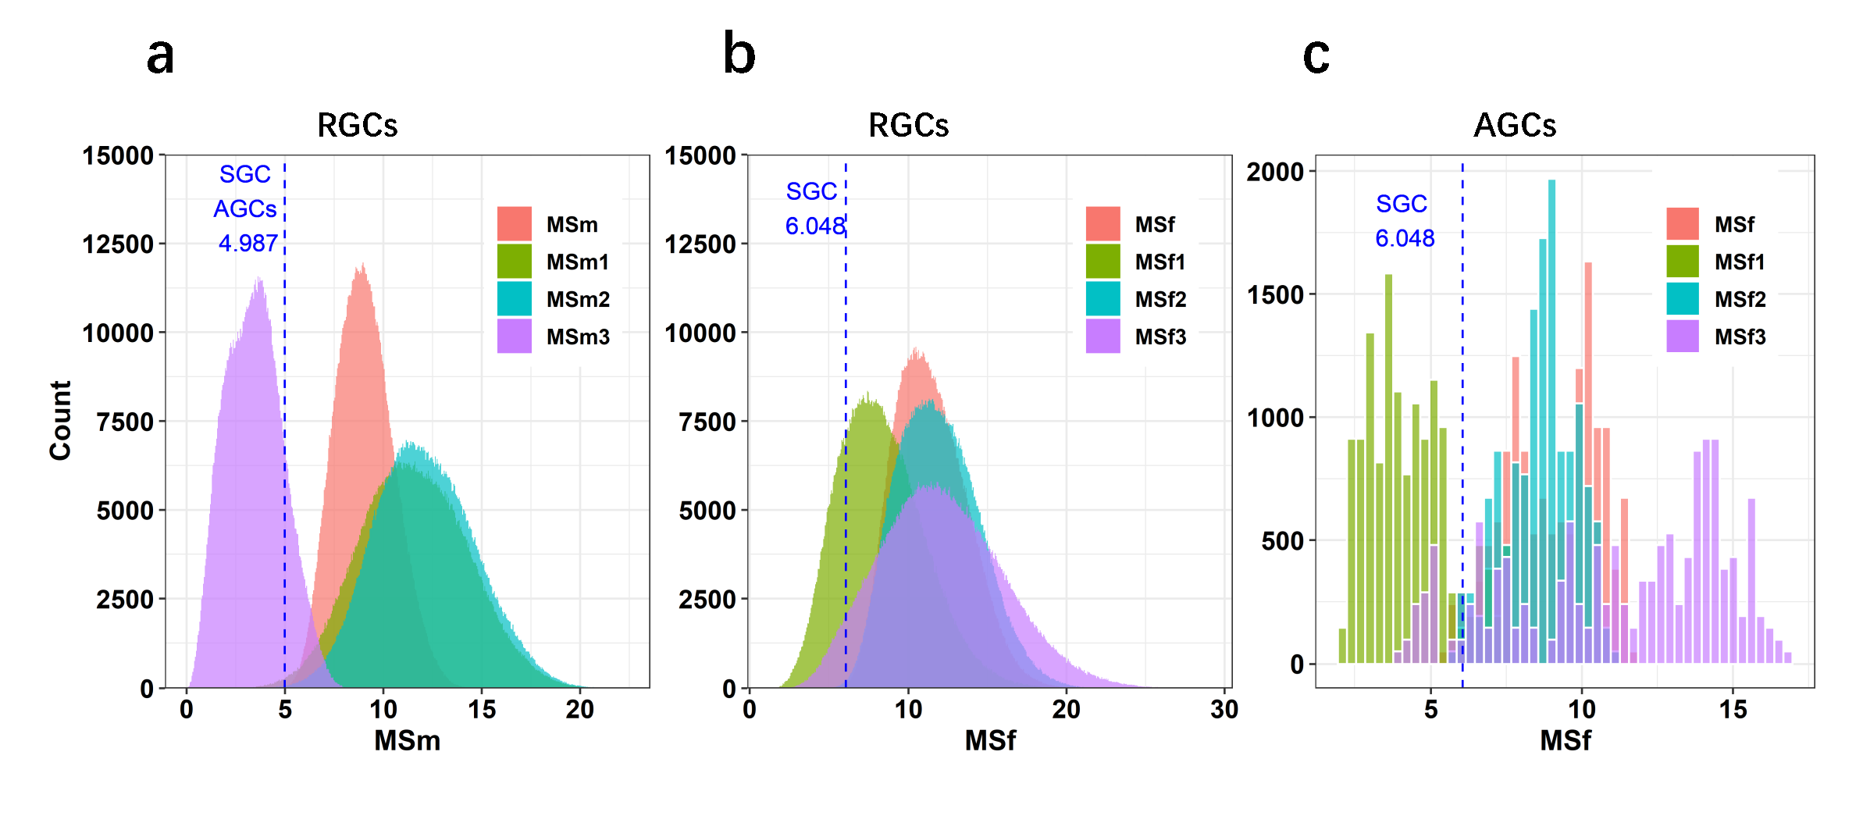
Fig 1. The frequencies of MSm and MSf and their components in the polar requirement.
(a-c) Histograms of mismatch and frameshift MS in the polar requirement, showing (a) RGCs' MSm, (b) RGCs' MSf, (c) AGCs' MSf, and their components in the standard genetic code (SGC) and alternative genetic codes (AGC). MSf and MSm are the total mismatch and frameshift MS, respectively; MSm1, MSm2, and MSm3 are respectively the mismatch MS at base position 1, 2, or 3; MSf1, MSf2, and MSf3 are respectively the frameshift MS with 1, 2, or 3 differences compared with the original codons. The blue text and a dashed line indicate the MSf or MSm value for the SGC (or AGCs).
Recent Publications (minimum 5)
(1) Wang X, Dong Q, Chen G, Zhang J, Liu Y, Cai Y. Frameshift and wild-type proteins are often highly similar because the genetic code and genomes were optimized for frameshift tolerance. BMC Genomics, 2022. 23(1): p. 416.
(2) Chen C, Wu Q, Ke Q, Wang T, Zhang Y, Wei F, Wang X, Liu G. Implementation of novel Boolean logic gates for IMPLICATION and XOR functions using riboregulators, BIOENGINEERED, 2022, 13(1): 1235-1248
(3) Wang X, Zhang J, Li Y, Chen G, Wang X. Enzymatic Synthesis of Modified Oligonucleotides by PEAR Using Phusion and KOD DNA Polymerases, Nucleic Acid Therapeutics, 2015, 25(1): 27-34
(4) Li B, Dong S, Wu J, Zhang J, Chen G, Dong Q, Zhu X, Wang X. Preparation of 5'-O-(1-Thiotriphosphate)-modified oligonucleotides using polymerase-endonuclease amplification reaction (PEAR). PLoS One. 2013 Jul 4;8(7): e67558.
(5) Wang X, Gou D, Xu SY. Polymerase-endonuclease amplification reaction (PEAR) for large-scale enzymatic production of antisense oligonucleotides. PLoS One. 2010 Jan 1;5(1): e8430.

Photograph

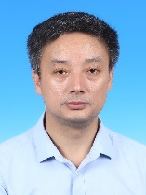
Biography
Dr Wang has been teaching genetics, molecular biology, genomics, and bioinformatics in the Ocean University of China since 1999. He has a wide research interest in the molecular biology, genetics, genomics, computational biology, and bioinformatics. In the field of molecular genetics, he discovered the shiftability of the protein-coding genes and proved that the genetic code, genes, and genomes were optimized for frameshift tolerance. In the field of molecular biology and biomedicine, he developed a novel polymerase-endonuclease amplification reaction for the preparation of modified oligonucleotides, which is useful as nucleic acid therapeutics. He is also interested in DNA computing, he developed novel Boolean logic gates using riboregulators and solved the SAT problem using a novel DNA computing algorithm.
Email: xiaolong@ouc.edu.cn

Notes/Comments:

