Title: Outcomes Among COVID-19 Patients with Underlying Hepatitis B Infection: A Two-Year Retrospective Study in a Tertiary Hospital

Authors: Dr. Jennylyn D. Isanan, Dr. Ralph N. Aniceto

ABSTRACT
Background: Chronic Hepatitis B infection is still a global burden endemically occurring in the Philippines, and with the ongoing COVID-19 pandemic, it is likely to find patients that may be suffering from co-infection. Elevated transaminases signifying liver injury have been commonly seen with COVID-19 patients as part of the disease’s manifestation. Studies showed that presence of underlying viral hepatitis infection may impact clinical outcomes of COVID-19 patients leading to worse prognosis.
Objectives: To describe the clinico-demographic profile and corresponding outcomes of COVID-19 patients with underlying Hepatitis B infection.
Methods: Medical data were collected from 640 medical charts of admitted COVID-19 patients who underwent Hepatitis B screening and their corresponding outcomes from July 2020 to December 2022.
Results: Of the 640 participants, 33 (5.2%) were found to have underlying hepatitis B infection. Among them, majority was found to have comorbidities, elevated ALT levels, moderate severity of COVID-19 and overall good survival. 3 (9.1%) out of 33 COVID-19 patients with underlying hepatitis B infection died. There was only a slightly higher mortality risk with hepatitis group compared to those without hepatitis (9.1% vs. 8.9%).
Conclusion: Majority of COVID-19 patients with underlying hepatitis infection survived albeit having slightly higher mortality risk compared to those without. Further analysis as to the Hepatitis infectivity status and its impact with COVID-19 co-infection is warranted.
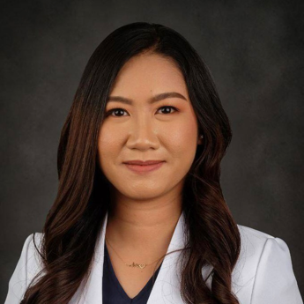
- My name is Dr. Jennylyn D. Isanan, 31 years old from the Philippines. I finished my Internal Medicine Residency at the Divine Word Hospital, a tertiary training hospital in the Philippines. I recently passed the specialty board examination on Internal Medicine last March 23, 2023 and currently building my career as a private practitioner and planning to further specialize in Gastroenterology.
- Email address: jenisanan25@gmail.com

