Author’s information
Name: Mahesh Kumar Gupta MBBS,MD, DNB gastroenterology and hepatology
Work as: Associate consultant, Gastroenterology and transplant hepatology, FMRI, Gurgaon, INDIA
Gmail: guptamahesh1982@gmail.com
Phone : +91 9599901855
Former Gastroenterology fellow GIPMER, Delhi.
Former Gastroenterology fellow Medanta, Gurgaon.
Former Assistant professor (gastro)medicine NIMS, Jaipur.
MIACM,MIAP,MICCM,MISG,MESI, MSGEI,MISSCD

STUDY: To compare the tissue diagnostic yield of solid lesion biopsies based on the histopathological Analysis of endoscopic ultrasound guided fine Needle aspiration (EUS–FNA) samples produced by the 19g procore needle, standard 19g needle and 22g procore needle: a single centre, observational study.
INTRODUCTION: Endoscopic ultrasound (EUS) is a sensitive method for detecting intestinal and extra-intestinal mass lesions including lymphadenopathy. ^{[1]} EUS-guided fine needle aspiration (FNA) is the current standard method for obtaining tissue for the diagnosis of pancreatic masses. ^{[2]} FNA allows evaluating cellular findings suggestive of malignancy but inflammation causes cellular changes undistinguishable from neoplasia solely based on cytological evaluation. Neoplasms such as lymphoma and stromal tumors require histological samples, because tissue architecture and cell morphology are essential for accurate pathological assessment including immunohistochemical analysis. ^{[3]} Whereas FNA provides only cells that are largely disrupted from their original arrangement, larger-calibre cutting needles allow for true biopsy specimens. Various EUS-guided techniques have been explored to retrieve tissue specimens with variable success and complication rates. [4] The standard needles were introduced initially for EUS-FNA and now procore needle with a “reversed bevel” designed for EUS-guided fine needle biopsy (EUS-FNB). ^{[1, 5]} Currently, the data are conflicting and more randomized trials comparing these needles to standard needles are required. ^{[1, 5, 6, 7]}
AIMS AND OBJECTIVES: To compare the tissue diagnostic yield of solid lesion biopsies based on the histopathological analysis of endoscopic ultrasound guided fine needle aspiration (EUS –FNA) samples produced by the 19G Procore needle, Standard 19G needle and 22G Procore needle.
MATERIAL AND METHODS: The study was conducted at Medanta -The Medicity, Gurgaon as Single Centre, prospective, observational study. All the Patients, above 18 years of age, having intestinal and extra-intestinal solid mass lesions including lymphadenopathy,were subjected to EUS guided FNA. The study was conducted from June 2016 to May 2017. Patients with cystic lesions, refusal to sign the informed consent, with coagulopathy (INR>1.5, Platelets <50000), excluded from study.
Methodology: All patients after applying inclusion and exclusion criteria and signing the informed consent, were subjected to EUS guided FNA using an Olympus GF-UCT180 linear echo endoscope for acquisition of sample. This was a prospective, observational study and patients were allocated to the three different needle groups for performing FNA by computerised based random method. Patient’s demographic data were recorded. Patient was kept fasting for 6 hours and clear fluids were allowed up to 2 hours before procedure. The procedure was performed in left lateral position and under conscious sedation using midazolam and propofol. The location, size, border, echogenicity, calcification/necrosis of the solid lesion (mass or lymph node) were examined with EUS. In presence of multiple lymph nodes; node with larger size/having sharply demarcated borders/hypo echoic in nature was preferred for FNA. All EUS-FNA were performed by a single person having experience of >10 yrs. We used 22-G procore needle (Echo Tip Procore, Cook Medical), 19-G standard needle (Boston scientific) and 19-G procore needle (Echo Tip Procore, Cook Medical) for FNA. In this study once the lesion was penetrated, the stylet was removed and suction was applied for 20 seconds by using a 10-mL syringe while moving the needle to and fro within the lesion. Suction was released before removing the needle. Three needle passes were performed in every case. Formalin fixed specimen were processed for histopathological evaluation including immunohistochemistry by a single senior histopathologist, not knowing about the type of needle used and provided the histopathological diagnosis. If histology was not possible then we used cytology for diagnosis although they are not included in histopathological diagnosis of this study. In the absence of diagnosis, we repeated EUS-FNA. After FNA, patient was observed for immediate adverse events for at least 2 hours and contact was maintained for 24 hours after the procedure to monitor for any adverse events like fever, infection, haemorrhage, perforation and acute pancreatitis.
STATISTICAL ANALYSIS: Quantitative data was presented in terms of means and standard deviation. Categorical data was presented as absolute numbers and proportions. Cross tables were generated and chi square test was used for testing of associations. P -value < 0.05 was considered statistically significant. SPSS software Version 24.0 was used for statistical analysis.
RESULTS: Total 215 patients were evaluated, out of which EUS-FNA was technically feasible in 210 (97.67%) cases. In five patients inspite of best efforts FNA was not feasible due to difficult approach. Out of five, in three patients, there was Uncinate process mass (needed 25G needle), in one patient, lesion was not visualized and in one patient, large vessel(aorta) interposition was there.

There were 145 males and mean age was 50.57±13.01 years (range 20-85 years). Three needle passes were made in every case. There was no significant difference between these three groups with regard to the age (p-value-0.676), gender (p-value-0.856), location (pvalue-0.998), echogenicity (p-value-0.123), border (p-value-0.216), size (p-value-0.735 & 0.374) of the lesions and presence of calcification (pvalue-0.093) or necrosis (p-value-0.729). When the samples were evaluated, sample suitable for pathological evaluation were obtained in 190 lesions (90.5%). A tissue core was observed in 96 cases (45.7%), a tissue core mixed with blood in 61 cases (29.0%), multiple small core fragments in 33 cases (15.7%) and blood only in 20 cases (9.6%).
There was significant difference between three groups with regard to the presence of histological core on gross pathological examination. (p-value0.002) but did not show any statistical significant differences in the histopathological diagnosis in these three groups. (p-value-0.997) When all 210 cases were analysed, 59 lesions (28.1%) were considered as malignant, 131 lesions (62.4%) as benign and 20 (9.5%) remained undiagnosed. The histopathological diagnoses were possible in 87.1%, 90.0% and 94.3% cases respectively with 22G Procore needles, 19G Procore needles and 19G Standard needles. There was no significant difference between all three groups whether histopathological diagnosis was possible or not (P-value-0.350).
There was significant difference between all three groups with regard to the presence or absence of blood clot (P-value -0.003), with an order of 19G procore (70.00%) > 22G procore (50.00%) > 19 G Standard (42. 8%).There were no post procedure complications noted in any group.

Table 1: Distribution of patient’s demographic data
Needle | No | Mean age | Male  Female
22P | 70 | 49.70 | 47/ 23
19S | 70 | 51.63 | 50/20
19P | 70 | 50.39 | 48/22
Total | 210 | 50.57 | 145/65
p-value |  | 0.676 | 0.856
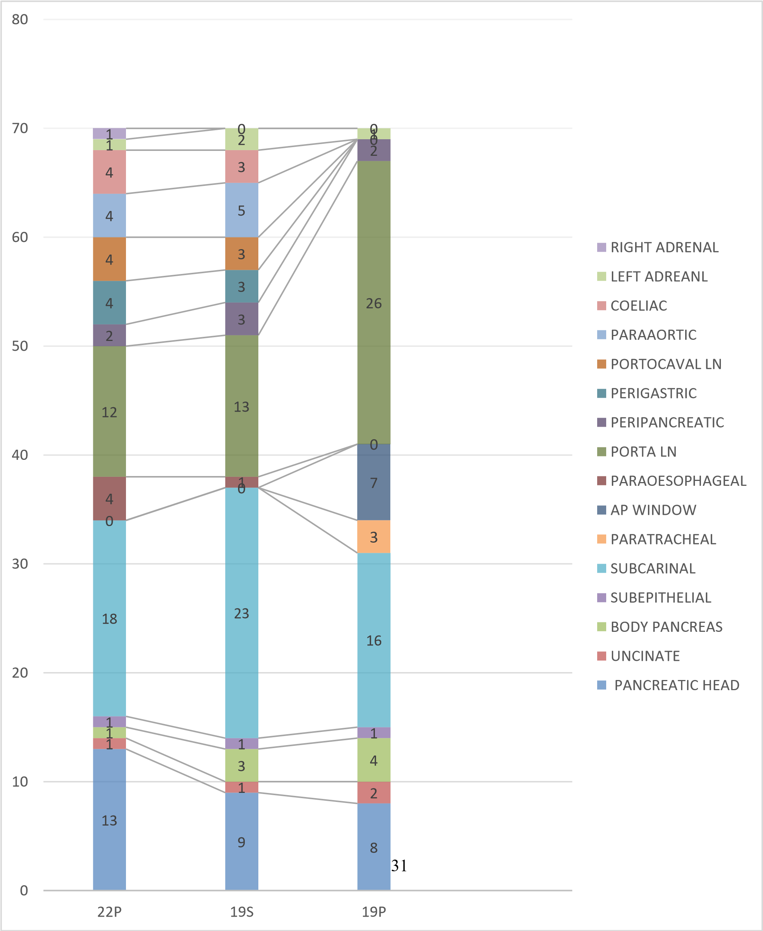
Fig.1Distribution of patients as per location of the lesion, p-value-0.998

Table 2. Distribution of patients as per on gross histopathological finding

Histopathology | Group |  |  | Total | p-value
Histopathology | 22P | 19S | 19P | Total | p-value
Tissue core | 35(50%) | 40(57.2%) | 21(30%) | 96(45.7%) | 0.0021
Tissue core mixed with blood | 11(15.7%) | 20(28.5%) | 30(42.8%) | 61(29.0%) | 0.0021
Multiple small fragmented core | 15(21.5%) | 6 (8.6%) | 12(17.2%) | 33(15.7%) | 0.0021
Blood only | 9 (12.8%) | 4(5.7%)) | 7 (10%) | 20 (9.6 %) | 0.0021
Blood Clots -Yes/ No | 35(50%)  /35(50%) | 30(42.8%)/  40(57.2%) | 49 (70%)/  21 (30%) | 114(54.3%)/  96 (45.7%) | 0.003

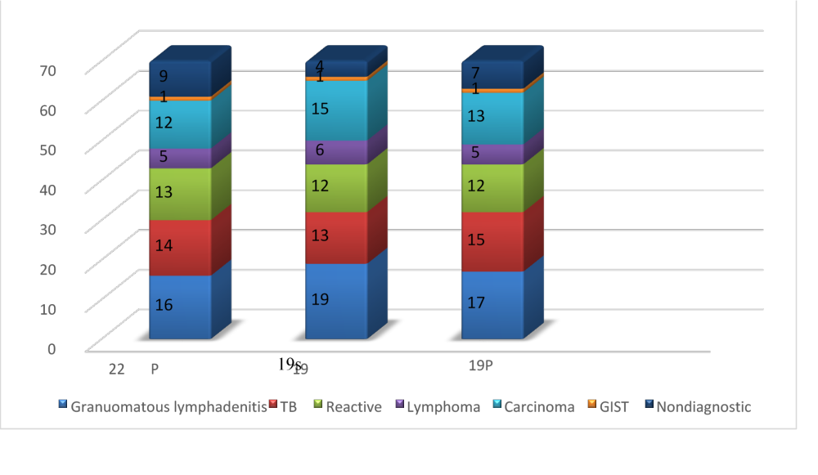
Fig. 2 Distribution of histopathological diagnosis
(p-value-0.997)
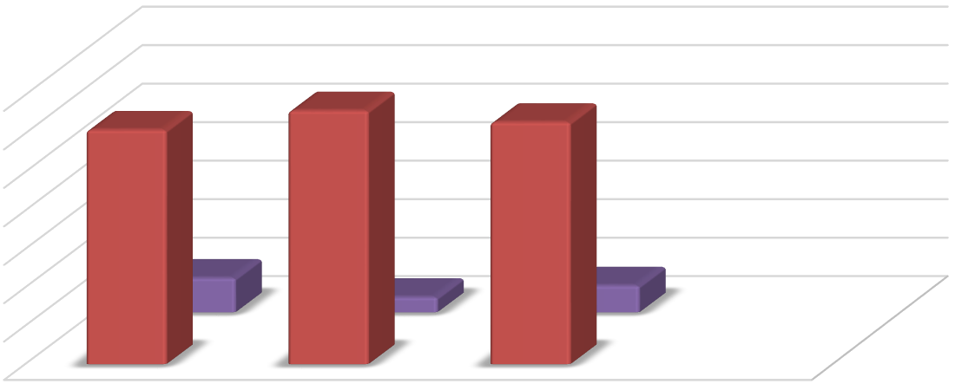
Fig 3 Distribution of patients as per histopathological diagnosis possible or Not (p-valu-.350)

Diagnostic
Nondiagnostic
0
10
20
30
40
50
60
70
22
P
19
S
19
P
61
66
63
9
4
7
Diagnostic
Nondiagnostic

DISCUSSION: In this study adequate tissue samples were obtained for histological evaluation in 90.5% cases (190/210), with the use of all three type of needles. There was no significant difference between these three groups with regard to the age, gender, location, echogenicity, border & size of the lesions, presence of calcification & necrosis in the lesions. The histopathological diagnoses were possible in 87.1%, 90.0% and 94.3% respectively with 22G Procore needles, 19G Procore needles and 19G Standard needles. Present study did not show any statistical significance differences in the tissue acquisition with in three groups. A Study by Iglesias-Garcia et al ⁽¹⁾ using 19-gauge, Echo tip Ultra FNB needle, featuring Procore reverse bevel technology (Cook Endoscopy Inc., Limerick, Ireland) showed that EUS-FNB was technically feasible in 112 lesions (98.24%). Sample quality was adequate for full histological assessment in 102 lesions (89.47%) that was similar to our study. Another Study by Larghi A et al, ⁽⁸⁾ in which 19 G standard needle was used, FNA was successfully performed in 119/120 patient (98.9%) and adequate samples for histological examination were obtained in 116 of the 119 patients (97.5%). In our study, it was possible in 66/70 (94.3%) cases, possible explanation for that is the number of solid pancreatic mass more in previous study compared to our study. Another Study by Varadarajulu et al ⁽⁹⁾ found that trans duodenal biopsy using a flexible 19-gauge needle (Boston-Scientific, Natick MA; United States) was technically feasible in all 32 patients attempted and a core specimen and histologic sample acquired in most patients. Study by Abdullah Alatawi et al ^{[10]} compared 22G Echo-ultra™ (Cook Medical, Cork, Ireland) for FNA and 22G Echo tip Procore (Cook Medical) for FNB for the sampling of solid pancreatic tumors under formalized conditions and found that a sample adequate for diagnosis was obtained in more than 90% of cases after the second needle pass in the FNB group, versus the third needle pass in the FNA group. Slide cellularity and presence of tissue micro fragments were significantly higher in the FNB group. Sensitivity for the diagnosis of malignancy was 88.4% versus 97.8% for the EUS-FNA and EUS-FNB group, respectively, while specificity for both techniques was 100%. No complications were recorded. A meta-analysis by Bang JY, Hasan M, Hawes RH et al ^{[11]} (n = 1617; including 641 cases with pancreatic mass lesions) compared the performance of the Procore and standard needles for EUS-guided sampling of pancreatic and other lesions and found no significant difference in diagnostic adequacy or accuracy, histological core tissue procurement or mean number of passes to diagnosis. There was no difference observed between the 19, 22 or 25 G needles for any of the outcome parameters. Similarly, our study did not show any statistical significance differences in the tissue acquisition with in three groups.

CONCLUSION: EUS-guided biopsy with these three needles was feasible and safe for histopathological diagnosis of intestinal and extra intestinal solid mass lesions and lymph nodes. The diagnostic yield of these three needles for providing adequate sample for histopathological analysis was in following order 19S > 19P > 22P (94.3% > 90.0% > 87.1%), that is clinically significant but not Statistical significant. Procore needles did not offer the extra possibility of obtaining a core sample for histopathological analysis in this study but there is high possibility of presence of blood clots [19G procore (70.00%) > 22G procore (50.00%) > 19 G Standard (42.8%).]
RECOMMENDATION: EUS-guided biopsy is feasible and safe for histopathological diagnosis for intestinal and extra intestinal mass lesions. Any of these three needles can be used for biopsy according to the availability and expertise of the endosonologist. Outcome depends on experience of endosonologist as well pathologist.

REFERENCES
- Iglesias-Garcia J, Poley JW, Larghi A, Giovannini M, Petrone MC, et al. Feasibility and yield of a new EUS histology needle: results from a multicenter, pooled, cohort study. Gastrointest Endosc 2011; 73:1189-96.
- Shah JN, Ahmad NA, Beilstein MC, Ginsberg GG, Kochman ML. Clinical impact of endoscopic ultrasonography on the management of malignancies. Clin Gastroenterol Hepatol 2004; 2:1069-73.
- Ribeiro A, Vazquez-Sequeiros E, Wiersema LM, et al. EUS-guided FNA combined with flow cytometry and immunocytochemistry in the diagnosis of lymphoma. Gastrointest Endosc 2001; 53:485-91.
- Zinzani PL, Colecchia A, Festi D, et al. Ultrasound-guided coreneedle biopsy is effective in the initial diagnosis of lymphoma patients. Haematologica 1998; 83:989-92.
- Hucl T, Wee E, Anuradha S, Gupta R, Ramchandani M et al. Feasibility and efficiency of a new 22G core needle: a prospective comparison study. Endoscopy. 2013 Oct; 45(10):792-98.
- Bang JY, Hebert-Magee S, Trevino J, et al. Randomized trial comparing the 22-gauge aspiration and 22-gauge biopsy needles for EUSguided sampling of solid pancreatic mass lesions. Gastrointest Endosc 2012; 321- 27.
- Lee YN, Moon JH, Kim HK, et al. Core biopsy needle versus standard aspiration needle for endoscopic ultrasound-guided sampling of solid pancreatic masses: A randomized parallel-group study.Endoscopy 2014; 46: 1056–62.
- Larghi A, Verna EC, Ricci R et al. EUS-guided fine-needle tissue acquisition by using a 19-gauge needle in a selected patient population: a prospective study. Gastrointest Endosc 2011; 74: 504-10.
- Varadarajulu S, Bang JY, Hebert-Magee S. Assessment of the technical performance of the flexible 19-gauge EUS-FNA needle. Gastrointest Endosc 2012; 76(2):336–43.
- Abdullah A, Frederic B, Sophie G, et al. Comparison of 22G reverse-beveled versus standard needle for endoscopic ultrasound-guided sampling of solid pancreatic lesions. United European Gastroenterol J.
2015 Aug; 3(4): 343–52.
- Bang JY, Hasan M, Hawes RH et al. EUS-Guided Tissue Acquisition: Meta-Analysis Comparing the Procore and Standard FNA Needles Gastrointest Endosc 2014; 79: AB427.

INTRODUCTION: Endoscopic ultrasound (EUS) is a sensitive method for detecting intestinal and extra-intestinal mass lesions including lymphadenopathy. FNA allows evaluating cellular findings suggestive of malignancy but inflammation causes cellular changes undistinguishable from neoplasia solely based on cytological evaluation, because tissue architecture and cell morphology are essential for accurate pathological assessment. Various EUS-guided techniques have been explored to retrieve tissue specimens with variable success and complication rates. Currently, the data are conflicting and more randomized trials comparing these needles to standard needles are required.
AIMS AND OBJECTIVES: To compare the tissue diagnostic yield of solid lesion biopsies based on the histopathological analysis of endoscopic ultrasound guided fine needle aspiration (EUS –FNA) samples produced by the 19G Procore needle, Standard 19G needle and 22G Procore needle.
MATERIAL AND METHODS: The study was conducted at Medanta -The Medicity, Gurgaon as Single Centre, prospective, observational study. All the Patients, above 18 years of age, having intestinal and extra-intestinal solid mass lesions including lymphadenopathy, were subjected to EUS guided FNA. The study was conducted from June 2016 to May 2017. Patients with cystic lesions, refused to sign the informed consent and with coagulopathy (INR>1.5, Platelets <50000) were excluded from study.
RESULTS: Total 215 patients were evaluated, out of which EUS-FNA was technically feasible in 210 (97.67%) cases. Three needle passes were made in every case. There was no significant difference between these three groups with regard to the age (p-value-0.676), gender (p-value-0.856), location (pvalue-0.998), echogenicity (p-value-0.123), border (p-value-0.216), size (p-value-0.735 & 0.374) of the lesions and presence of calcification (pvalue-0.093) or necrosis (p-value 0.729). Sample suitable for pathological evaluation were obtained in 90.5% cases with a tissue core in 45.7% cases. 28.1% lesions were malignant,62.4% were benign and 9.5% remained undiagnosed. The histopathological diagnoses were possible in 87.1%, 90.0% and 94.3% cases respectively with 22G Procore, 19G Procore and 19G Standard needles (p-valu-.350). Samples for the presence of blood clot in order of 19G procore (70.00%) > 22G procore (50.00%) > 19 G Standard (42. 8%), (P-value 0.003). There were no post procedure complications noted in any group.
CONCLUSION: EUS-guided biopsy with these three needles was feasible and safe for histopathological diagnosis of intestinal and extra intestinal solid mass lesions and lymph nodes. The diagnostic yield of these three needles for providing adequate sample for histopathological analysis was in following order 19S > 19P > 22P (94.3% > 90.0% > 87.1%), that is clinically significant but not Statistical significant. Procore needles did not offer the extra possibility of obtaining a core sample for histopathological analysis in this study but there is high possibility of presence of blood clots [19G procore (70.00%) > 22G procore (50.00%) > 19 G Standard (42.8%).]
Key words: EUS-FNA- Endoscopic ultrasound fine needle aspiration, G- Gauge, P- Procore, S- Standard

