Invasive mucormycosis in chronic granulomatous disease

Abdulnasir Al-Otaibi¹, MD, Dayel Al-Shahrani², MD, Eman Al-Idrissi², MD, and Hail Al-Abdely³, MD

1 Division of Infectious Diseases, The Hospital for Sick Children, University of Toronto, Toronto, Ontario, Canada.
2 Division of Infectious Diseases and Immunology, Department of Pediatrics, King Fahad Medical City, Riyadh, Saudi Arabia.
3 Division of Infectious Diseases, Department of Medicine, King Faisal Specialist Hospital and Research Centre, Riyadh, Saudi Arabia.

Abstract

Mucormycosis is an uncommon fungal infection caused by members of the order Mucorales. Populations at risk for this potentially life-threatening infection include hematopoietic stem-cell transplant (HSCT) recipients, patients with hematological malignancies, diabetes mellitus, ketoacidosis, burns, trauma, premature neonates, and patients receiving iron chelation. Rhizopus is the most commonly identified species, followed by Mucor spp. Common patterns of mucormycosis are cutaneous, gastrointestinal, rhinocerebral, and pulmonary. Amphotericin B is the antifungal drug of choice for treatment of mucormycosis. Combination polyene-caspofungin treatment was found to be associated with improved survival in patients with rhino-orbital-cerebral mucormycosis, compared to polyene monotherapy. Surgery is an important adjunctive therapy and was shown to decrease mortality in patients with mucormycosis. We described rare presentations of pulmonary mucormycosis caused by Rhizopus spp. in 2 patients with CGD; with chest wall and spinal involvement in a child, and cardiovascular involvement in an adult patient.

Case 1:

A 2-year-old girl presented with pneumonia and pleural effusion that failed to respond to prolonged courses of broad spectrum antibiotics and pleural drainage. Examination revealed a febrile, malnourished child with enlarged liver and spleen. Chest examination showed a firm mass extending from the axial to the posterior aspect of the right chest wall. CT scan showed consolidation involving right lower lobe, middle lobe, and posterior segment of the right upper lobe with pleural effusion. A right chest wall mass with intraspinal extension was also noted. Cultures of tissue obtained from surgical biopsy of the chest wall mass grew Rhizopus spp. She was subsequently diagnosed to have CGD based on oxidative burst test result. Treatment with liposomal amphotericin B was initiated at a dose of 5 mg/kg/day then increased to 7 mg/kg/day. Caspofungin and interferon γ (IFN-γ) were added to treatment. She underwent surgical debulking of the chest wall mass and near-total pneumonectomy. She was then referred to a specialized center for HSCT.

Image

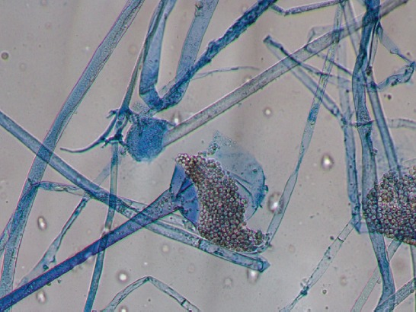

Rhizopus spp. grown from intraoperatively obtained lung tissue.

Recent Publications

1. Dotis J, Pana ZD, Roilides E. Non-Aspergillus fungal infections in chronic granulomatous disease. Mycoses. 2013; 56:449–462.
2. Blumental S, Mouy R, Mahlaoui N, et al. Invasive mold infections in chronic granulomatous disease: a 25-year retrospective survey. Clin Infect Dis. 2011; 53:e159–e169.
3. Falcone EL, Holland SM. Invasive fungal infection in chronic granulomatous disease: insights into pathogenesis and management. Curr Opin Infect Dis. 2012; 25:658–669.
4. Vinh DC, Freeman AF, Shea YR, et al. Mucormycosis in chronic granulomatous disease: association with iatrogenic immunosuppression. J Allergy Clin Immunol. 2009; 123:1411–1413.
5. Zaoutis TE, Roilides E, Chiou CC, et al. Zygomycosis in children: a systematic review and analysis of reported cases. Pediatr Infect Dis J. 2007; 26:723–727.



Biography
Abdulnasir Al-otaibi is a clinical fellow in pediatric infectious diseases at The Hospital for Sick Children, University of Toronto, Toronto, Ontario, Canada.
Dr Al-otaibi has an interest in infectious diseases in immunocompromised hosts, particularly invasive fungal infections.
Email:
abdulnasir.al-otaibi@sickkids.ca

Notes/Comments:

