Isolation and characterization of antibacterial peptide produced by Pediococcus pentosaceus PB2 Isolated from Pito, a Sorghum-Based Fermented Beverage in Nigeria
DR OTUNBA, AA PhD, DANIEL & FOLA Biotechnology Foundation, Nigeria

Abstract
Fermented products, including Pito, provide several health benefits, particularly when probiotics are used in the fermentation process. Pediococcus pentosaceus PB2 isolated during Pito production was previously identified on the basis of phenotypic and molecular analyses. P. pentosaceus inhibited growth of indicator bacteria on bacteriocin screening medium. Proteinase K completely inactivated this antibacterial property of the P. pentosaceus strain which suggested that the antibacterial agent was proteinaceous in nature.
The proteinaceous substance was partially purified (12.62-fold with a recovery of 13.3%) by ammonium sulphate precipitation and separation on carboxy-methyl ion exchanger. The proteinaceous substance was 4.87 kDa in size, as determined by tricine-SDS-PAGE and the optimal activity was at 40⁰C and pH 5 against both E. coli and L. monocytogenes. Antibacterial activity of the proteinaceous substance was over 60% when treated with organic solvents (ethanol, phenol, acetone, chloroform and isoamyl-alcohol).
Plasmid screening revealed the presence of two plasmids with 0.9 and 1.2 kb sizes in the P. pentosaceus strain. The antagonistic effects were lost when the plasmids were cured with ethidium bromide. This revealed that the antagonistic agent is a plasmid encoded proteinaceous compound.
The study revealed the possibility of using a strain of Pediococcus pentosaceus isolated from fermented sorghum as a probiotic because of its activity against clinical important enteropathogens and its tolerance to acidity and bile salts. Also, the antibacterial peptide extracted from P. pentosaceus can be modified for therapeutic purpose.

Image
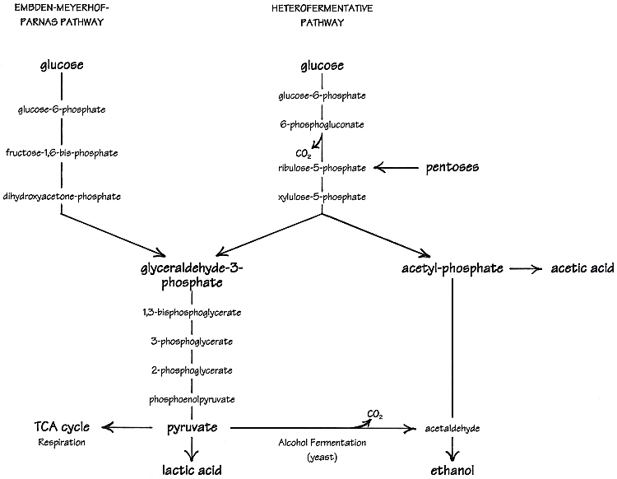
Figure 1: Diagrammatic illustration of metabolism of carbohydrate by lactic acid bacteria
Recent Publications
- Osuntoki, A. A., Oyede, T. A., & Otunba, A. A. (2006). Membrane Stabilizing Activity And Phytochemistry Of Hibiscus rosa-sinensis Leaves. Nigerian Quarterly Journal of Hospital Medicine, 16(2), 53-55.
- Iwalokun, B. A., Usen, U. A., Otunba, A. A., & Olukoya, D. K. (2007). Comparative phytochemical evaluation, antimicrobial and antioxidant properties of Pleurotus ostreatus. African Journal of Biotechnology, 6(15).
- Iwalokun, B. A., Oluwadun, A., Otunba, A., & Oyenuga, O. A. (2012). Chemical Composition and Antimicrobial Activity of a New Chemotype of" Hyptis suaveolens"(Poit) from Nigeria. Current Research Journal of Biological Sciences, 4(3), 265-272.
- Odeyemi, O. A., Odeyemi, O. A., Bamidele, F. A., & Adebisi, Otunba A. (2019). Increased research productivity in Nigeria: more to be done. Future Science OA, 5(2), FSO360.
- Babalola, B. A., Adetobi, T. E., Akinsuyi, O. S., Adebisi, Otunba A., & Folajimi, E. O. (2021). Computational Study of the Therapeutic Potential of Novel Heterocyclic Derivatives against SARS-CoV-2. COVID, 1(4), 757-774.
- Otunba, A. A., Osuntoki, A. A., Olukoya, D. K., & Babalola, B. A. (2021). Genomic, biochemical and microbial evaluation of probiotic potentials of bacterial isolates from fermented sorghum products. Heliyon, 7(12), e08536.

Photograph

Biography
Dr A A Otunba has his expertise in molecular biology and passion in improving the health and wellbeing. His open and contextual evaluation indigenous food create new pathways for improving healthcare. He has developed his proficiency over years of experience in research, evaluation, training and workshops both in education institutions. The foundation where he works was founded in Nigeria with sole aim of imparting contemporary knowledge in molecular biology and biotechnology thereby ensuring that Nigeria is not left behind the global biotechnological revolution. A number of trainings have be conducted in organization premises and outstations, in universities where requests have been made. Hands on practical sessions done over the years include DNA and RNA extraction, fermentation processes, soxhlet extractions, PCR technologies, electrophoreses, microbiological analyses, protein evaluation by kjeldahl digestion and bioinformatics techniques to mention a few.
Email: hadbat2.oa@gmail.com

