Debittering of Olives in Modified Atmosphere Packing
Y. OZDEMIR, S. KAYAHAN, A. OZTURK

Food Technology Department (Ataturk Horticultural Central Research Institute, TURKEY)

Abstract
The aim of the project is to develop new methods for olive debittering which has ever been used by industry and found in the literature. Storage in N₂/CO₂ gasses will be used for development of this innovative olive debittering methods. This research was a pre-work of “New Table Black Olives Production Methods Development with Ethylene and CO₂ Application” This research was aimed to verify this hypothesis by determining the degradation of oleuropein and this hypothesis will be used for table olive processing. Gemlik olives were harvested at 6 maturity index. Sensorial bitterness, visual quality, oleuropein content and tissue hardness of fresh olives were determined. Olives were put in CO₂:N₂ 30:70 %, CO₂:N₂ 50:50 % and 100 % N₂ pack. Pack:olive volume was 3:1 and olives were packed in atmosphere pressure. Packs were stored at 20ºC until sensorial bitterness of olives reduce to 1,5 value so that each day olives were analyzed. 16th day of packaging bitterness value of olives were determined under 1,5 for 30:70 % CO₂:N₂ applications. Tissue hardness loss of olives between 16-29%, oleuropein content reduction was 5-42 % and sensorial bitterness reduction was 7-55% for stored olive samples. As a result of visual quality determination indicator of deterioration on olives were determined in 100 % N₂ pack. Results of this research showed that CO₂:N₂ 30:70 % or CO₂:N₂ 50:50 % applications could break up oleuropein which responsible for prevent the consumption of raw olives without high loss of tissue hardness. Future studies will be possible to produce table olive which is not depend on water, salt and/or chemical uses.

Keywords— CO₂, N₂, olive bitterness, olive debittering

Professional Biography (100-150 words)

Yasin OZDEMIR has completed his PhD at the age of 29 years from Namik Kemal University and carried out 6 national research project. He has 1.st National Olive Oscar Award for his innovative olive technology research project at 2015. He has 3 registered patents on table olive and olive sausage processing. He has Environment Awards/Academician Special Award from Istanbul Chamber of Industry at 2018. He has published more than 50 papers in reputed journals and has been serving as an editorial board member of repute.
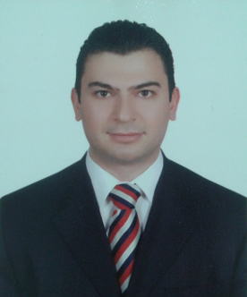
Paste your Photograph here
Email Id: gidaciyasin@hotmail.com

Any Comments:

