Abstract Title: Food Innovation: The Cambrian Explosion
F. Attanasio

¹ Food Innovation LAB (Italy)

Abstract

Innovation is a process of generating new and improved solutions for current and future needs/wants. From a business perspective, innovation supports the growth of any organisation, and its outcome is often represented in terms of profit, although it can also be expressed as knowledge, human experience and efficiency. As such, the concept of innovation is suitable for products/services development, process improvement, and novel business models implementation.

Recent Scientific findings and continuous technological development, combined with uncertainty and complexity of economic environment, define the main features of innovation in the food industry:
- Desirability - creating value for customers.
- Usability - maintaining the ability to be familiar and of easy usage for customers.
- Specificity - fitting into a given (economic, social, geographical and technological) environment.
- Survival - strategic resource for the growth of any business organisation.
- Dual focus - “improving” the present and “creating” the future.
- Protection - Building a protected ecosystem, where organisations can thrive and preserve their competitive advantages.

Our aim is to offer an overview of the main concepts behind innovation in the food industry; for this purpose it has been explored and reported how food science could allowed the development of new commercial opportunities.

Keywords—Innovation, new product/service development, innovative business models

Biography - Francesco Attanasio (PhD, MBA)

Dr Attanasio is a food technologist and nutritional scientist by training with a deep knowledge in nutrition and biotechnology. His interest for the startup-ecosystem has shaped his professional aim, which is to combine science and technology in order to create new business opportunities.
His professional focus is related to:
- Development of food able to sustain microbiota and immune system;
- Valorisation of food industry waste by biotechnological methods;
- Evaluation of alternative food sources (e.g. microorganisms, seaweed, insects, etc.).

Additionally, as innovation practitioner, he supports companies in creating “riskless” approaches for maximising the success-rate of innovation implementation.

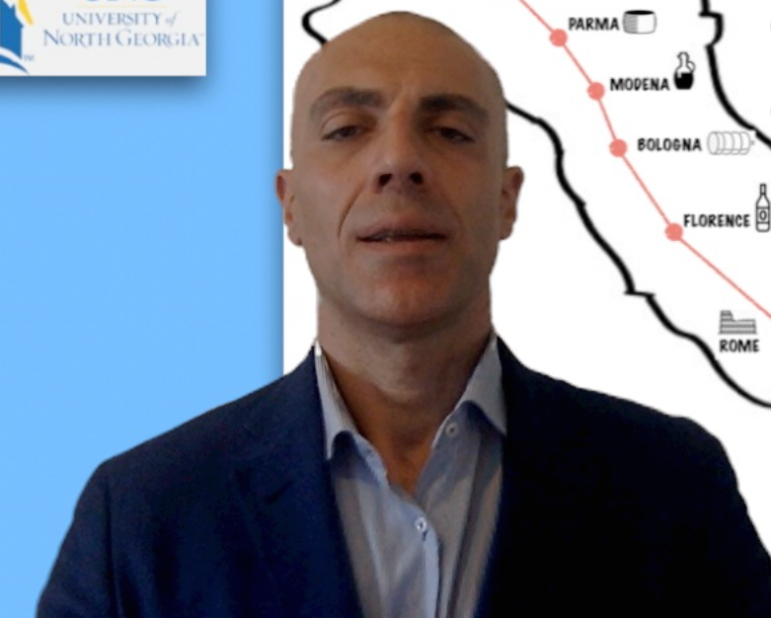


Email Id: attanasio@ng-food.com

