Management of Diabetes with Alkaline food



"Let food be thy medicine and medicine be thy food"- Hippocrates

Dr Jitendra Arya

Diabetes Mellitus

The term diabetes is the shortened version of the full name diabetes mellitus. Diabetes mellitus is derived from:
- the Greek word diabetes meaning siphon - to pass through
- the Latin word mellitus meaning honeyed or sweet
This is because in diabetes excess sugar is found in blood as well as the urine. It was known in the 17th century as the “pissing evil”.

Diabetes is first recorded in English, in the form diabete, in a medical text written around 1425. It was in 1675 that Thomas Willis added the word “'mellitus'” to the word diabetes. This was because of the sweet taste of the urine. This sweet taste had been noticed in urine by the ancient Indians,Greeks, Chinese, Egyptians, and Persians as is evident from their literature.

History of the treatment of diabetes
Sushruta, Arataeus, and Thomas Willis were the early pioneers of the treatment of diabete.Sushruta (6th century BCE) an Indian healer identified diabetes and classified it as “Madhumeha”. Here the word “madhu” means honey and combined the term means sweet urine. The ancient Indians tested for diabetes by looking at whether ants were attracted to a person's urine. The Korean, Chinese, and Japanese words for diabetes are based on the same ideographs which mean “sugar urine disease”.

Starvation treatment
In 1919 Dr. Frederick Allen of the Rockefeller Institute in New York published his “Total Dietary Regulations in the Treatment of Diabetes” that introduced a therapy of strict dieting or starvation treatment – as a way to manage diabetes.

Diabetes epidemiology
Diabetes is the fastest growing long term disease that affects millions of people worldwide. According to the charity Diabetes UK, more than two million people in the UK have the condition and up to 750,000 more are unaware of having the condition.
In the United States 25.8 million people or 8.3% of the population have diabetes. Of these, 7.0 million have undiagnosed diabetes. In 2010, about 1.9 million new cases of diabetes were diagnosed in population over 20 years. It is said that if this trend continues, 1 in 3 Americans would be diabetic by 2050.

Types of diabetes
There are two types of diabetes – Type 1 and type 2.
Type 1 diabetes is called insulin-dependent diabetes mellitus and occurs at a younger age or childhood. In these patients there is complete lack of the hormone insulin that mandates external administration of the hormone regularly as treatment.

Around 75% of people with diabetes have type 2 diabetes mellitus. This was earlier termed non-insulin dependent diabetes mellitus (NIDDM) or maturity-onset diabetes mellitus. The number of people with type 2 diabetes is rapidly increasing. In type 2 diabetes, not enough insulin is produced or the insulin that is made by the body is insufficient to meet the needs of the body. Obesity or being overweight predisposes to type 2 diabetes.
Gestational diabetes

Gestational diabetes occurs in pregnant women who have never had diabetes before but who have high blood sugar levels during pregnancy. Gestational diabetes affects about 4% of all pregnant women. After childbirth the mother may go on to develop type 2 diabetes.

How is blood sugar regulated normally?
When food is taken, it is broken down to smaller components. Sugars and carbohydrates are thus broken down into glucose for the body to utilize them as energy source. The liver is also able to manufacture glucose.

In normal persons the hormone insulin, which is made by the beta cells of the pancreas, regulates how much glucose is in the blood. When there is excess glucose in the blood, insulin stimulates cells to absorb enough glucose from the blood for the energy that they need. Insulin also stimulates the liver to absorb and store any glucose that is excess in blood. Insulin release is triggered after a meal when there is rise in blood glucose. When blood glucose levels fall, during exercise for example, insulin levels fall too.
A second hormone manufactured by the pancreas is called glucagon. It has the opposite function of stimulating the liver to release glucose when necessary.

What happens in diabetes?
Due to lack or insufficiency of insulin there is high blood glucose in diabetes. Excess glucose in the blood can damage the blood vessels. This leads to several complications like heart disease, kidney damage, nerve damage, eye damage and blindness, impotence and stroke.
Diabetes, when not controlled, may raise the propensity for infections. Infections and gangrene of the lower limbs is common in uncontrolled diabetes. This may necessitate an amputation if severe. People with diabetes are also 15 per cent more likely to have an amputation than people without the condition.

Symptoms of diabetes
The main symptoms of diabetes are three – polydipsia, polyphagia and polyuria. These mean increased thirst, increased hunger and increased frequency of urination. In addition patients complain of feeling very tired and weight loss and loss of muscle bulk. Type 1 diabetes can develop quickly, over weeks or even days whereas type 2 diabetes may develop gradually.

Management

Cells and tissues are building blocks of our body. These are made of 16 chemical elements. Balance between these chemical elements in body is essential for achieving a good health. Acid-alkali balance in body helps in keeping body chemistry balanced. The acid-alkaline balance in the body is 20:80.
For a normal healthy individual, blood reaction is alkaline in nature which is important for physical and mental health. The blood is alkaline due to the fact that main products of digestion of carbohydrates and fats are carbon dioxide, gas and water. Normally carbohydrates and fats constitute approx. 90% of body fuel. Of remaining 10%, 5% is also converted into carbon dioxide, water and gas. Therefore, blood gets a large amount of acid to be transported to points of discharge of body such as lungs. Since blood is alkaline it is able to transport this acid from tissue to lungs etc.
Acidosis or Hypo-alkalinity of blood: Ability of blood to carry carbon dioxide gets reduced when blood alkalinity goes down even slightly. As a result acid gets accumulated in tissues resulting in a condition called Acidosis or Hypo-alkalinity of blood.

One must strive to maintain a balance between acid-alkaline foods consumed. Food items that leave alkaline ash help in increasing blood alkalinity. Non-vegetarian food items (flesh-based diets) leave acidic ash and lower the alkaline nature of blood. Eggs also lower alkalinity of blood but to a lesser extent than flesh based diet. Cereals, breads do the same but to a much less extent. Foods which increase alkalinity of blood include fresh fruits such as plum, prunes and green & root vegetables.
One must design daily diet in such a way as to consume 80% alkaline-making food items such as fresh fruits, legumes, root vegetables and 20% acid-forming foods such as fish, meat, cereals, bread. Establishing a good pH balance will help one maintain a good health. In condition of acedosis, one must consume more alkaline-forming food items for faster recovery.

What Does Acid/Alkaline Mean?
Our bodies have what’s called a pH balance, which measures the acidity in our blood. That level can determine our overall state of health – and whether or not we’re at risk for serious illness.
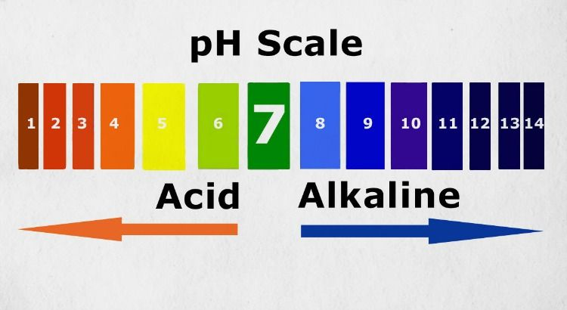
Our blood is measured on a pH scale that ranges from 0 to 14. Zero is considered most acidic, while fourteen is highly alkaline. The ideal pH of our blood for optimal health is around 7.35, which is neither too acidic or too alkaline, but neutral.

The reason the acid-alkaline balance matters to you is because it directly impacts your state of health.
Best Alkaline Foods
Although you don’t have to be strict vegetarian to eat a high alkaline diet, the diet is mostly plant-based. Here is a list of foods to emphasize most:
- Fresh fruits and vegetables promote alkalinity the most. Which are the best choices; for example, are bananas alkaline? What about broccoli? Some of the top picks include: mushrooms, citrus, dates, raisins, spinach, grapefruit, tomatoes, avocado, summer black radish, alfalfa grass, barley grass, cucumber, kale, jicama, wheat grass, broccoli, oregano, garlic, ginger, green beans, endive, cabbage, celery, red beet, watermelon, figs and ripe bananas.
- All raw foods: Ideally try to consume a good portion of your produce raw. Uncooked fruits and vegetables are said to be biogenic or “life-giving.” Cooking foods depletes alkalizing minerals. Increase your intake of raw foods, and try juicing or lightly steaming fruits and vegetables.
- Plant proteins: Almonds, navy beans, lima beans and most other beans are good choices.
- Alkaline water.
- Green drinks: Drinks made from green vegetables and grasses in powder form are loaded with alkaline-forming foods and chlorophyll. Chlorophyll is structurally similar to our own blood and helps alkalize the blood.
- Other foods to eat on an alkaline diet include sprouts, wheatgrass, kamut, fermented soy like natto or tempeh, and seeds.
Yoga therapy:
Sukshma vyayama
SuryaNamaskar (avoid in severe cases) Instant relaxation technique (IRT)
Standing series
Tadasana Ardhakatichkrasan Ardhachakrasan Padahastasan Trikonasan Parshvakonsan
Supine series
Uttitapadasana Pavanamuktasana Vipareethakarni
Sarvangasana
Matsyasana
Quick relaxation technique (QRT)
Prone series
Makarasana Bujangasana Shalabhasana

Sitting series
Vajrasana
Ustrasana Paschimottasana Vakrasana Ardhamatsyendrasana Gomukhasana Baddhakonasan
Deep relaxation technique (DRT)
Pranayama
Abdominal breathing Surya anuloma viloma
Suryabedhana Nadishodana Ujjayi Bhramari
Meditation
Ohm Kara chanting
A, U, M Kara chanting .

