Story of Gum Arabic (Acacia senegal ), Past , Present and Future

Prof .Omaima Nasir ,PhD&PD
Taif University , Turabah University College , Saudia Arabia

Abstract

Plant gum exudates have been exploited for several thousand years and still have a wide variety of practical applications particularly in the food industry, in which they are commonly used as food additives. Gum Arabic (GA) is derived from exudates of Acacia senegal or Acacia seyal trees. Acacia is known as a good source of dietary fiber because it contains about 90 percent soluble fiber, is an important part of the diet. The Food and Drug Administration (FDA) have approved Acacia as an additive in foods and drugs. Currently, the principal source of GA is the Kordofan province of Sudan which produces over 80% of the world’s supply. Recent animal and clinical studies shed some light into mechanisms involved in the therapeutic action of GA and it may be useful in the prophylaxis and treatment of obesity, diabetes, colon carcinoma, inflammatory disease and malaria. The objective of the oral presentation is to provide a broad overview of the research data uncovering the biological effects of GA, and to highlight possible avenues for future research.
- Gum Arabic counteracts carbohydrate induced obesity, hyperglycemia and hyperinsulinism
- Gum arabic counteracts intestinal inflammation and tumor growth
- Gum Arabic gum possibly enhances bone mineralization

Image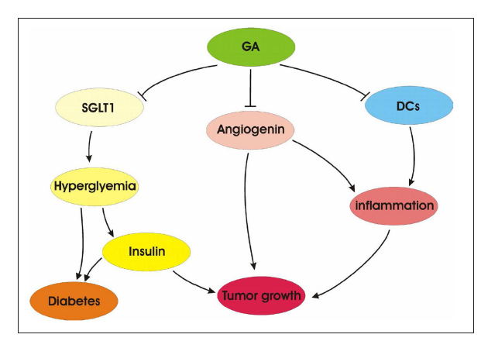

Fig. 1. Cartoon illustrating the intestinal effects of gum arabic. GA = gum arabic, SGLT1 = sodium coupled glucose transporter
Recent Publications (minimum 5)
- Omaima Nasir : Renal and Extrarenal Effects of Gum Arabic(Acacia Senegal) – What Can be Learned from Animal Experiments ?. Kidney Blood Press Res 2013;37:269-279 DOI: 10.1159/00035 0152 Published online: July 31, 2013© 2013 S. Karger AG, Baselwww. karger.com/kbr .
- Nasir Omaima, et.al: Effects of Gum Arabic (Acacia senegal) on Renal Function in Diabetic Mice.Kidney Blood Press Res. 2012 Apr 3;35(5):365-372. [Epub ahead of print]PMID:22473073.
- Nasir Omaima, et.al Downregulation of angiogenin transcript levels and inhibition of colonic carcinoma by gum arabic (Acacia senegal).Nutr Cancer. 2010;62(6):802-10.PMID:20661830 [PubMed - indexed for MEDLINE].
- Nasir Omaima, et.al Downregulation of mouse intestinal Na(+)-coupled glucose transporter SGLT1 by gum arabic (Acacia Senegal).Cell Physiol Biochem. 2010;25(2-3):203-10. Epub 2010 Jan12.PMID:20110681 [PubMed - indexed for MEDLINE] .
5. Xuan NT, Shumilina E, Nasir Omaima, Bobbala D, Götz F, Lang F. Stimulation of mouse dendritic cells by Gum Arabic.Cell Physiol Biochem. 2010;25(6):641-8. Epub 2010 May 18.PMID:20511709 [PubMed - indexed for MEDLINE].
Photograph 

Biography
Dr.Omaima has completed her PhD from Khartoum University, Sudan with a joint program scholarship from DAAD, Germany and postdoctoral studies from Tuebingen University, Germany. She has teaching experince of more than 15 years in Basic Sciences. She has been working as Aassociate Professor of physiology in Taif University. Omaima holds an international patent on efect of Gum arabic with more than 32 papers published in reputed journals and now she is a group research leader working in different scientific fields in taif University.
.Email: dahaboma@yahoo.com
Notes/Comments:
The University Clinic of Tubingen (UKT) aims to develop a beverage including appropriate concentrations of Gum Arabic to achieve weight reduction, prevention of [colon] carcinoma and improvement of bone mineralization. Such a beverage is expected to have strong impact on the health of the respective consumers. UKT has filed two patents on the use of Gum Arabic to prevent or treat tumor growth, inflammation, anemia, obesity and osteoporosis

