Incidence of Listeria monocytogenes in ready-to-eat food sold in Johannesburg, South Africa

Hattie MAKUMBE,¹ Bhekisisa DLAMINI,¹ Frederick TABIT²

¹ University of Johannesburg, Department of Biotechnology and Food Technology, Doornfontein Campus, Johannesburg, South Africa.
²UNISA, Department of Life and Consumer Sciences, Florida, Johannesburg, South Africa.

Abstract
Listeria monocytogenes is one of the most important foodborne pathogens associated with ready-to-eat (RTE) food. South Africa has recently (2017 – 2018) been plagued with a Listeria outbreak that resulted in 1065 confirmed cases and 218 deaths. L. monocytogenes can persist for years in food processing plants due to resistance to disinfectants. This study investigated the incidence of Listeria species in 80 RTE food sold in the formal (dairy and processed meat) and informal markets (vegetable salads, beef stew and rice) of Johannesburg, South Africa. High Enterobacteriaceae, S. aureus and E. coli counts were obtained which ranged from 1.9 -7.5 log CFU /g. Listeria spp microbial counts in the food samples ranged from 3.5 – 6.0 log CFU/ g except in cooked rice. The Listeria isolates were identified using biochemical tests and confirmed with the Biolog identification system. The percentage incidence for L. monocytogenes in ready to eat food was 12.5%. When MIC’s were under consideration, all disinfectants were effective against L. monocytogenes strains. For antimicrobial work, rates of resistance amongst the antibiotics ranged from 17-100%. Therefore, more effective preventive control strategies for L. monocytogenes are needed to reduce the prevalence of the pathogen in RTE food that is sold in Johannesburg.

Image

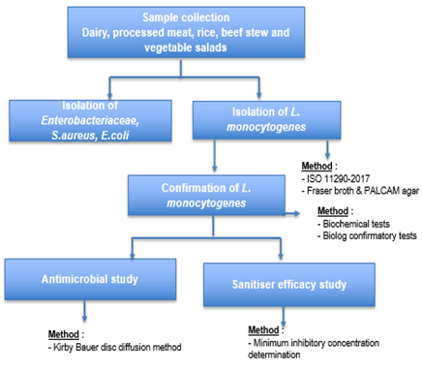
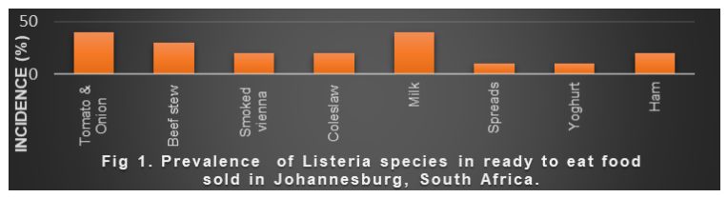
Recent Publications
- Makumbe H (2019) Incidence of Listeria monocytogenes in ready-to-eat food sold in Johannesburg, South Africa, SAAFOST presentation.

Photograph

Biography

Born in Mutare, Zimbabwe. Attended high school at Mutare Girls High School. Did under and postgraduate at the University of Johannesburg, South Africa. Currently doing PHD in Food Technology. Married happily to Marrion Makumbe.

Email: hattie-hope@hotmail.com

