A Semi-Automatic Dispenser for Solid and Liquid Food in Aquatic Facilities
Dr Raphaël CANDELIER, PhD, Sorbonne Université, CNRS, France
M. Alex BOIS, Sorbonne Université, IBPS, France
M. Stéphane TRONCHE, Sorbonne Université, IBPS, France
M. Jérémy MAHIEU, Sorbonne Université, IBPS, France
Dr Abdelkrim MANNIOUI, PhD, , Sorbonne Université, IBPS, France

Abstract (300 word limit)
We present a novel, low-footprint and low-cost semi-automatic system for delivering solid and liquid food to zebrafish, and more generally to aquatic animals raised in racks of tanks. It is composed of a portable main module equipped with a contactless reader that adjusts the quantity to deliver for each tank, and either a solid food module or a liquid food module. Solid food comprises virtually any kind of dry powder or grains below two millimeters in diameter, and, for liquid-mediated food, brine shrimps (Artemia salina) and rotifers (Rotifera) have been successfully tested. Real-world testing, feedback and validation have been performed in a zebrafish facility for several months. In comparison with manual feeding this system mitigates the appearance of musculoskeletal disorders among regularly-feeding staff, and let operators observe the animals’ behavior instead of being focused on quantities to deliver. We also tested the accuracy of both humans and our dispenser and found that the semi-automatic system is much more reliable, with respectively 7-fold and 84-fold drops in standard deviation for solid and liquid food.

Recent Publications (minimum 5)
- Migault G et al. (2018) Whole-Brain Calcium Imaging during Physiological Vestibular Stimulation in Larval Zebrafish. Current Biology 28:1-13.
- Wolf S. et al. (2017) Sensorimotor computation underlying phototaxis in zebrafish. Nature Communication 8:651.
- Jouary A. et al. (2016) A 2D virtual reality system for visual goal-driven navigation in zebrafish larvae. Scientific reports 6:34015.
- Olive R. et al. (2016) Rheotaxis of Larval Zebrafish: Behavioral Study of a Multi-Sensory Process. Frontiers in system neuroscience, 10:14.
5. Wolf S. et al. (2015) Whole-brain functional imaging with two-photon light-sheet microscopy. Nature Methods 12:5.

Image

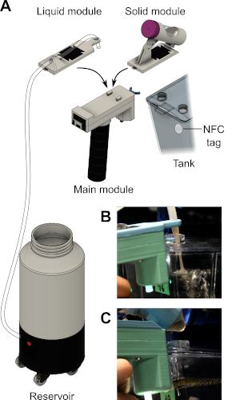

Figure 1 : The semi-automatic food dispenser. (A) Scheme of the system. The main module can host either the liquid food or solid food module to form a functional assembly. The solid food module directly hosts tubes of powder while the liquid food module has an external reservoir mounted on caster wheels. (B) Picture of the liquid food assembly during delivering. (C) Picture of the solid food assembly during delivering.

Photograph

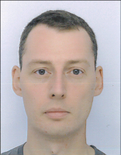Biography (150 word limit)
Dr Raphaël Candelier is a biophysicist specialized in neuroscience. He has been working for the last 10 years on larval zebrafish, for which he has developed new ways of recording behavior and imaging whole-brain activity with single cell-resolution during various tasks. His main research interests are the multi-scale mechanisms of the sensory-motor feedback loop and the general features of multi-sensory processing. He has recently started a research project on chemotaxis (i.e. attraction/repulsion of animals with chemical cues) aiming at exploiting the unique features of zebrafish to reveal general mechanisms of the vertebrate brain.

Email: raphael.candelier@upmc.fr

Notes/Comments:

