Antioxidants modulate in vitro adipocyte function and lipolysis during obesity: Are antioxidant therapies efficient?
Author: MERZOUK H,
Co-authors: SAIDI A, MEDJDOUB A, MERZOUK SA.
Laboratory of Physiology, Physiopathology and Biochemistry of Nutrition, Department of Biology, Faculty of Natural and Life Sciences, Earth and Universe, Abou-Bekr Belkaïd University, Tlemcen 13000, Algeria.

Abstract (300 word limit)

Nowadays, there has been an explosion of interest in the role of specific functional foods promoting health. Antioxidants, such as vitamins and polyphenolic compounds, are molecules capable of reducing the causes or effects of oxidative stress, caused by environmental factors, disease, infection and inflammation.

Obesity with excessive adipose tissue is associated with a chronic inflammatory state and evident oxidative stress. Micronutrient deficiencies in obesity may influence several physiological functions including adipocyte dysfunction. It has been proposed that increased oxidative stress in adipose tissue is an important cause of obesity-associated diseases, and that antioxidants may be therapeutic approaches. Previous studies showed some beneficial effect of vitamin supplementation on obesity-associated metabolic complications. However, the magical supplement theory of obesity is not proved yet. In addition, little attention has been directed towards adipose tissue function and redox status in the obese state. We then explored the in vitro effects of vitamins C and E and polyphenols (chlorogenic acid and curcumin) on adipocyte function including lipolysis, and oxidant / antioxidant status in a rat model of diet-induced obesity.

Adipocytes were isolated from abdominal adipose tissue and were cultured in the presence or the absence of vitamins (C, E) or polyphenols (chlorogenic acid and curcumin). Cell proliferation, membrane fluidity, glucose consumption, LDH and glycerol efflux, ATP and redox balance (catalase, superoxide dismutase, reduced glutathione, hydroperoxides, and carbonyl proteins) were investigated.

The results showed altered membrane fluidity, glucose consumption, low ATP concentrations and glycerol release with a concomitant oxidative stress in adipocytes of obese rats. Adipocyte function and Redox balance was improved in the presence of antioxidants. However, only curcumin enhanced lipolysis.

In conclusion, antioxidants had beneficial effects on adipocyte function and redox status, with effective effect of curcumin on lipolysis. Antioxidants should be considered in therapeutic approaches for normalizing adipose function in obesity.
Image

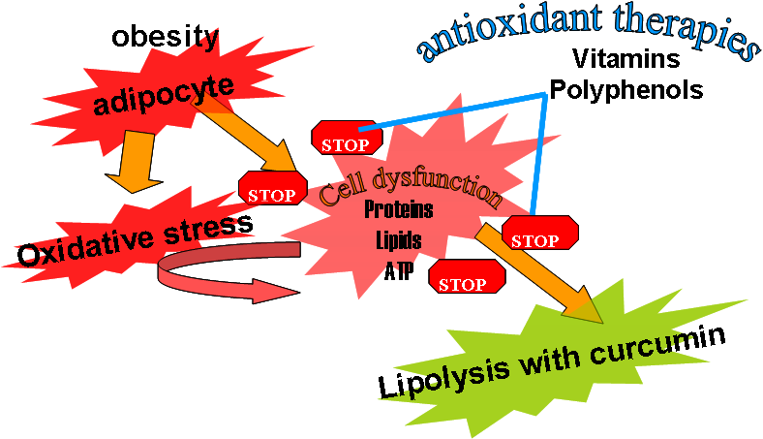

Recent Publications (minimum 5)
1. Snehal CP, Pereira MP, MyungKi CL (2017). Obesity and risk factors for cardiovascular disease and type 2 diabetes: Investigating the role of physical activity and sedentary behaviour in mid-life in the 1958 British cohort. Atherosclerosis 233: 363-369.
2. Rutkowski JM, Stern JH, Scherer PE (2015). The cell biology of fat expansion. J Cell Biol 208: 501–512.
3. Manna P, Jain SK (2015). Obesity, oxidative stress, adipose tissue dysfunction, and the associated health risks: Causes and therapeutic strategies. Metabolic Syndrome and Related Disorders 13: 423-444.
4. Abdali D, Samson SE, Grover AK (2015). How Effective Are Antioxidant Supplements in Obesity and Diabetes? Med Princ Pract 24:201–215.
5. Meng S, Cao J, Feng Q, Peng J, Hu Y (2013). Roles of chlorogenic acid on regulating glucose and lipids metabolism: a review. Evid Based Complement Alternat Med 2013:801457.
6. Baret P, Septembre-Malaterre A, Rigoulet M, D’Hellencourta CL, Priault M, Gonthiera MP, Devin A (2013). Dietary polyphenols preconditioning protects 3T3-L1 preadipocytes from mitochondrial alterations induced by oxidative stress. Int J Biochem Cell Biol 45: 161-174.

Photograph

Biography (150 word limit)
Hafida MERZOUK, Professor in Physiology and Nutrition, Algeria. In addition to theoretical and practical teaching at the university, she participated in the training of doctoral theses on various topics focused on cellular nutrition and major pathological syndromes. Currently, she is the director of PPABIONUT laboratory where she manages several research projects on preventive nutrition and bioactive molecules, on major pathological syndromes related to nutrition: diabetes, high blood pressure, obesity, metabolic syndrome, and their prevention by functional foods. Her research is oriented towards understanding the origin of chronic diseases which resides in the dysfunction of cells, due to chronic deficiencies in vitamins, minerals and other essential cellular substances. The role played by antioxidants as protective factors against pathologies must be highlighted and transmitted to the population. Her integration into the SANMO society of nutrition allows her to provide information on the importance of adequate nutrition for general population, and to promote preventive nutrition.
Email: hafidamerzouk_2@hotmail.com

