Functional Assessments and Histopathology of Hepatic and Renal Tissues of Wistar Rats Fed with Cocoa Containing Diets.
Paul Chidoka Chikezie¹, Chiedozie Onyejiaka Ibegbulem², and Ezeikel Chinemerem Dike¹
¹Department of Biochemistry, Imo State University, Owerri, NIGERIA
²Department of Biochemistry, Federal University of Technology, Owerri, NIGERIA
Presenting author: Paul C. Chikezie; e-mail: p_chikezie@yahoo.com; Phone: +2348038935327

Abstract
The liver and kidney are organs of homeostasis. Biochemical and histological methods were used to determine functional integrity of renal and hepatic tissues of Wistar rats following the consumption processed cocoa bean-based beverages (PCB-BB) - and raw cocoa bean products (RCBP) - containing diets. Thirty Wistar rats were designated on the basis of experimental diets received for 28 days. At the end of the 28-day experimental feeding duration, blood samples as well as renal and hepatic tissues from the experimental rat groups were measured for functional and histological indices, respectively. Serum ALT activities of the experimental rat groups showed no significant difference (p > 0.05) and were within relatively narrow range of 32.17±4.98 IU/L – 41.00±10.85 IU/L whereas, serum AST activities gave wide variation within the range of 15.67±2.13 IU/L – 34.83±8.31 IU/L; p < 0.05. Serum bilirubin concentrations of experimental rat groups were < 1.0 mg/dL. Serum total protein and albumin concentrations varied within relatively narrow range. Serum creatinine concentration was significantly lower (p < 0.05) than serum urea concentration. Histology showed evidence of moderate disarrangement of hepatic tissues architecture and degenerated tubules and glomerular turfs. The pattern of activity of ALT > AST in serum appeared to correlate with the extent of disarrangement of hepatic tissue architecture. The experimental rat groups did not exhibit hyperbilirubinemia. Also, PCB-BB - and RCBP - containing diets did not substantially interfere with the capacity of the hepatocytes to biosynthesized plasma proteins and the functionality of renal tissues.
Keywords: Creatinine; histopathology; kidney; serum; Theobroma cacao

Image
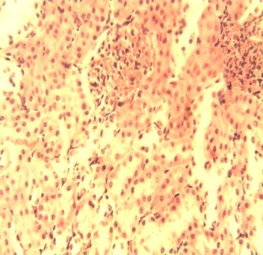
VC
B
VC
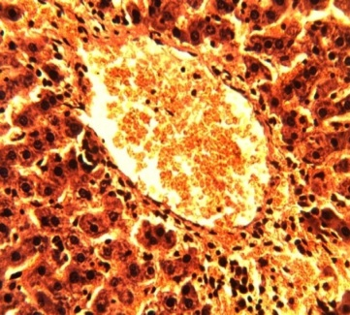
Figure 6: Photomicrograph of sections of organs from WR-RCBP. A: Hepatic tissue with its central vein (CV) and Kupffer cells along the sinusoids (blue arrow). B: Renal tissue showing venous congestion (VC); H&E ×400.
CV
A

Recent Publications (minimum 5)
- Ojiako, A.O., Chikezie, P.C. and Ogbuji, C.A. (2016). Blood glucose level and lipid profile of alloxan-induced hyperglycemic rats treated with single and combinatorial herbal formulations. Journal of Traditional and Complementary Medicine. 6(2), 184-192.
- Ojiako, A.O., Chikezie, P.C. and Ogbuji, C.A. (2015). Histopathological studies of renal and hepatic tissues of hyperglycemic rats administered with traditional herbal formulations. International Journal of Green Pharmacy. 9(3), 184-191.
- Chikezie, P.C. (2015). Short-term capacities of ethanolic Theobroma cacao bean extract to ameliorate oxidative stress, hyperglycemia and dyslipidemia in alloxan-induced diabetic rats. Journal of Investigational Biochemistry. 4(1), 23-29.
- Chikezie, P.C., Ojiako, A.O. and Nwufo, K.C. (2015). Overview of anti-diabetic medicinal plants: The Nigerian research experience. Journal of Diabetes and Metabolism. 6(6):546, 7 pages.
- Chikezie, P.C. and Uwakwe, A.A. (2014). Protective effect of Allium Sativa extract against carbon tetrachloride-induced hepatic oxidative stress and hyperlipidemia in rats. African Journal of Biotechnology. 13(15), 1671-1678.

Biography (150 word limit)
DR. PAUL C. CHIKEZIE is a Research Scientist/Lecturer at the Department of Biochemistry, Imo State University, Owerri, Nigeria. DR. PAUL C. CHIKEZIE holds a Bachelor of Science (B.Sc.) degree in Biochemistry, Masters of Science (M.Sc.) degree in Medical Biochemistry/Immunochemistry and Doctor of Philosophy (Ph.D.) degree in Medical Biochemistry, as well as Certificate in Advanced Digital Appreciation. DR. PAUL C. CHIKEZIE has over seventeen (17) years of research and cognitive experience in the academia with one hundred and two (102) scholarly publications, which include scientific articles in reputable international and local learned journals, as well as edited books and book chapter contributions. DR. PAUL C. CHIKEZIE’s research interests encompass clinical enzymology/toxicology, oxidative stress, phytomedicine, food chemistry/nutritional biochemistry, polyphenol oxidases and haemoglobinopathies with emphasis on sickle cell anaemias.
Email: p_chikezie@yahoo.com
Notes/Comment

