Decontamination of Foods by Pulsed Ultraviolet Light: A Review
Ali Demirci, PhD,
Pennsylvania State University, University Park, PA, USA

Abstract (300-word limit)
Pulsed Ultraviolet (UV)-Light is an emerging technology, which has a potential to be used for decontamination food products. The light generated in pulses consists of a continuum broadband spectrum from deep UV to the infrared, especially rich in UV range below 400 nm, which is germicidal. The recent studies suggest pulsed UV light inactivates microorganisms not only photochemical reactions, but also by other mechanisms associated with the use of high intensity pulses such as photo- thermal and photo-physical mechanisms, Microbial cells become inactive with conventional UV induced photochemical reactions have taken place, but the cell structures remain intact after UV treatment. However, pulsed UV light also damages the cell structures for some of the pulsed UV treated cells. Therefore, pulsed UV-light can be considered a powerful tool for inactivation of microorganisms on food surfaces or liquids. Many studies have demonstrated the effectiveness of pulsed UV-light on microbial loads on food surfaces. In this paper, various studies in our lab for applications of pulsed UV-light treatment will be summarized.

Conclusion and Significance: Pulsed UV light is an emerging technology, which has a great potential to be used for the decontamination of foods. This paper will not only provide a review for the recent applications of this technology, but also increase awareness of this technology for the food industry.

Image:
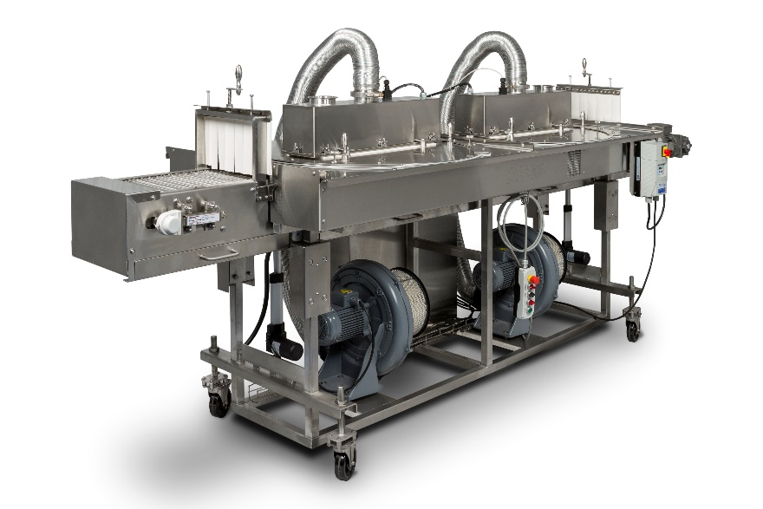
Recent Publications (minimum 5)

- Bialka, K. L. and A. Demirci. 2008. Efficacy of Pulsed UV-Light for the Decontamination of Escherichia coli O157:H7 and Salmonella spp. on raspberries and strawberries. Journal of Food Science. 73(5):M201-M207.
- Demirci, A. and L. Panico. 2008. Pulsed ultraviolet light. Food Science and Technology International. 14:443-446.
- Keklik, N. M., A. Demirci, and V. M. Puri. 2010. Decontamination of unpackaged and vacuum packaged boneless chicken breast with pulsed UV-light. Poultry Science. 89:570-581.
- Krishnamurthy, K., J. C. Tewari, J. Irudayaraj, and A. Demirci. 2010. Microscopic and spectroscopic evaluation of inactivation of Staphylococcus aureus by pulsed UV light and infrared heating. Food Bioprocess Technol. 3:93–104.
- Keklik, N. M., A. Demirci, and R. Bock. 2011. Surface decontamination of whole chicken carcasses using a pilot-scale pulsed UV light system. Transactions of ASABE. 54(3): 993-1000.
- Can, F. O., A. Demirci, V. M. Puri, and H. Gourama. 2014. Decontamination of Hard Cheeses by Pulsed UV-light. Journal of Food Protection. 77(10): 1723–1731.
- Uslu, G., A. Demirci, and J. M. Regan. 2016. Disinfection of synthetic and real municipal wastewater effluent by flow-through pulsed UV-light treatment system. Journal of Water Process Engineering 10: 89–97.

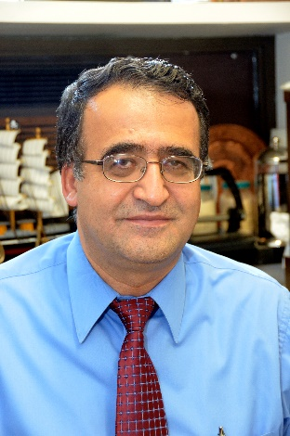

Biography (150-word limit)
Dr. Ali Demirci’s teaching and research focus on Microbiological Engineering, which has two directions: i) Bioprocessing/ fermentation processes for productions of value-added products; ii) Inactivation/control of pathogenic microorganisms in foods and environment by novel non-thermal processing methods. He holds two U.S. patents and has authored numerous refereed journal article and book chapters. He made numerous presentations at regional, national, and international conferences. He is currently serving as the associate editor for Transactions of ASABE and have served on editorial boards of several peer-reviewed journals. He received his Ph.D. degree in Food Science and Technology with a minor in Chemical Engineering at Iowa State University in 1992. He began teaching in the Department of Food Engineering at University of Gaziantep, Turkey. Then, he worked as a Research Associate at Iowa State University until he joined to the Department of Agricultural and Biological Engineering at The Pennsylvania State University in 1999.

Email:
demirci@psu.edu

Notes/Comments

