Metal accumulation in two crops across the Mbale Waste Dumpsite, Uganda
Florence Barbara Awino, PhD Candidate, University of Canberra, Australia
A. Jasmyn J. Lynch, Dr, University of Canberra, Australia
William Maher, Professor, University of Canberra, Australia
Frank Krikowa, Mr., University of Canberra, Australia

Abstract
The environmental impacts and health risks from poor waste management is a global challenge. Improper waste management contaminates soil, food chains, surface and ground water. Harmful food and water contaminants are reported to cause 200 diseases and two million annual deaths. Globally, over 800 million people cultivate contaminated soils. Global food production and trade could bring all countries into a biological and chemical risk loop. We need to identify vulnerable areas and strongly regulate farming on contaminated environments to ensure that food is secure, safe and tradable.

This study was conducted at Mbale dumpsite in Eastern Uganda (34⁰10’30.0” and 1⁰04’50.0”). The aim was to investigate metal occurrence and spatial variations in Zeamays and Amaranthus cruentus crops on the dumpsite. The dumpsite was sub-divided into dump centre (DC), slope (S), and river bank (RB). 108 Zeamays seeds, leaves, and Amaranthus cruentus leaves, and flowers samples were collected, and analysed for aluminum (Al), chromium (Cr), iron (Fe), manganese (Mn), cobalt (Co), nickel (Ni), copper (Cu), zinc (Zn), arsenic (As), selenium (Se), cadmium (Cd), mercury (Hg), and lead (Pb) using ICP-MS. Data was statistically analysed using SPSS.

In both crops, Fe, Al, Zn, Mn and Cu were in high concentrations, whereas Pb, Cr, Co, Cd, As, Hg, Se and Ni occurred in trace amounts. Significant variations were in Al, Zn, Fe, Cr, and Co across the dumpsite. Pb concentration was high in leaves and flowers but insignificantly varied across the site. The highest overall metals accumulation was at the dump centre and in leafy crops. Pb, Cr, Al, and Zn concentrations in the two crops were above WHO/FAO consumer food safety limits.

Metal accumulation in the two crops was specific, and depended on soil and metal properties, environmental factors, crop planting patterns, crop types and parts. Pb, Cr, Al, and Zn concentrations in Zeamays and Amaranthus cruentus crops on Mbale dumpsite could pose risks to consumers.

Image:
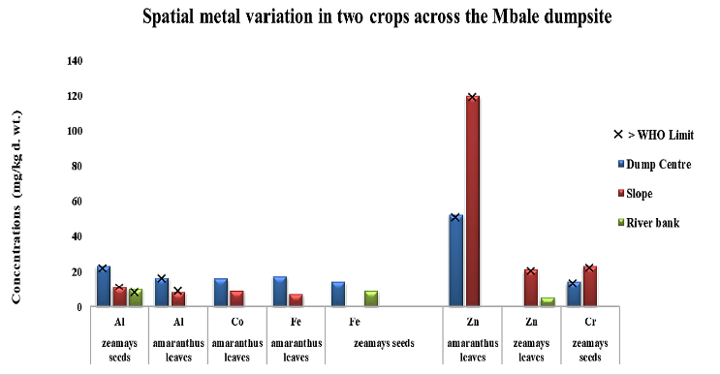

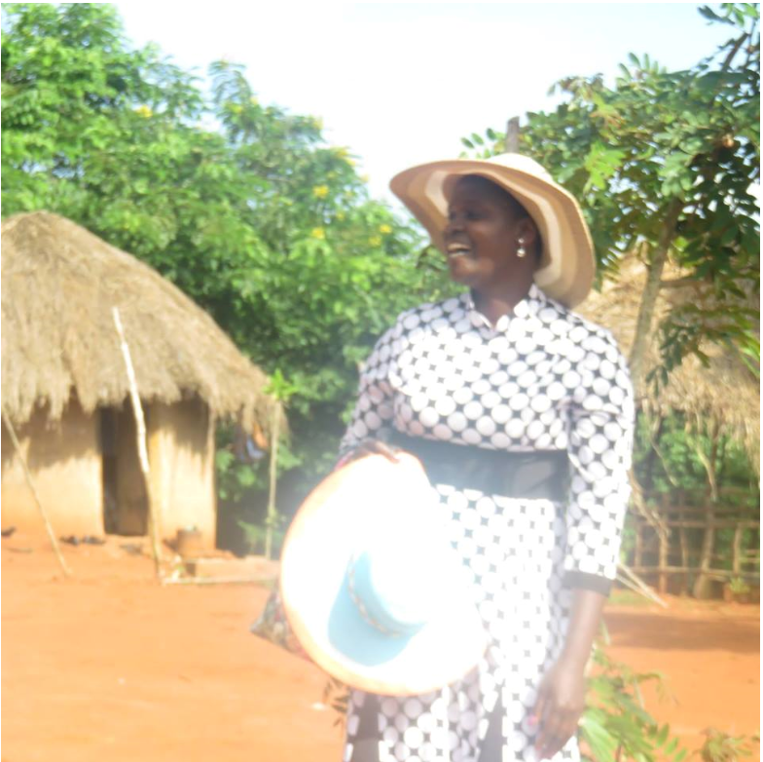 Biography

Florence Barbara Awino is a scientist with interest in environmental chemistry and pollution, groundwater quality, food safety, solid waste management, and environmental management.

Her career began in 2000, and has since worked for public service, academia, consultancy, and outreach. She holds a master’s degree in Water Resources and Environmental Management from ITC-Twente University, The Netherlands; and a bachelor’s degree in Geology and Chemistry from Makerere University, Uganda.

Florence has awards from Schlumberger Faculty for the Future Women in Science, University of Canberra, Netherlands Fellowship Program, Nile Basin Initiative, and Ugandan Government. She is a member of SETAC, and Graduate Women in Science. She has passion to advocate for clean and healthy environment. She also mentors young girls into ESTEM and is an activist for women and children in domestic violence.

Florence is currently a PhD Candidate at the University of Canberra, Australia, researching on “uncontrolled toxic metals and health risks in Mbale dumpsite crops, Uganda”.
Email: florence.awino@canberra.edu.au

Notes/Comments

Leafy crops cultivated on dumpsites in developing countries accumulate metals above food safety limits. Further assessment and potential regulation to reduce exposure and protect consumer health is needed. Waste effects and risks have impacted on national economies and livelihood through reduced food availability due to bans, export market closures, and costly solutions to address environmental and health threats.

