Critical appraisal of evidence-based clinical practice guidelines for management of women with postpartum hemorrhage using the AGREE II instrument

Dr. Sahar Abdulghani*, Dr. Khalid Akkour, Dr. Lateefa Al-Dakheyl, Dr. Neama Meriki, Dr. Khurram Bhatti, and Dr. Yasser Amer, Obstetrics and Gynecology Department & Quality Management Department, University Medical City, King Saud University, Riyadh, Saudi Arabia
*Presenter

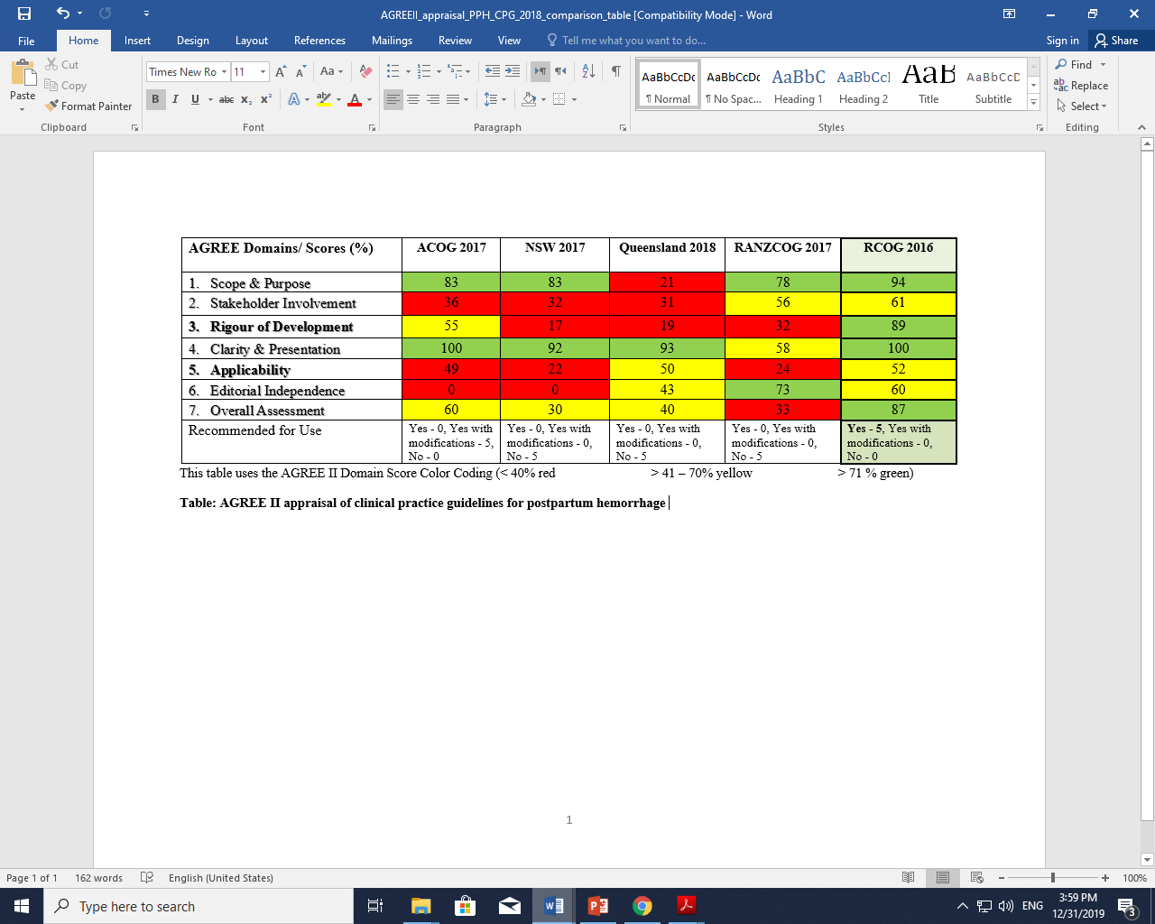
Abstract (300 word limit)
Statement of the Problem: Clinical practice guidelines (CPGs) are based on best possible scientific evidence, expert opinion and patient preferences. Postpartum hemorrhage (PPH) has a continuously rising incidence worldwide and remains one of the major causes of maternal death in both developed and developing countries. Recent data suggest that rates of obstetric hemorrhage are increasing in developed countries, including the United States, and that rates of hemorrhage-associated severe maternal morbidity exceed the morbidities associated with other obstetric and medical conditions. Approximately 30% in some countries and over 50 % of direct maternal death worldwide are due to hemorrhage. Primary Postpartum hemorrhage (PPH) is defined as excessive bleeding in the first 24 hours post birth, a blood loss of 500 ml after vaginal birth and a blood loss of 1000ml after CS. Secondary PPH is abnormal bleeding from the birth canal between 24 hours and 12 weeks postnatal. Most cases of PPH have no identifiable risk factors therefore early recognition of hemorrhage is crucial. Recommendations in CPGs focus on basic clinical skills, prompt recognition of severity of hemorrhage and emphasize communication and teamwork. Methodology & Theoretical Orientation: A systematic review of eligible PPH CPGs was conducted using the AGREE II Instrument. The review panel included five consultant obstetricians and a CPG methodologist. Findings: Five PPH CPGs were eligible for our review ACOG, NSW, Queensland, RANZCOG, and RCOG). Cut-off point for domain standardized scores were 80%. Most included CPGs scored high in clarity of presentation. Three CPGs scored >80% in scope and purpose (ACOG, NSW, RCOG). RCOG was superior in all domains including Rigor of development (89%) except editorial independence domain (60%). The top three CPGs in applicability domain were RCOG (52%), Queensland (50%), and ACOG (49%). RCOG was superior in overall assessment and recommendation for use in practice by all reviewers. Conclusion & Significance: PPH CPGs quality assessment varied across all the six domains of AGREE II, demonstrating the importance of using a formal CPG appraisal tool prior to selection of a CPG for implementation in routine daily practice by obstetricians for women with PPH.

Image
Recent Publications (minimum 5)
- Brouwers M, Kerkvliet K, Spithoff K. The AGREE Reporting Checklist: a tool to improve reporting of clinical practice guidelines. BMJ. 2016;:i1152. pmid:26957104Heilig M, Egli M (2006) Pharmacological treatment of alcohol dependence: Target symptoms and target mechanisms. Pharmacology and therapeutics 111:855-876.
- Amer YS, Wahabi HA, Abou Elkheir MM, et al. Adapting evidence‐based clinical practice guidelines at university teaching hospitals: A model for the Eastern Mediterranean Region. J Eval Clin Pract. 2019; 25: 550– 560. https://doi.org/10.1111/jep.12927
- Postpartum Haemorrhage, Prevention and Management (Green-top Guideline No. 52) [Internet]. Royal College of Obstetricians &amp; Gynaecologists. 2019 [cited 31 December 2019]. Available from: https://www.rcog.org.uk/en/guidelines-research-services/guidelines/gtg52/
- Novo A, Subotic-Popovic A, Strbac S, Kandic A, Horga M. Application of Agree II Instrument for Appraisal of Postpartum Hemorrhage Clinical Practice Guidelines in Bosnia and Herzegovina. Acta Inform Med. 2016;24(3):211–214. doi:10.5455/aim.2016.24.211-214
- WOISKI, M. D., VAN VUGT, H. C., DIJKMAN, A., GROL, R. P., MARCUS, A., MIDDELDORP, J. M., MOL, B. W., MOLS, F., OUDIJK, M. A., PORATH, M., SCHEEPERS, H. J. AND HERMENS, R. P. From Postpartum Haemorrhage Guideline to Local Protocol: A Study of Protocol Qualityn-text: (Woiski et al., 2016)

Photograph



Biography

Dr Sahar H. Abdulghani has her expertise in evaluation and passion in improving maternal health and wellbeing. Her open and contextual evaluation model based on responsive constructivists creates new pathways for improving healthcare. She has built this model after years of experience in research, evaluation, teaching and administration both in healthcare and educational Institutions. This foundation is based on fourth generation evaluation (Guba& Lincoln, 1989) which is a methodology that utilizes the previous generations of evaluation: measurement description and judgment. It allows for value-pluralism. This approach is responsive to all stakeholders and has a different way of focusing.
DR Sahar H. Abdulghani MD, SBOG, JBOG, Maternal Fetal Medicine Specialist. (American Registry for Diagnostic Medical Sonography (ARDMS ) Department of Obstetrics and Gynecology, College of Medicine, King Khalid University Hospital, King Saud University Medical City, Riyadh.
ORCID ID: https://orcid.org/0000-0001-6474-9385
Email: Sabdulalghani@KSU.EDU.SA, saharhhag@yahoo.com
P.O BOX 4663 11412 Riyadh, Kingdom of Saudi Arabia
Telephone +966-505256616

