Abstract Template
Abstract Title: Diagnosis of rare pediatric diseases by Retcam imaging
Zeinab Elsanabary

Author Affiliation (University of Cairo, Egypt)

Abstract (not more than 300 words)

Retcam imaging is known for its use in early diagnosis of ROP, however, many rare pediatric diseases are detected by its widely professional use. The aim of this poster is to highlight the diagnosis of rare conditions as peripheral active toxoplasmosis, Aicardi syndrome, papilledema in Down’s syndrome and multiple hamartomas in Tuberous sclerosis in infants.
Diagnosis of these conditions helped in their early management.

Keywords—Retcam, Aicardi syndrome, Hamartoma

- Down’s syndrome with papilledema
- 8 months female infant with bilateral ptosis and papilledema shown with Retcam imaging, neuroimaging shows premature closure of skull fontanelles and sutures leading to increased ICT and papilledema (A rare finding in Down’s syndrome)
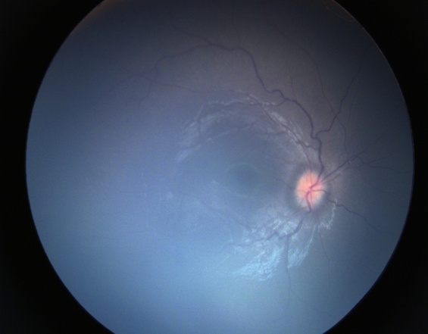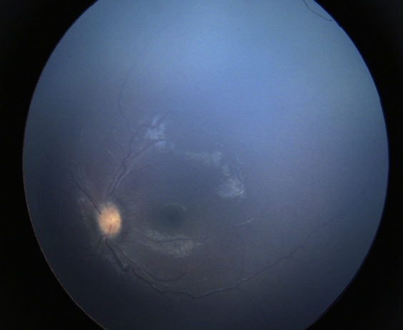

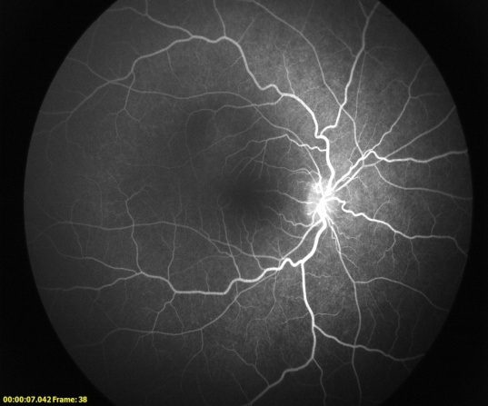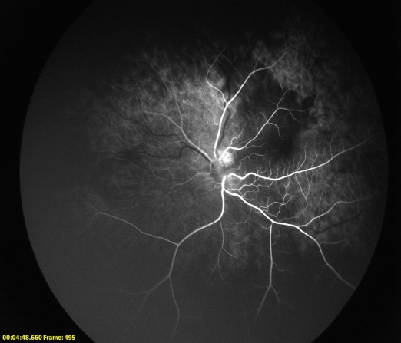
- Aicardi syndrome:
It is diagnosed with agenesis of corpus callosum, infantile spasms, Retinal lacunae & Morning Glory appearance
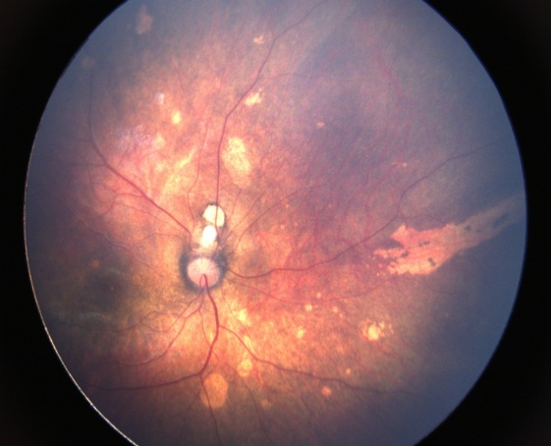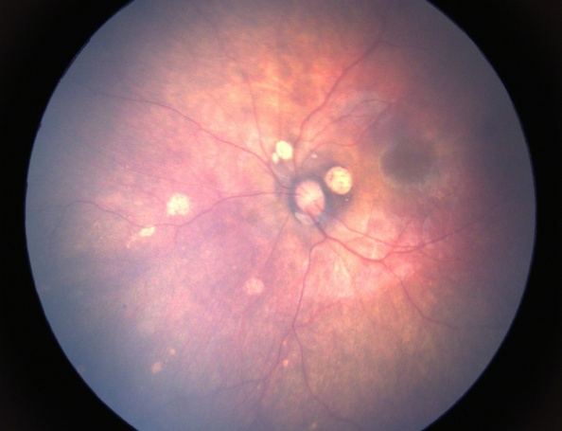

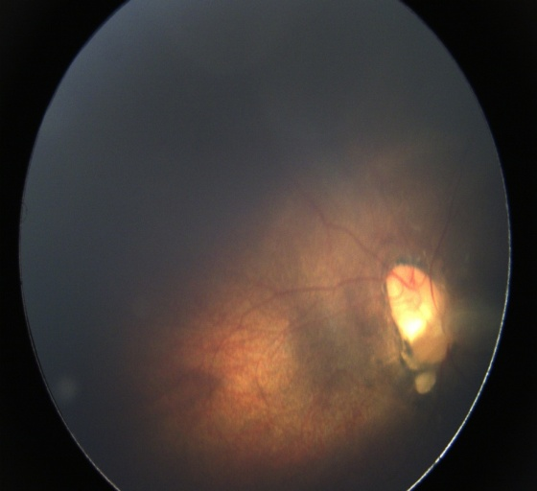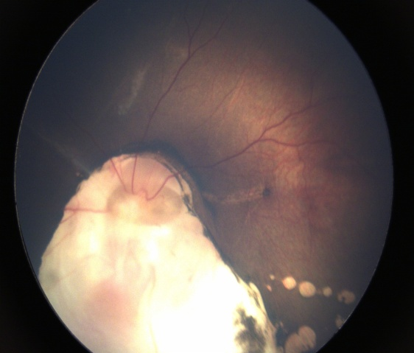
- Active peripheral toxoplasmic lesions
3 years old female presenting with central toxoplasmic chorioretinal scar. Fluorescein angiography Retcam imaging showed peripheral active lesions, an uncommon feature.
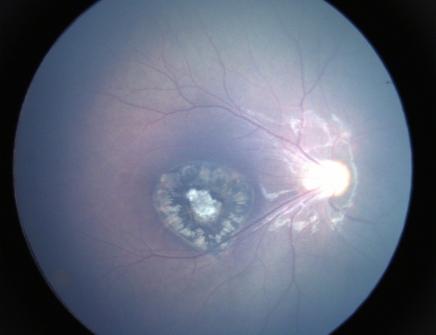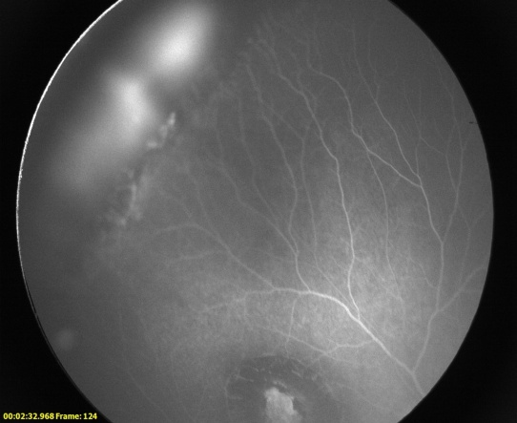

- Tuberous sclerosis (Astrocytic Hamartomas)
5 months old male infant presented with left esotropia, had multiple leaking hamartomas in both eyes, suspicious for retinoblastoma, but proved to be tuberous sclerosis Retcam fluorescein angiography imaging showing multiple leaking lesions, by CT scan showing paraventricular subependymal nodules and Confetti skin lesions

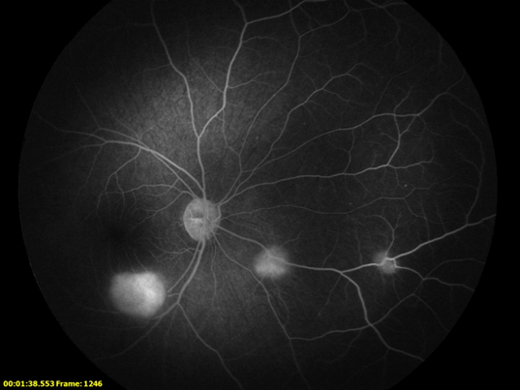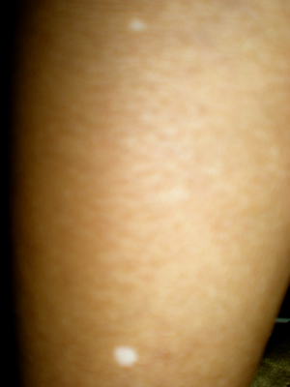
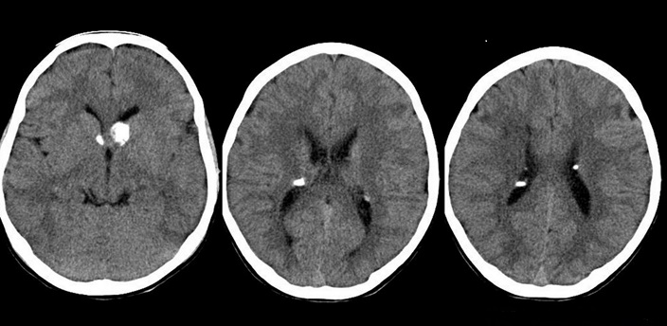

Professional Biography (100-150 words)

Dr Zeinab Elsanabary has completed her PhD at the age in 1991 from Cairo University. She has published about 30 publications as single author or in collaboration with others and supervised about 35 theses, as Master and Doctorate. She was the Founder and Vise CEO of Bostan Diagnostic Eye Center since 2005, a specialized center for investigative ophthalmology which is now a recognized and pioneer center for ophthalmic diagnosis. She was Head of Ophthalmic Diagnostic Laser Unit, Kasr El Eini Hospitals, Cairo University starting from August 2011 till August 2015. She was assigned as Sub-investigator in a clinical trial about treat and extend in wet AMD (Novartis) in 2013 and Principal investigator in a clinical trial about Bematoprost SR implant for glaucoma (Allergan) in 2016 (ongoing). She has teaching duties for junior fellows. She got National Encouraging Award in Advanced Scientific Technology in the Medical Science 2001

Email Id:ezeinab@hotmail.com

