Core Cognition Therapy: A hypothesis that task-intentioned weight shift can restore anticipatory postural adjustments of the transversus abdominis through the ideomotor pathway

Dae-Young Lee, MD, Department of Orthopedic Surgery, SaeGil Hospital, Seoul, Republic of Korea

Abstract (300 word limit)
Statement of the Problem: Disruption of the neural control subsystem—the central coordinator of Panjabi's spinal stability model —perpetuates spinal instability in chronic low back pain, recurrent spinal pain, and postoperative dysfunction. This disruption manifests as excessive superficial muscle guarding, which suppresses the feedforward function of the transversus abdominis (TrA). Motor control exercise (MCE) relies on volitional draw-in commands that paradoxically reinforce superficial co-contraction when guarding is present. Cognitive functional therapy (CFT) effectively reframes pain-related cognition and reduces protective behaviors, yet lacks a direct neurophysiological pathway to reactivate automatic deep stabilizer function. The therapeutic gap between dismantling guarding and restoring deep stabilizer automaticity remains unfilled. Methodology & Theoretical Orientation: I propose Core Cognition Therapy (CCT)—a four-stage therapeutic pipeline grounded in ideomotor theory and anticipatory postural adjustment (APA) physiology. The pipeline integrates: (1) substantial reduction of superficial muscle guarding through behavioral relaxation, (2) a weight-shift task to activate the ideomotor mechanism without volitional contraction commands, (3) automatic TrA anticipatory postural adjustment via the internal forward model, and (4) consolidation through sensorimotor cognition for lifestyle integration. The central claim is that task intention alone—not volitional muscle commands—triggers the forward model to generate TrA APAs through an ideomotor-mediated, non-volitional pathway. Recent stabilographic evidence confirms that ideomotor loading engages postural control mechanisms at the whole-body level. Findings: CCT generates specific, falsifiable predictions: TrA APA onset during CCT weight shift should be earlier than during MCE draw-in; superficial co-contraction should be lower during CCT; and TrA activation should persist during untrained daily tasks. A three-phase research program (proof-of-concept, pilot RCT, definitive multi-center RCT) is proposed. Conclusion & Significance: CCT offers a fundamentally different rehabilitation paradigm that bypasses corrupted volitional pathways by leveraging task-triggered, ideomotor-mediated APA restoration—potentially filling the therapeutic gap between CFT and MCE for patients with spinal neural control dysfunction.

Image
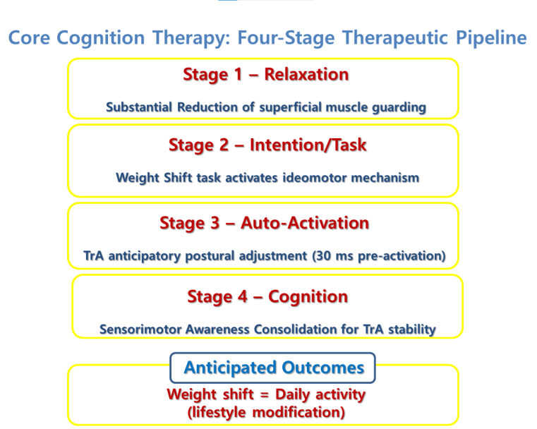
Figure 1. Conceptual diagram of the core cognition therapy (CCT) four-stage pipeline and its neurophysiological mechanisms. The diagram illustrates the causal chain from Panjabi's neural control disruption through guarding, ideomotor trigger, anticipatory postural adjustment (APA) restoration, to sensorimotor cognition consolidation. Stage 1 (Relaxation) dismantles superficial muscle guarding through behavioral experiments. Stage 2 (Intention/Task) introduces a weight-shift task intention that activates the ideomotor pathway without volitional contraction commands. Stage 3 (Auto-activation) depicts automatic transversus abdominis (TrA) feedforward activation via the internal forward model. Stage 4 (Cognition) shows consolidation of sensorimotor awareness for integration into daily functional activities. Arrows indicate the sequential progression and mechanistic linkages between stages.

Recent Publications
- Panjabi MM (1992) The stabilizing system of the spine. Part I. Function, dysfunction, adaptation, and enhancement. J Spinal Disord 5:383-389.
- O'Sullivan PB, Caneiro JP, O'Keeffe M, et al. (2018) Cognitive functional therapy: an integrated behavioral approach for the targeted management of disabling low back pain. Phys Ther 98:408-423.
- Shin YK, Proctor RW, Capaldi EJ (2023) Strong evidence for ideomotor theory: unwilled manifestation of the idea through muscular execution. Front Psychol 14:1066839.
- Hodges PW, Richardson CA (1997) Feedforward contraction of transversus abdominis is not influenced by the direction of arm movement. Exp Brain Res 114:362-370.
- Mamaev VV, Boichuk EL, Smirnova NA (2025) The role of ideomotor representations in the displacement of the overall centre of mass. Theory and Practice of Physical Culture 11:36-38.
- Lee DY, Lee JB, Park SY, Kim HS (2024) Nonlaminotomy bilateral decompression: a novel approach in biportal endoscopic spine surgery for spinal stenosis. Asian Spine J 18:867-875.
- Lee DY, Lee JB, Park SY, Jin HB, Kim HS, Kook SH (2025) Biportal endoscopic non-facetectomy foraminal decompression and discectomy: ligamentum flavum turn-down technique. Asian Spine J 19:259-266.

Photograph


Biography
Dr. Dae-Young Lee is an orthopedic spine surgeon at SaeGil Hospital, Seoul, Republic of Korea, specializing in biportal endoscopic spine surgery and spinal rehabilitation. He developed two novel minimally invasive techniques—Nonlaminotomy Bilateral Decompression (NLBD) and Non-Facetectomy Foraminal Decompression (NFFD)—both published in the Asian Spine Journal. His clinical observation that patients who relaxed superficial trunk guarding after minimally invasive decompression recovered faster than those with persistent co-contraction led to the conceptualization of Core Cognition Therapy (CCT), a hypothesis integrating ideomotor theory with anticipatory postural adjustment physiology. Dr. Lee's research bridges the gap between surgical innovation and rehabilitation science, aiming to establish a unified framework for postoperative spinal recovery. He is committed to advancing evidence-based, patient-centered spine care through both technical surgical refinement and mechanistic rehabilitation research.
Email: saegil2015@gmail.com

Notes/Comments:

