Redox behaviour and voltammetric determination of Dacarbzine based on electrocatalytic effect of functionalized multiwalled carbon nanotubes-Nafion suspension doped on bare GCE
D. K. Sharma, University of Rajasthan, Jaipur, India, 302004
K K Jhankal, University of Rajasthan, Jaipur, India, 302004
P. Sinha University of Rajasthan, Jaipur, India, 302004

Abstract
A functionalized multiwalled carbon nanotubes f-MWCNT-Nafion based glassy carbon electrode sensor was developed for detailed investigations on redox behaviour, electrode kinetics and redox mechanism of anticancer drug Dacarbazine using voltammetric techniques. Results thus obtained were compared with bare GCE. Unfunctionalized and functionalized MWCNTs were differentiated by getting an estimate of atomic spacings of each, using powder XRD analysis (fig. 1), while morphological studies of the modified surface of GCE were done by FE-SEM (fig. 2). Cyclic voltammetry, Controlled potential coulometry and Differential pulse anodic stripping voltammetry were utilized for detailed studies of redox behaviour and determination of Dacarbazine All observations were made on the basis of one irreversible, one step and diffusion controlled electrochemical oxidation signal of Dacarbazine at a potential of 0.84V versus Ag/AgCl in Citrate buffer of pH 4.75. Diffusion coefficients (1.12×10⁻³ and 3.72×10⁻³ cm²/sec), and heterogeneous rate constants (1.75 and 2.19 s⁻¹) were calculated at both bare GCE and Modified GCE respectively. Increased values of said two parameters indicated that modification of surface of bare GCE improved the electron transfer rate between electrode-electrolyte interface and an oxidation mechanism was also proposed based on 2H⁺/2e⁻ participation. Furthermore, Differential Pulse anodic Voltammetric strategy to detect Dacarbazine was developed based on f-MWCNT-Nafion/GCE electrochemical sensor. The linearity range of peak current with respect to concentration was found to be 5.9×10⁻⁵ to 5.3×10⁻⁴ M with the limits of detection (LOD) and quantification (LOQ) of 8.6×10⁻⁷ and 2.87×10⁻⁶ M respectively, indicating about high sensitivity of the developed method. The proposed method was finally applied for the determination of drug in bulk, pharmaceutical formulations and in blood serum. Obtained results favoured the use of f-MWCNT-Nafion/GCE as sensor for the rapid determination of Dacarbazine.

Image
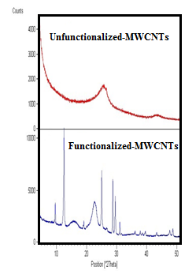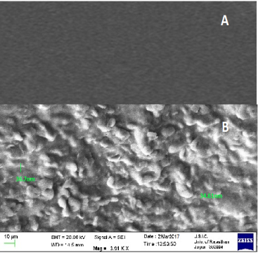

Fig. 1: XRD spectrum of unfunctionalized and f-MWCNTs
Fig. 2: SEM image of surface of (a) bare GCE. (b) f- MWCNT-Nafion /GCE.
Reference

[1] Rycenga, M.; McLellan, J. M.; Xia,Y. Advanced Materials 2008, 20 (12), 2416-2420.
[2] Dallas, P.; Sharma, V.K.; Zobril, R. Adv. Colloid Interface Sci. 2011, 166, 119-135.
[3] Bhakya, S.; Muthukrishnan, S.; Sukumaran, M.; Muthukumar, M. Appl Nanosci 2016, 6, 755–766.
[4] Abdalla Shalaby; Wafaa S. Hassan; Hassan A. M. Hendawy; A. M. Ibrahim Journal of Electroanalytical Chemistry 2015.
[5] Knoth, H.; Scriba, G. K. E; Buettner, B. Pharmazie 2015, 70.
[6] Sinha, P.; Shekhawat, A.; Sharma, D. K. Reports in Electrochemistry 2015, 5, 21-28.

Photograph


Biography
Dr. D K Sharma obtained his Ph.D. degree and working as professor in Department of Chemistry, University of Rajasthan, Jaipur, India. He didi his post-doc from Texas A & M University, USA, working on Project entitled “electrochemical incineration of human waste in confined spaces” funded by NASA (US Space Agency). He has more than 30 years of research experience in applied electrochemistry i.e. electro-organic synthesis, electro-analysis, electrochemical sensor development etc. He has published more than 60 research articles in peer reviewed reputed journals.
Email: sharmadkuor@gmail.com

Notes/Comments:

