Title of the abstract entitled: Comparative Study of Incretin Versus Non- Incretin Based Therapies on Type 2 Diabetes Patients in Addis Ababa, Ethiopia.
Alias Tesfamariam (MSc in medical Biochemistry) in Ethiopia
Email address: aliast06gmail.com
Abstract
Statement of the Problem: T2DM is a progressive and complex disorder that is difficult to treat effectively. The majorities of T2DM patients were overweight or obese at diagnosis. The first line oral anti-diabetic drugs were cause weight gain, hypoglycemia and other micro and macro vascular complications either as monotherapy or in combination with other oral anti-diabetic therapy. Today's clinicians are presented with an extensive range of oral anti-diabetic drugs for treatment of T2DM. The main classes are heterogeneous in their modes of action, safety profiles and tolerability. But, recently introduced incretin-based therapies appear to offer advantages over other oral anti diabetic drugs for T2DM treatment. Objective: The aim of the present study was to compare the effect of incretin-based therapies and non- incretin based therapies among type-2 diabetic patients attending diabetic clinics at Tikur Anbessa Specialized Hospital, and Huleshet Higher Private Clinic, Addis Ababa, Ethiopia.
Methods: Hospital based cross-sectional study was conducted between the two types of treatment strategies among type-2 diabetic patients. Sixty type-2 diabetic patients were randomly selected from patients attending diabetic clinic at Tikur Anbessa Specialized Hospital, who were receiving non- incretin based therapies and 30 type-2 diabetic patients who were receiving incretin-based therapies from Huleshet Higher Private clinic were included in this study.
Results: The mean total cholesterol (TC), triglyceride (TG), low density lipoprotein (LDL), serum urea and serum creatinine were significantly lower in type-2 diabetic patients who received incretin-based therapies than non-insulin based treated type-2 diabetic patients. The mean value of high density lipoprotein (HDL) was also significantly higher as compared to type-2 diabetic patients who were receiving non- incretin based therapies. The mean value of body mass index (BMI) and fasting blood sugar (FBS) were lower in the incretin-based therapies as compared to non-incretin based treated type-2 diabetic patients but statistically not significant (p>0.05). Among diabetic patients, females had higher level of FBS, TG, LDL, serum urea, BMI and lower level of TC, HDL and serum creatinine as compared to males in both groups. However, the differences were not statistically significant (p>0.05).
Conclusion: The incretin-based therapy helps in normalizing lipid profiles, FBS and also better adjustments in kidney clearance pattern. It also as a result helps in adjusting the weight to height ratios and helps to maintain BMI in the normal range.

Image
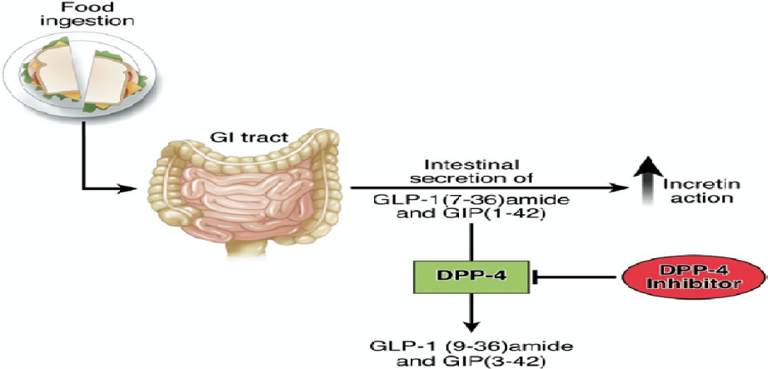
Figure-2: The biology of incretin [Baggio & Drucker, 2007].

