Synthesis of (Ti,Cr)C and (Ti,W)C solid solutions powders by mechanical alloying: Application for cutting tools
Dr MOHSEN MHADHBI, TN PhD, Laboratory of Useful Materials, National Institute of Research and Physical-chemical Analysis, Technopole, Sidi Thabet 2020 Ariana, TUNISIA

Abstract
TiC- and Ti(CN)-based cermets have been used as cutting tool materials because of their attractive mechanical properties. In this work, solid solution nanocrystalline powders, (Ti,Cr)C and (Ti,W)C, were prepared by mechanical alloying (MA) from a mixture of elemental Ti, Cr, C and Ti, W, C powders, respectively. Mechanical alloying were carried out in a planetary ball mill (Fritsch pulverisette 7), at room temperature. The powders were MA for 20 hours under argon atmosphere. The MA powders were analyzed by X-ray diffraction (XRD), scanning electron microscopy (SEM) and transmission electron microscopy (TEM). The experimental results indicate the formation of nanocrystalline (Ti,Cr)C and (Ti,W)C solid solutions with a mean crystallite size of 20 and 15 nm, respectively. The short diffusion path and the presence of defects induced during milling accelerated the solid state reaction.

Image

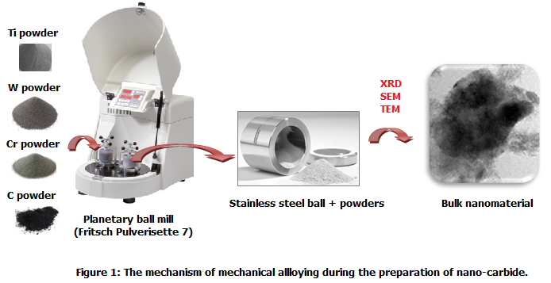

Recent Publications
- Krifa M, Mhadhbi M, Escoda L, Saurina J, Suñol JJ, Llorca-Isern N, Artieda-Guzmán C, Khitouni M (2013) Phase transformations during mechanical alloying of Fe–30%Al–20%Cu, Powder Technology 246: 117-124.
- Sekri A, Mhadhbi M, Escoda L, Suñol JJ, Khitouni M, Makhlouf T (2015)Synthesis and structural characterization of nanocrystalline Fe-Ni-Zr-B alloy prepared by powder metallurgy, Journal of the Tunisian Chemical Society 17:49-56.
- Masmoudi M, Mhadhbi M, Escoda L, Suñol JJ, Khitouni M (2016) Microstructural evolution and corrosion behavior of nanocrystalline FeAl synthesized by mechanical alloying, Journal of Alloys and Compounds 657:330-335.
- Mhadhbi M (2017) Book Chapter on Titanium carbide: Synthesis, properties and applications ACSBooks.
5. Mhadhbi M (2018) Book on Phase change materials and their applications IntechOpen.

Photograph


Biography (150 word limit)
Dr. Mohsen Mhadhbi has Ph.D. of Chemistry from the Faculty of Sciences of Sfax at University of Sfax (Tunisia). Since 2011, he is Assistant Professor and member of a research team of Laboratory of Useful Materials focusing on synthesis and characterization of nanomaterials for industrials responders (hydrogen storage, cutting tools and biomedical applications) at National Institute of Research and Physical-chemical Analysis at University of Carthage (Tunisia). Mhadhbi has served as teacher in Inorganic Chemistry in different Institutes in Tunisia. He has supervised several researchers in materials science. Her published work in national and international impacted journals and books. Mhadhbi is a member of different associations. He is also reviewer's and editorial board member in different scientific journals and congresses.

Email: mohsen.mhadhbi@inrap.rnrt.tn

Notes/Comments:

