ILEAL DIVERTICULOSIS WITH PERFORATION
Dr. Shubham Kamble, Second Year Junior Resident, General Surgery, VDGMC Latur.
Dr. Ganesh Swami, Associate Professor, General Surgery, VDGMC Latur.
Ileal diverticulosis is rare acquired herniation of mucosa and submucosa through weakened areas of muscularis mucosa of ileal mesentery with worldwide incidence ranging from 0.1% to 1.4%. These are pseudo-diverticula occurring mainly after 6th decade of life. In 15% of cases acute complications may arise such as intestinal obstruction, hemorrhage, localized peritonitis secondary to perforation. We report here a case of perforated ileal diverticulosis presented to us with abdominal pain. A 14 year old male presented with chief complaints of generalized abdominal pain since one day which was sudden in onset, gradually increased in intensity and was associated with three episodes of non-bilious vomiting. Patient denies history of abdominal trauma. Physical examination revealed tachycardia with no other significant findings. On palpation, abdomen had generalized tenderness with guarding and rigidity, no rebound tenderness or blood per rectum. Lab investigations showed raised WBC counts (16000/cc). Remaining hematological, biochemical, and coagulation profiles were normal. An erect abdominal radiograph revealed free air under right dome of diaphragm. USG showed free fluid in abdomen and pelvis suggestive of hollow viscus perforation. The patient was adequately resuscitated and underwent an exploratory midline laparotomy. Intraoperative finding revealed multiple ileal diverticulae with perforation of single ileal diverticulum. Small bowel resection with anastomosis was done with washout of abdomen. Histopathological examination of resected specimen confirmed presence of multiple small bowel diverticulae. The small bowel diverticular disease is much common in elderly patient but if younger patient presented with similar complaints, surgeons can keep this as differential. Ileal diverticuli along with perforation in relatively young age makes this case an outlier among small bowel diverticular disorders. Small bowel diverticuli have always been diagnostic challenge for surgeon and sometimes skilled radiologist. Early diagnosis and prompt treatment are of greater importance when it comes to younger patients to reduce mortality.
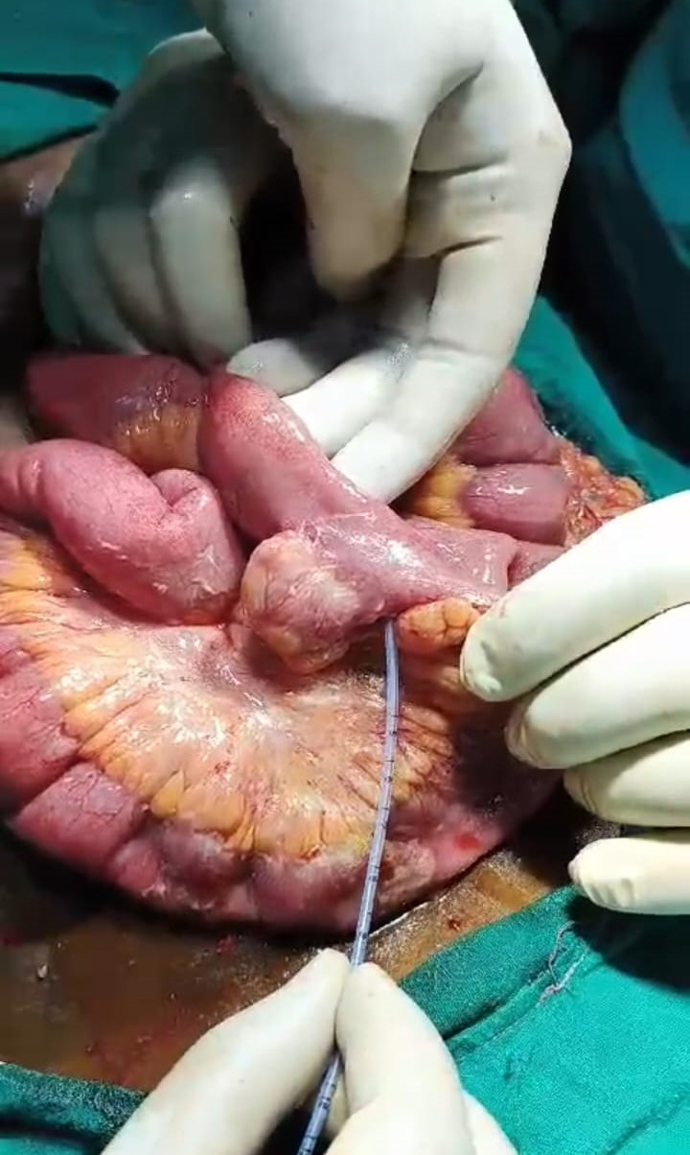
Intraoperative picture suggestive of diverticular perforation


Email: drshubham12597@gmail.com

Recent Publications
- Ileal diverticulitis: an uncommon diagnosis for right lower quadrant pain Svetlana Kleyman
- Penetration and Perforation of Terminal Ileum Diverticulitis Fumito Saijo
- Right-sided diverticulitis mimics appendicitis Thomas Gilmore
- Jejuno–ileal diverticulitis: Etiopathogenicity, diagnosis and management Radwan Kassir
- Acute Abdomen Secondary to Ileal Diverticulum: A Case Report Yeudiel Suro Santos
- Acute Ileal Diverticulitis: Computed Tomography and Ultrasound Findings Lyo Min Kwon

I am a second year General Surgery resident working full time at government medical college and hospital, Latur. I did my undergraduation from Seth GSMC & KEM Hospital, Mumbai. I am committed to acquire diverse clinical and surgical skills. I have learned to handle trauma cases and few emergency operable cases under the supervision of experienced surgeons. A passionate advocate for advancing surgical knowledge, I am enthusiastic about actively participating in research endeavours. My work reflects a commitment to innovation and desire to enhance patient outcomes through evidence-based practices. I am recognized for my leadership, good decision taking and kindness. Beyond the operating room, I invest in medical education, participating in quizzes and teaching juniors. I have a specific interest in GI surgery and Plastic Surgery, aiming to make meaningful contributions to the field. I always merge my clinical expertise with empathy, ensuring holistically driven treatment plans for my patients.

