Multiple primary cancers of the liver and kidney treated with surgery:
case report.

Gan-Erdene B.¹, Taivan N., Rolomjav.S², Janibek.³, Khongor B. ¹, Gantulga V.⁴, Chinburen J.⁵

- General Surgery Department of Second General Hospital, Mongolia
- Diagnostic Radiology Department of Second General Hospital , Mongolia
- Pathology Department of Second General Hospital, Mongolia
- Interventional Radiology Department of Second General Hospital, Mongolia
- Director at National Cancer Center of Mongolia
E.mail: Dr.pambiga@gmail.com

Abstract. A 56 year old female patient was admitted to the general surgery department of Second General Hospital presenting with abdominal discomfort. After abdominal ultrasound and abdominal contrast enhanced CT we found HCC in right liver lobe and other malignant tumor in right kidney, which is not metastasis. The biopsy from the right kidney mass approved a RCC like histological picture. The patient underwent right hepatectomy and right nephrectomy with preserved right adrenal gland. The post-operative histological conclusion was a HCC with fibrolamellar type and clear cell RCC. We discharged the patient on post operative 7th day with no complication.

Keywords: multiple primary cancer, RCC, HCC.

Introduction. The coexistance of two primary malignant tumors is very rare.
Multiple primary malignant neoplasms (MPMN) were first described by Billroth in 1889.(1)
Mongolia has the highest HCC incidence in the world with 93.7, followed by EGYPT.(2) . The number one cause of cancer-related death was the HCC, responsible for 44% of male and 42% of female cancer deaths. (3)
Still there are no case reports of synchronous primary liver and kidney cancers in Mongolia. We don’t have surgical and oncological guidelines for double primary cancers. (4) The treatment of synchronous double cancer generally relies on surgery; however, in surgically non resectable tumors, chemotherapy is considered the most promising form of treatment, targeting each tumor, but concentrating on the most aggressive. (4)
Case report. A 56 year old, 162 cm in height, 78 kg in weight female patient was admitted to the General Surgery Department of the Second General Hospital of Mongolia in September, 2019, presenting with abdominal discomfort and fatigue for last 2 weeks. There was no history of HBV and HCV infection and over usage of alcohol, no remarkable family history. In addition: all vital signs were all in with in the normal range (heart rate-78 beats per minute, blood pressure- 120/70 mmHg, respiration rate 18 breaths per minute), in clinical examination no tenderness and no pain in the abdomen.
Firstly we did blood analysis and abdominal ultrasonography due to Ultrasonography is most frequently the first imaging modality used in evaluation of parenchymal organs of the abdomen. At the ultrasonography we found a HCC like heterogeneous 6 cm sized tumor in the SVI/VII of the liver and a hypo echoic, around 2.5 cm lesion in the right kidney. In the blood test: WBC-7*10^9/ml, RBC-4.5*10^12/ml, HGB-14.1 g/dl, PLT-350*7*10^9/ml, ALB-41 g/l, total protein-71 g/l, total bilirubin-13 u/l, direct bilirubin-3.69 u/l, alkaline phosphatase- 95 iu/l, Na-137 mkmol/l , Potassium-4.3 mkmol/l, ALT-45 u/l, AST-49 u/l, creatinine-75 mkmol/l, Urea- 6mmol/L, AFP-15 ng/ml, Ca19-9-23 u/ml , negative for HBsAg, Anti-HCV.
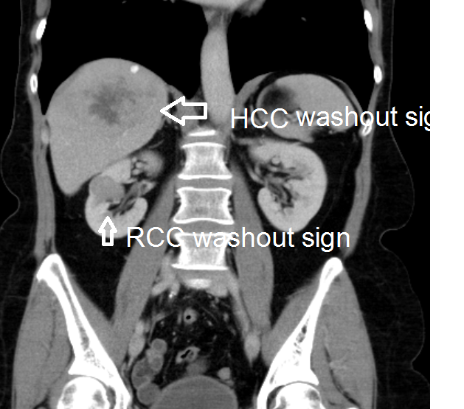
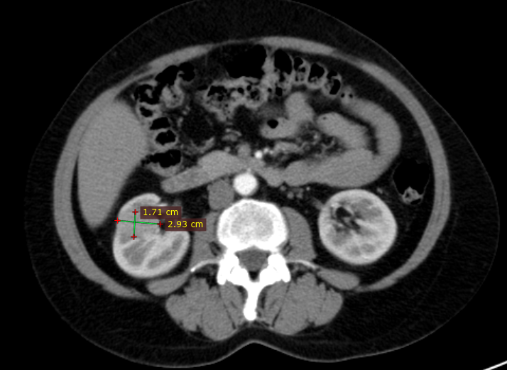
Secondly we did abdominal contrast enhanced CT to confirm the diagnosis of the primary liver cancer and kidney tumor and to mark the resection margin.
Figure 1
Figure 2
Figure 1-3. Washout sign of the HCC and RCC on CECT
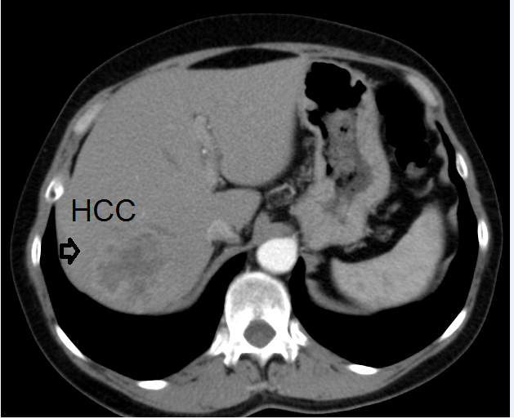
Figure 3

CECT revealed the HCC in SVI/VII of the liver and right kidney RCC. We decided to do the FNA from the kidney mass, in order to preserve the kidney, because the sensitivity of CECT for RCC is not so high.
3 days later our pathologist approved the atypical cells of Renal Cell Carcinoma. One week later from our first inspection the patient underwent surgery: the Right hepatectomy, right nephrectomy preserving the right adrenal gland. The laparotomy performed by the right Makuuchi incision, the liver resection was done by Glissonean approach technique with 10 minutes of Pringle maneuver and Kelly clamping technique. The Right hepatic vein and right kidney artery and vein separately resected by Echelon- endoscopic liner cutter. There was no remarkable enlarged lymph node. The abdominal drainage tube was left through the resection margin, which is removed in POD 5.
The surgery was successful with in 3 hours, with 200 ml of blood loss. First day after surgery the patient was in ICU under strict control. We did not experienced the kidney or liver failure after surgery. The patient discharged on POD 7 with no complication
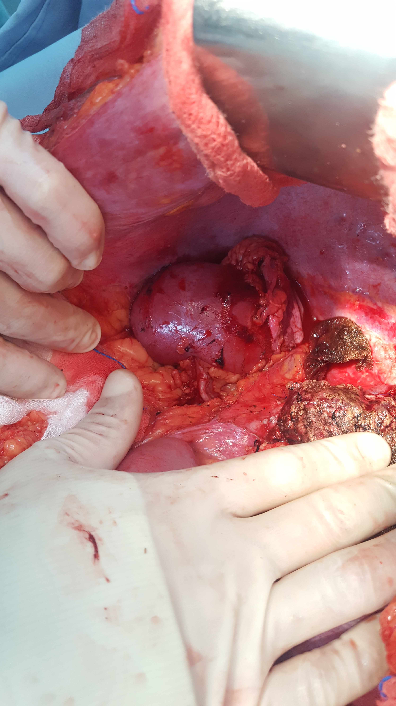
Figure 6
Figure 4
Figure 5
Figure 4. Before liver resection
Figure 5. After right hepatectomy
Figure 6. Right kidney with dissected vessels and ureter
Figure 7. Specimens (macro)

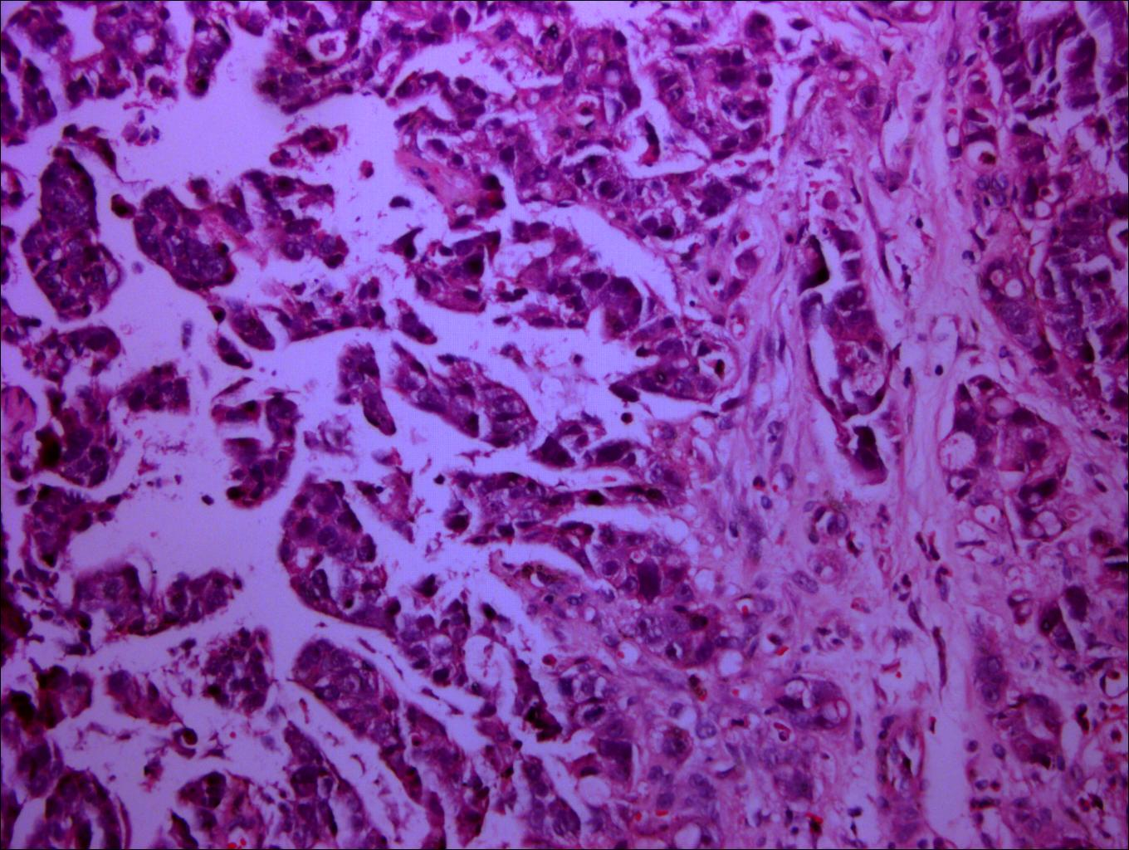
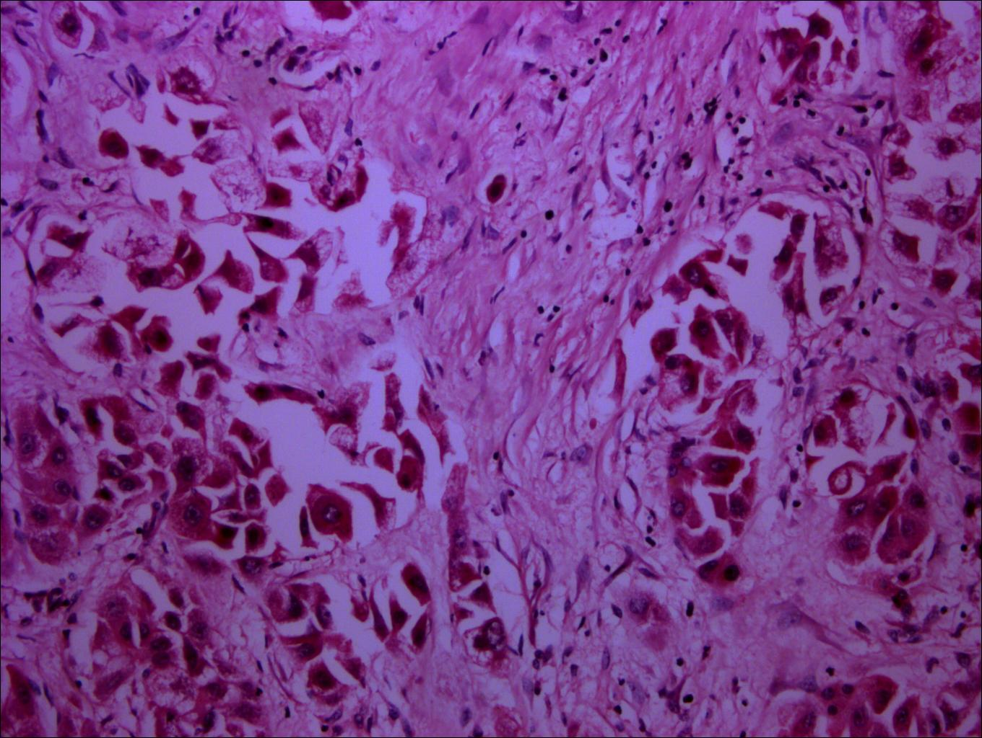
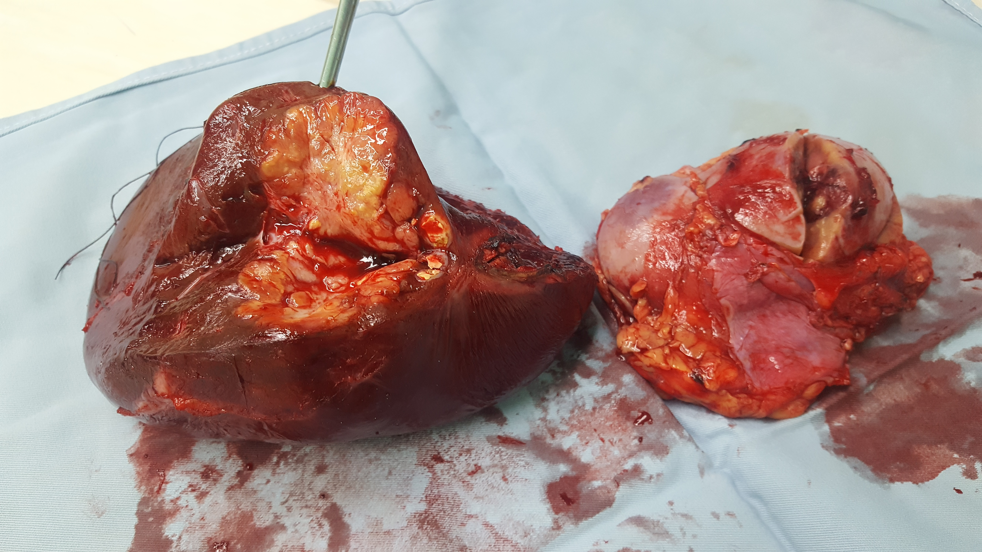
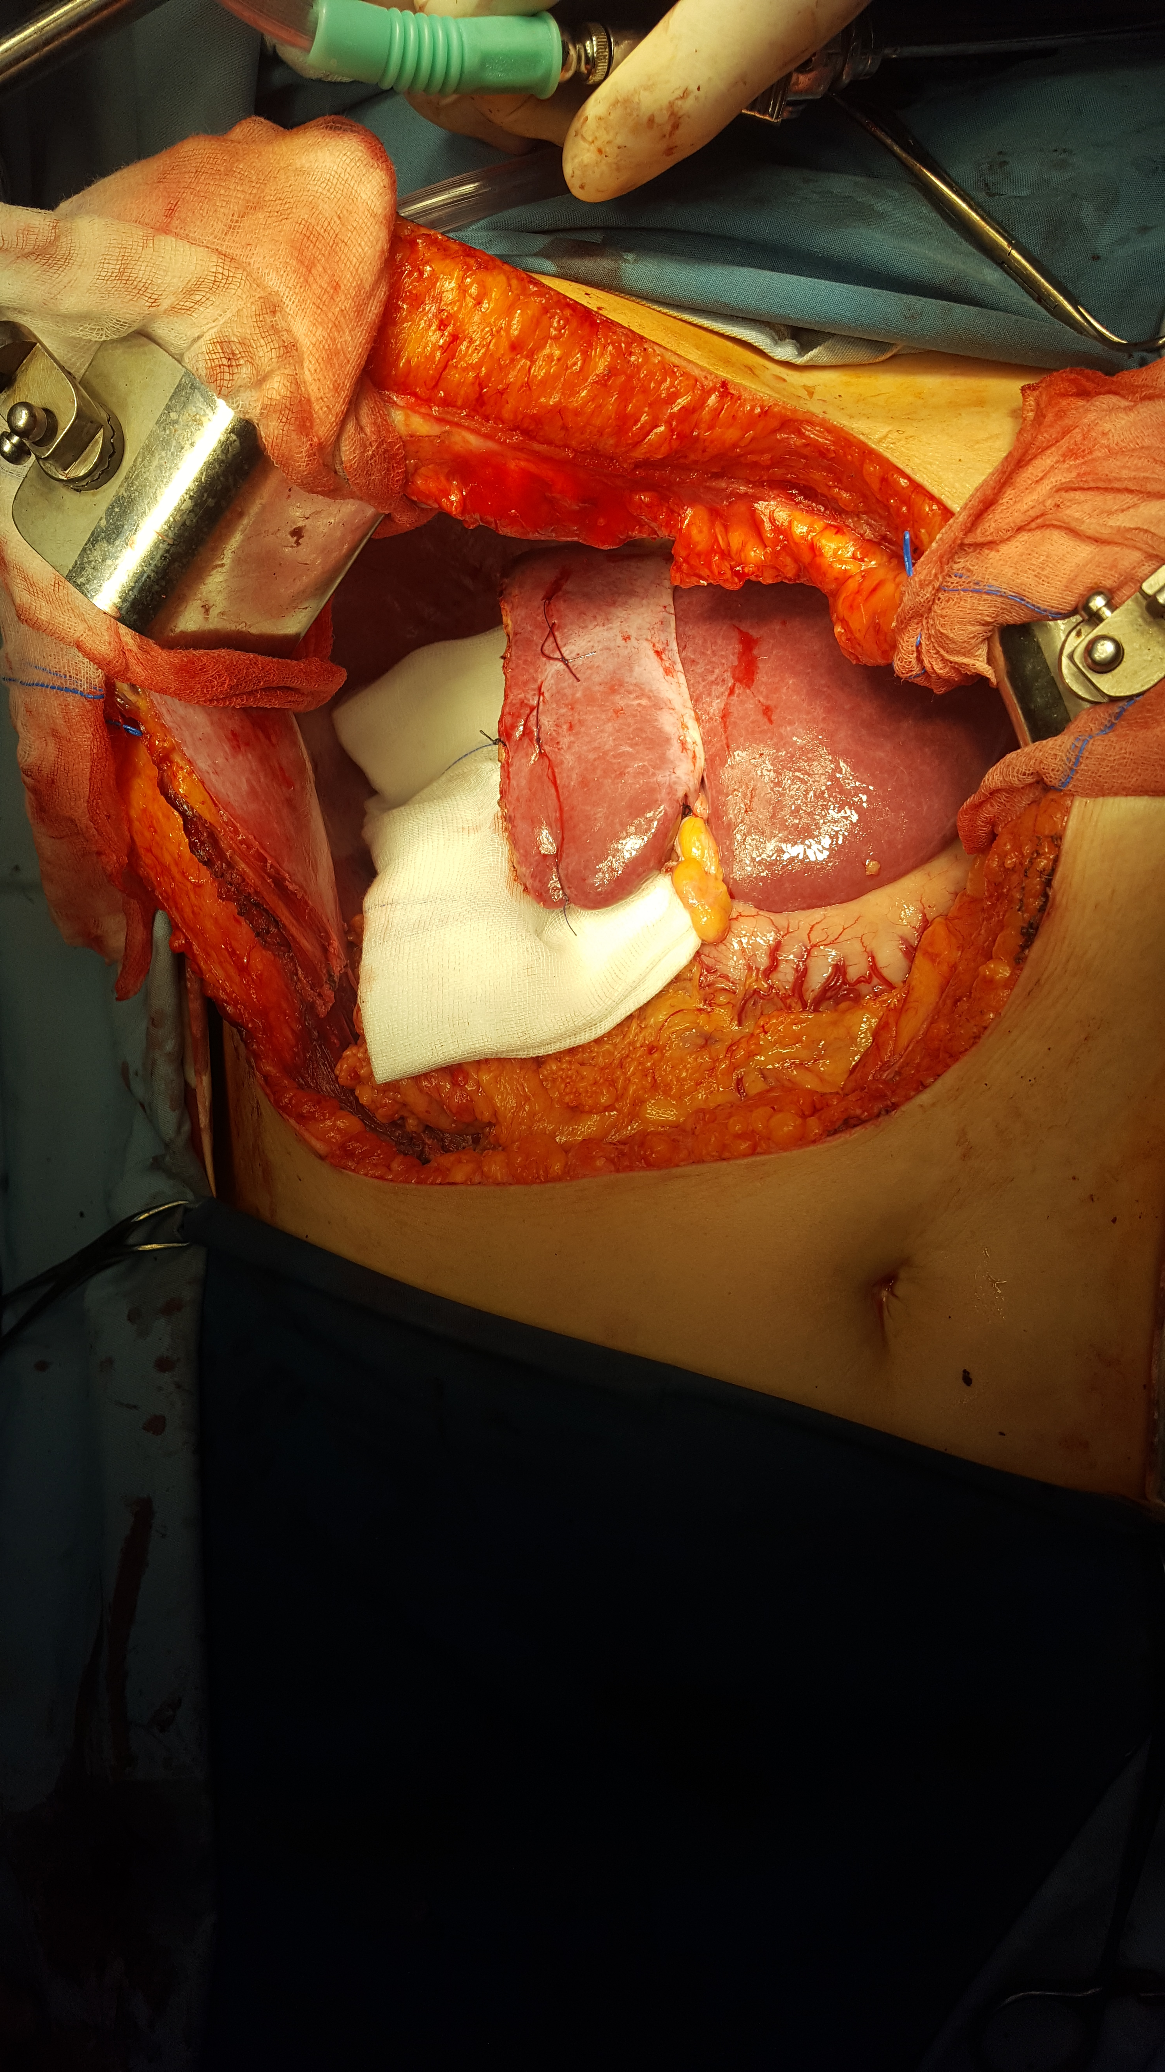
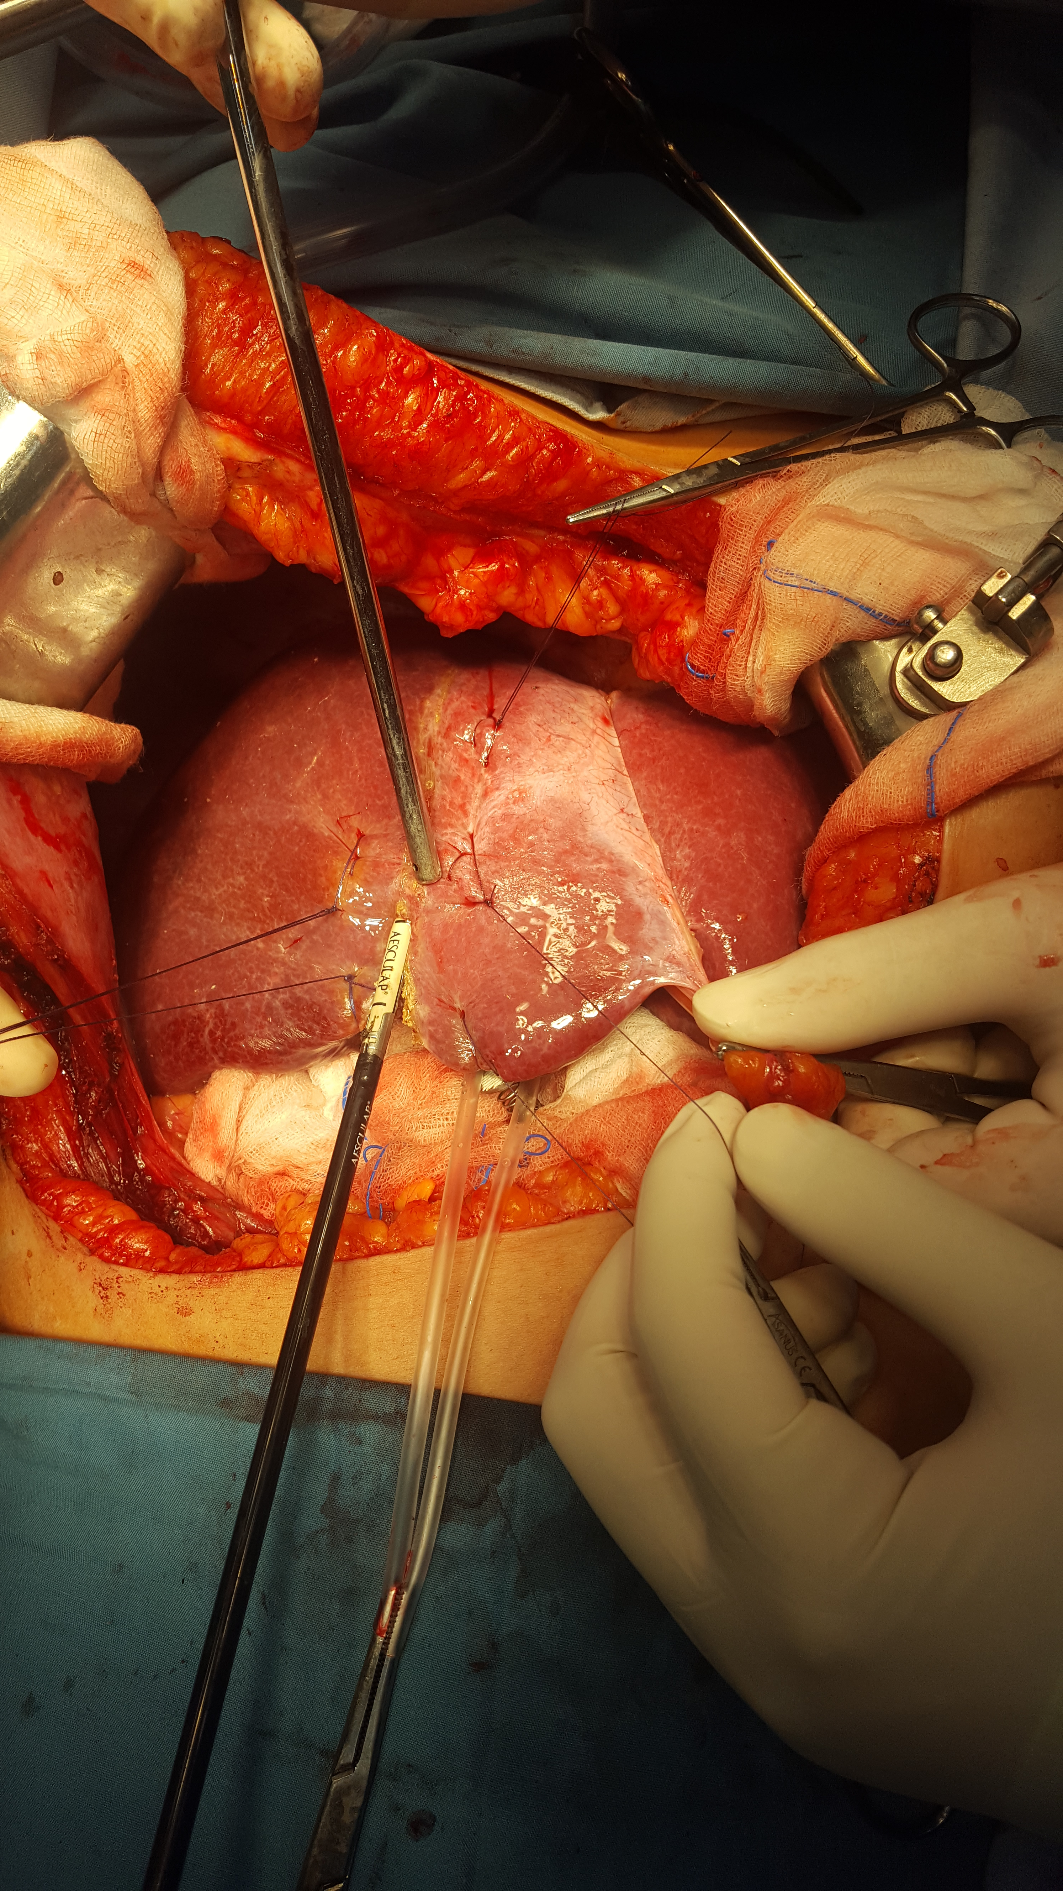
Our pathologist approved the Hepato Cellular Carcinoma, fibrolamellar type, with G2-moderately differentiation, chronic hepatitis stage 2/4, grade 3/4 F3 (by Metavir) fibrosis score-4/6 (by Ishak), pT2NxMx by AJCC, and the clear cell Renal Cell Carcnoma, Furhman grade I-II, pT1NxMx.
Figure 7
Figure 8
Figure 9

Figure 8. Histological picture of HCC with x40 zoom
Figure 9. Histological picture of HCC with x10 zoom
Figure 10. Histological picture of RCC with x40 zoom
Figure 11. Histological picture of rCC with x10 zoom

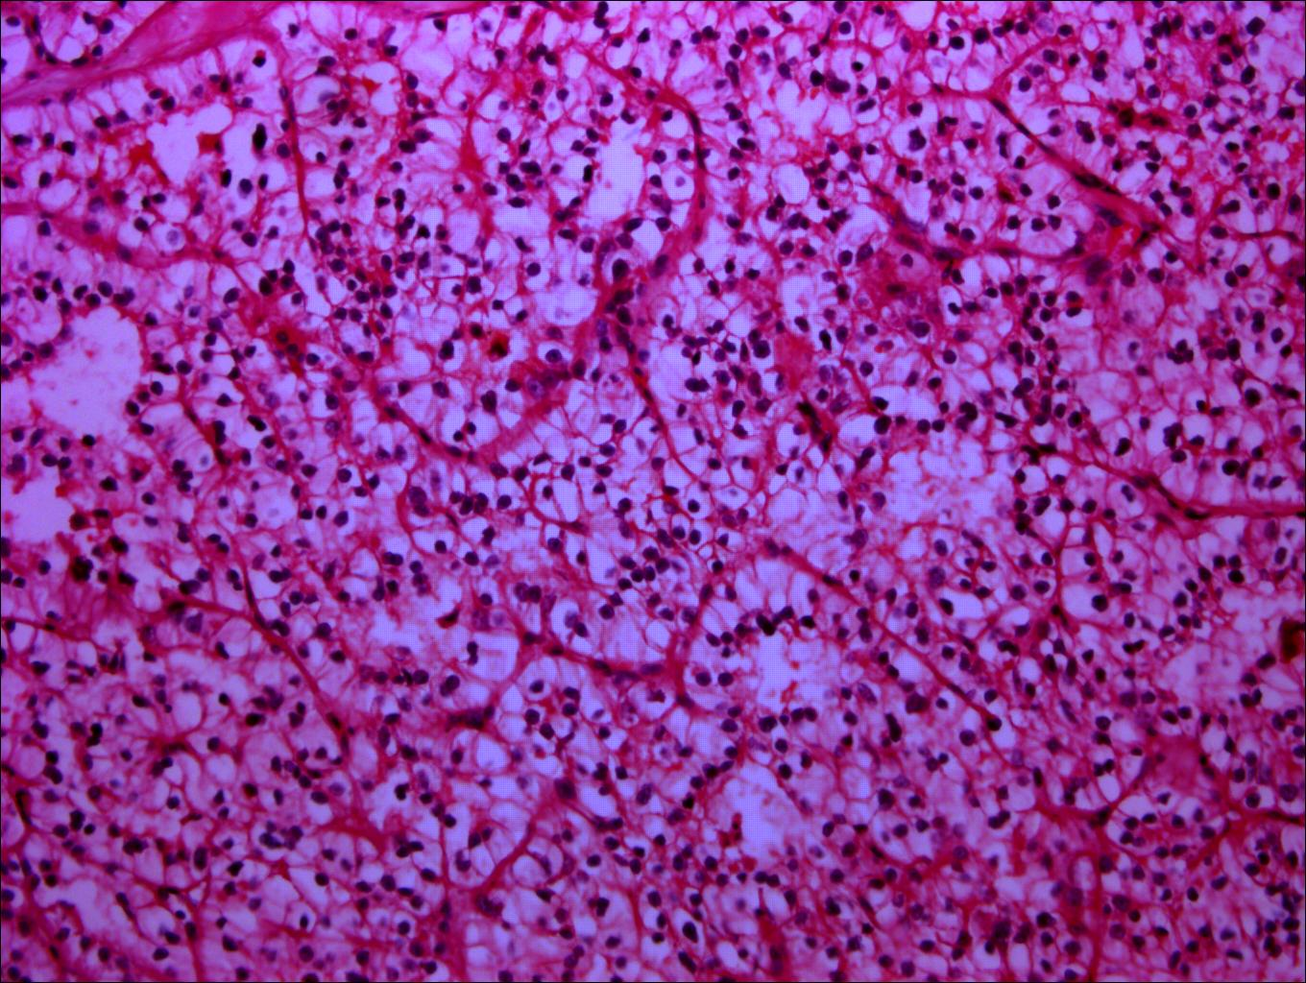
Figure 8. HCC macro picture x40
Figure 9. HCC macro picture x10
Figure 10. RCC macro picture x40
Figure 11. RCC macro picture x10

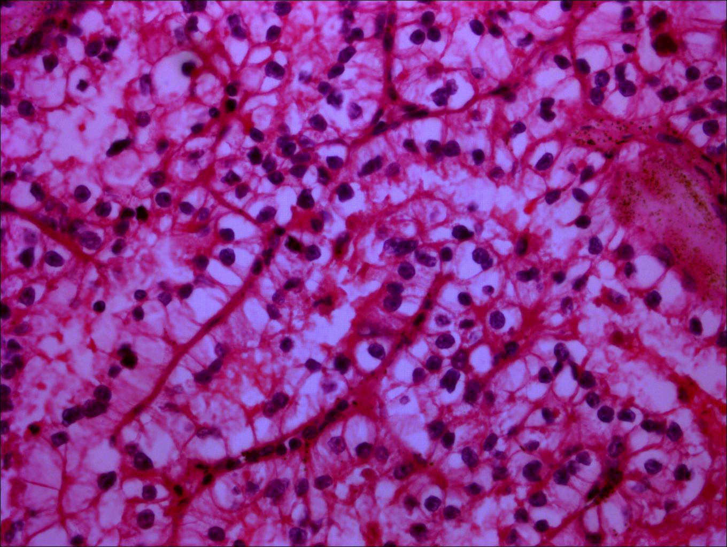
Discussion.
Figure 11
Figure 10
The occurrence of multiple primary malignant tumors in a single patient is particularly rare, with a literature review of 1,104,269 patients with cancer reporting the incidence of multiple primary malignancies as 0.73-11.70%.(1) The incidence of 3.7% of all synchronous cancers related to the RCC. (5)

We have experienced a very rare case of synchronous primary cancers of the liver and kidney.

The routine inspection for this patient is for every 3 months with blood analysis, tumor markers, abdominal US, chest Xray.

There are many case reports of diagnosing and treatment of multiple alimentary tract primary cancers, but there are a few reports of their recurrence and survival. We have to describe the character of malignancy.

References.
1. Demandante CGN, Troyer DA, Miles TP. Multiple primary malignant neoplasms: Case report and a comprehensive review of the literature. Am J Clin Oncol Cancer Clin Trials. 2003;26(1):79–83.
2. World Cancer Research Fund International. Liver cancer statistics. 2015;12–5. Available from: http://www.wcrf.org/int/cancer-facts-figures/data-specific-cancers/liver-cancer-statistics
3. Development center for health. Эрүүл мэндийн үзүүлэлт 2018 Health indicators. 2018;
4. Kourie HR, Markoutsaki N, Roussel H, Rahmi G, Van der Stiegel M, Palazzo L, et al. Double pancreatic and gastric adenocarcinomas: A rare association. Clin Res Hepatol Gastroenterol [Internet]. 2013;37(6):e137–40. Available from: http://dx.doi.org/10.1016/j.clinre.2012.09.008
5. Garcia JHP, Coelho GR, Cavalcante FP, Valença JT, Brasil IRC, Cesar-Borges G, et al. Synchronous hepatocellular carcinoma and renal cell carcinoma in a liver transplant recipient: A case report. Transplantation. 2007;84(12):1713.

