Abstract Template
Abstract Title: DISCREPANCY DORSUM-TIP IN RHINOPLASTY: AVOIDING SUPRATIP DEFORMITY
Carlos Oaxaca
^{UNAM}
^{TORRE MEDICA SANTE}
^{ASPS}
^{IFATS}
^{EROPEAN SOCIETY OF RHINOPLASTY}

Abstract (not more than 300 words)

Introduction: The most frequent deformity after Rhinoplasty is undoubtedly SUPRATIP. Very challenging complication seen more than 20% of cases reported. Generally speaking, almost this percentage have to be reoperated for several deformities after primary Rhinoplasty. Looking that with time, all noses tend to fall down the tip in the first month from 1-3 mm, leading lack of tip projection, resulting with supratip, that is precisely the hump above the tip and causes are two reasons: lack of lowering the cartilaginous dorsum or lack of tip projection.
Material and Methods According with these data, we see in consultations a lot of secondary nose deformities, from mild to severe, operated on elsewhere. I started 10 years ago with this new concept about CREATING DISCREPANCY between the dorsum and nasal tip projection. According with different types of noses, and specifically the thick of skin and cartilages under, we operated on noses with very thick skin, called MESTIZO NOSE (described several years ago by Ortiz Monasterio). This type of nose has the following characteristics: thick skin, wide dorsum, very thin lower lateral cartilages. We have proposed, several surgical steps:
Reinforce the tip structure creating concept of “tetrapod” (concept described and published by Arturo Regalado) where we add inter medial crura cartilage graft, folding of the lower lateral cartilages (alar preservation, Regalado), plus triple or more Peck graft for the tip, but this grafts MUST BE al least 1.2 cm. above the nasal dorsum, and even that at the end of the surgery, the tip will look a little bit overprojected, in one month we will look straight dorsum, with normal tip projection.
For the noses with thin skin, we follow almost the same concept, except that the discrepancy for the tip with dorsum must be no more of 1 cm. We operate all cases under open Rhinoplasty, placing the step incision in the most lower part of columella. We placed nasal bandage and splint and was changed every 5 days, until the 15 postoperative day. The surgical procedure was dine under general anesthesia and the patients were discharged the same operative day. We prescribed antibiotics and antinflamatory drugs (ibuprofen).

Results
The patients were evaluated at 5, 10, 30, 15 postoperative days were the nasal bandages were changed and on 15th day we take them off. Then we booked the patient at 1, 3, 6 and 12 months after surgery. We will present several cases with follow up from 6 months to 3 years.
We found that the tip projection fall down at the first postoperative month at least 1-3 mm.

Conclusions
It is very important to create this DISCREPANCY BETWEEN DORSUM AND TIP PROJECTION in order to avoid SUPRATIP DEFORMITY, that we don’t have had after 10 years of practicing this concept, getting NATURAL RESULTS IN RHINOPLASTY.

.

Keywords—Four key words or phrases in alphabetical order, separated by commas

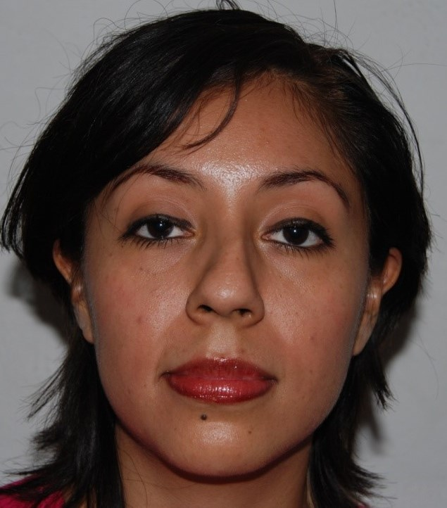
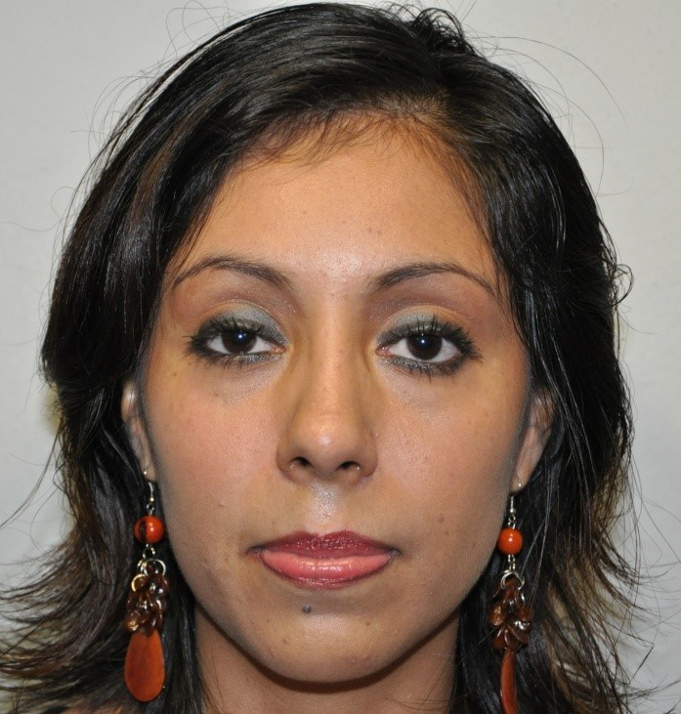

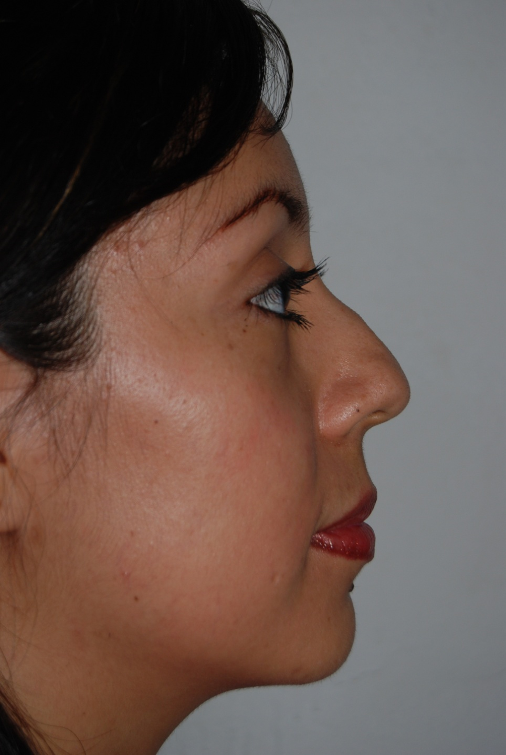
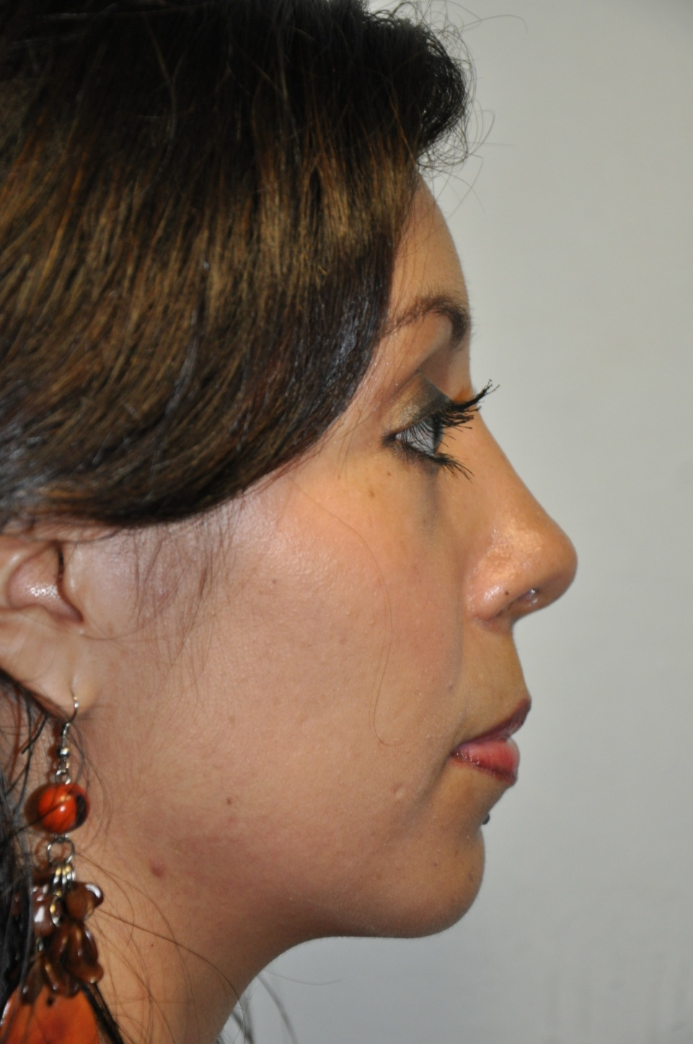

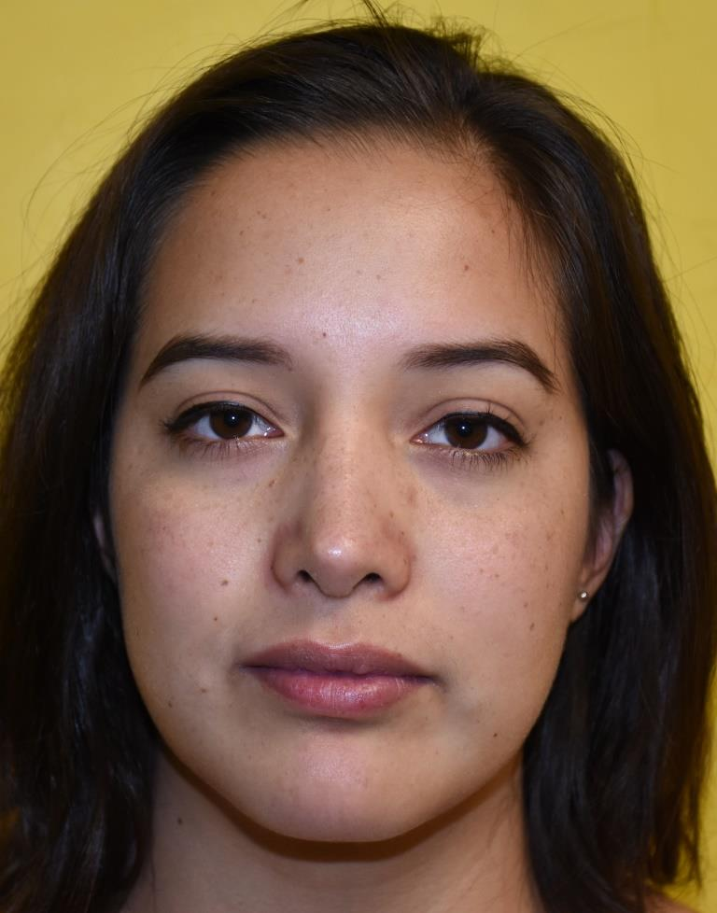
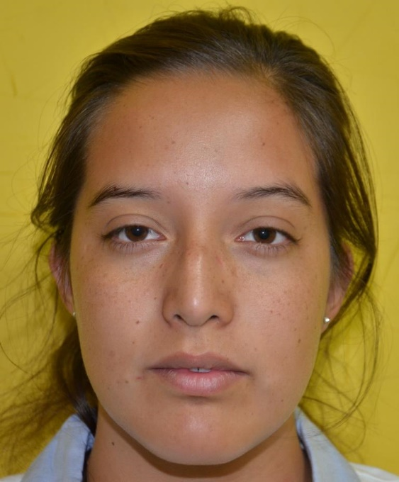

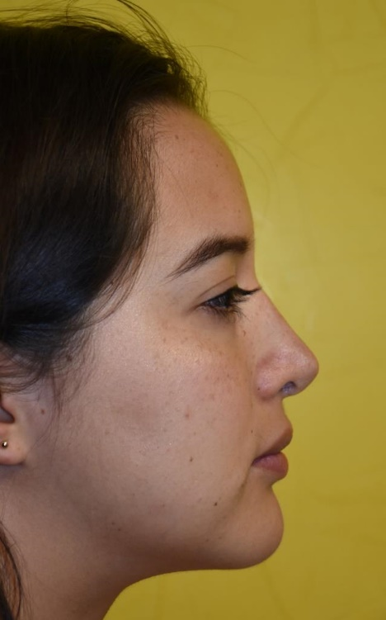
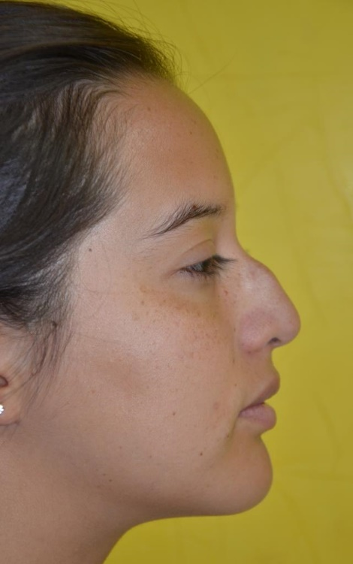

Professional Biography (100-150 words)

Dr. Carlos Oaxaca has completed his PhD at the age of 24 years old from Universidad Nacional Autonoma de Mexico and his specialty in Plastic and Reconstructive Surgery from same University. He is member of American Society of Plastic Surgeons (ASPS), International Federation for Adipose Therapeutics and Science (IFATS), European Society of Rhinoplasty, Mexican Association for Plastic and Reconstructive Surgery where he is General Coordinator for Scientific Committee, Member for Mexican Council for Plastic and Reconstructive Surgery, President of Interactive Plastic Surgery Network and works in Private Practice for 29 years. He has published several articles as so-author an chapter of Aesthetic Book in Europe.
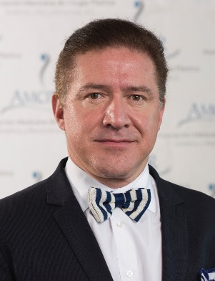

Email Id:
droaxaca@prodigy.net.mx
droaxaca@hotmail.com

Any Comments:
Note: To submit your abstract go through the following link: https://goo.gl/N3ZDtY

