Customized care of stoma in our settings.
Mohammad Ibrahim Khalil¹, Sifat E Rabbani², Md. Ashiqur Rahman³, ABM Khurshid Alam⁴.

Abstract
Background: Stoma is always a physical, mental, social and overall financial burden for a patient. A surgeon always creates stoma only when he has no other alternative or in some way there is high risk of anastomotic leakage. Though it is usually done with a prior consent of patient but in our perspective often a patient suffers psychological trauma encountering stoma after recovery from anaesthesia specially those one created during emergency operations. Selection of site and type of stoma varies according to disease site, type of operation, incision, skin conditions etc. In most of the cases it is created temporarily with the hope of restoration after the intended purpose is served. Intestinal stoma is created in a variety of conditions ranges from benign to malignant conditions of small and large gut. Most of the patients in government hospital are from poor socioeconomic groups. Cost and availability of stoma appliances in rural areas are a troublesome factors for them. As the “necessity knows no law” and so gives way of invention of appropriate alternate technology. Many patients came to us with surprising stoma management system of their own modification. We also have tried linseed oil, tincture iodine and Zink oxide paste in some cases for prevention of skin excoriation and found promising result. In this study we have evaluated specially two methods and their effectiveness.
Objectives: To find out the cost effective alternative method of stoma care for the under privileged group in the society.
Method: This prospective, noninvasive, comparative interventional study was performed in Dhaka Medical College Hospital over three years between the period of October 2015 to October 2018.Total 122 patients were included in this study. Among them 48 patients had colostomy and 74 patients had ileostomy. Patients were selected on the basis of purposive sampling. Patients who were of poor economic group were expressed and demonstrated the alternate method. They had their trial during hospital admission. Patients were followed up after 2weeks, 1month and for some patients, up to 1 year depending on type of stoma (permanent).
Results: Total 122 patients were evaluated in this study among them 70 were male and 52 were female. 74 patients had Ileostomy and 48 patients had colostomy. Most of the patients were operated as emergency basis (84) and only 38 patients had routine surgery. Of these 122 patients, 64 patients were informed about stoma preoperatively whereas 58(47.54%) patients didn’t know about stoma before operation and hence no prior consent about stoma (42 of emergency and 16 of routine operation). Patients were divided in two groups for evaluation and comparison. Group 1 patients used commercial stoma appliances and group 2, patients used betel leaf as wafer with a self-made pad. Fecal soiling encountered by patients in stoma appliance group (group1) is 7.14% where as in group 2 (betel leaf user) is 13.46%. Skin excoriation was found in 20% patients in group 1, it was 5.77% in group 2. Some form of allergic reactions were present in 14.77% of the group 1 patients. No allergic event was found in group 2 patients. In the initial 2 weeks, patient having ileostomy faced difficulty in managing soiling in both groups. Foul smelling was interrogated from family members and patient, complained from 14.28% and 19.23% of patients in group 1 and group 2 respectively. Commercial stoma appliances costs about 2500-3000 BDT (USD35) per month with additional cost of fitting in private hospital or doctor’s chamber. In group 2 patients, cost was just for buying betel leaf which is cheap (USD 0.5, BDT.40, approx.) and available all over the country more over no need of technical person to fit this.
Conclusion: Though there is much advancement in stoma care, it is always a psychological trauma for the patients. Moreover, modern stoma care appliances are also expensive, not available everywhere and experts to fit it is not available in rural areas of Bangladesh. In our observation, on average one wafer remains in place for maximum 2 weeks in our hospital. It takes at least TK. 2500 taka every months for the stoma appliances. Betel leaf with 3 layer pad saves money and easily affordable by the patients. Betel leaf is cheap and available everywhere in Bangladesh and pad is made of used cotton clothes. This is highly effective in stoma care and also cost effective.
Key words: stoma care, alternate method, betel leaf.
Author information:
- Dr. Mohammad Ibrahim Khalil, assistant professor, department of surgery, Dhaka Medical College & Hospital. address of correspondence, email: drshahin32@gmail.com mobile no: +8801710086817
- Dr. Sifat E Rabbani, Assistant Registrar, detp. Of surgery, DMCH
- Dr. Md. Ashiqur Rahman, Indoor medical officer, dept. of surgery, DMCH.
- Prof. ABM Khurshid Alam, Professor& Head, dept. of surgery, DMCH.

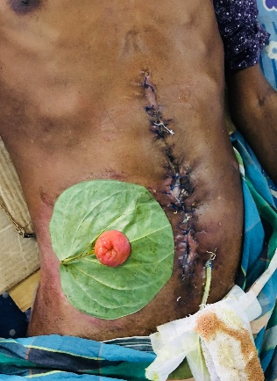  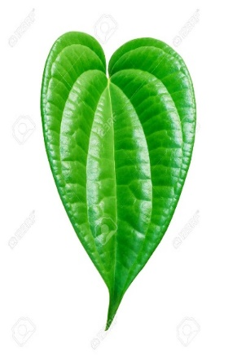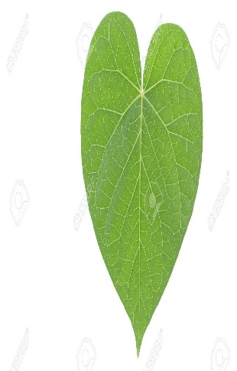Picture1: Betel leaf

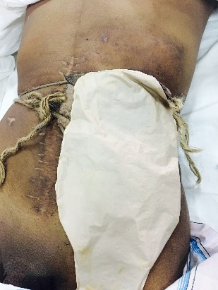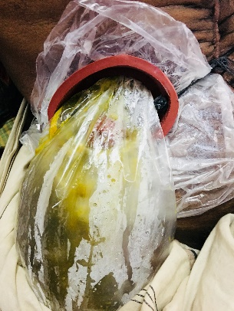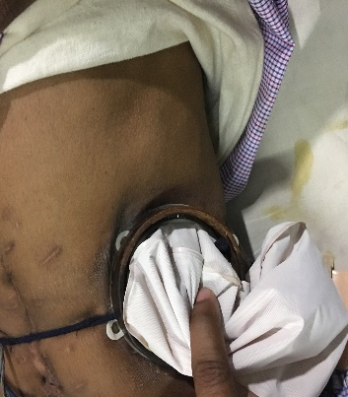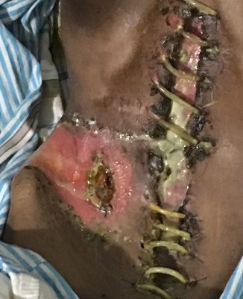
Picture 2: Customization by patients and skin excoriation

Acknowledgement: We like to acknowledge all the patients for their commitment to come for follow up and Prof. Tahmina Banu who was first to use betel leaf for stoma care in Bangladesh in Paediatric patients.

