Abstract Template
Abstract Title: Adult‑to‑adult living donor liver transplantation:
significance of middle hepatic vein and
it’s Operative techniques to optimize the recipient’s outcome
Prof. Kakhaber Kashibadze, MD. Ph.D Merab Nakashidze, Prof. Sanjay Goja

Head of Surgical Department of Shota Rustaveli State University. Batumi, Georgia.
Surgical Department of Shota Rustaveli State University. Batumi, Georgia
Head of HPB surgery and liver transplantation of Narayana Health Medical Centers, Delhi, India.

Abstract (not more than 300 words)

Nowadays adult-to-adult, living donor, right liver lobe transplantation is quite widely performed operation. There are not that bad results around the world regarding outcome and safety of donors and recipients. Nevertheless, this intervention still remains one of the most complicated operation and requires very high level of knowledge and surgical skills. This is why in developed countries there is a restricted amount of these procedure. However, over the last decade, positive tendencies regarding growth of partial and quantitative adult living donor liver transplantation has been observed. Our aim is to discuss operating methods and problems connected to adult, living donor right liver lobe transplantation that includes reimplantation of middle vein roots from 5th and 8th segments to vena cava inferior with usage of non-ringed expanded polytetrafluoroethylene (ePTFE graft).
Exactly this method we are using in our clinic during liver transplantation. Vascular prostheses are used for the adequate blood flow from frontal sector (5th and 8th segments), to reduce congestion-compression ischemia in the transplant. The aim of the study was to analyze different technics of middle vein reconstruction and to compare the results with usage of natural vein implants. For the safety reasons in donors and optimization of transplantation results in recipients we were using safety algorithms during the extraction of two types of transplants. First- modified expanded right liver lobe transplant and just expanded right liver lobe transplant. The reconstruction to provide a wide and comprehensive flow from the frontal sector was performed in all the cases.
During the period from 2014 to 2018 by our team total of 67 cases of adult right liver lobe transplantation with implantation of middle vein to vena cava inferior with usage of non-ringed expanded polytetrafluoroethylene (ePTFE graft) were examined. Where in 23 cases recipient received modified expanded right lobe transplant and in 44 cases recipients received just modified right lobe transplant. All 67 cases were compared to 56 cases, where right liver lobe transplantation with implantation of middle vein to vena cava inferior was performed with usage of natural vein implant. Preoperative indicators for donors and recipients were comparable. Cold ischemic period was relatively prolonged in the group with prosthesis. As the postoperative indicators of the recipients also percentage of permeability in transplants were also comparable in the different periods of observation. However, after 12 months, observation has shown us that passability in cases with 2 or more tributary with middle vein was lower (V-88 %, ePTFE 86,3%) than in cases with one tributary reconstruction (V-95,2%, ePTFE 94,7%).
As we can see usage of prosthetic material (ePTFE) gives us equivalent passability and outcome compared to venous graft usage in recipients, but gives us also additional advantages: correct selection of the size during the reconstruction of frontal part, without complications and additional modification, which lowers the chances of infection and other complications connected with anastomosis. Individual and selective approach to donor hepatectomy, which is based on optimal functioning volume and metabolic requirements, represents not only the key for complicated adult-to-adult LDLT but also creates safe conditions for enhancement of capacities.

Professional Biography (100-150 words)

was born in 1968 Batumi, Georgia. In 1991 finished with honors Tbilisi State Medical. In 1996 defended his dissertation work about characteristics of blood elements during polytrauma injuries and was granted with Ph. D. grade. In 2006 he also defended Dissertation work about reperfussion-ischemic injury of intestines and their correction during the vascular ischemia of the intestines. After that he was chosen as full Prof. and head of clinical department in Batumi State Unviersity. From 2012 he is head of Surgical and liver transplantation department, of EVEX corporation referral hospital of Batumi. In 2014 he has performed first successful adult-to-adult living donor liver transplantation in Georgia. In 2016 to 10kg kid. Because of which he was granted with medal of honor. 1995-2014 he made 6 month fellowship programs in Tbilisi, Kiev, Minsk, Izmir and Gurugram.

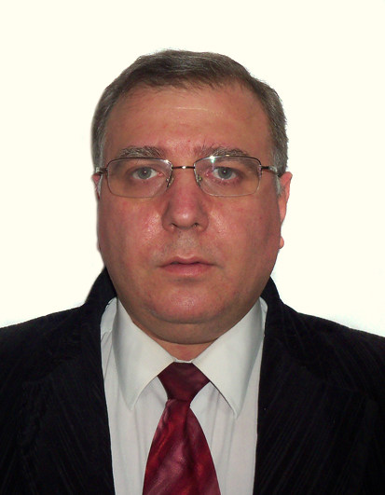
Paste your Photograph & Logo here

Email Id:

Any Comments:
Full Name: Kakhaber Kashibadze
Current Affiliation (Hospital/University/Organization): Batumi Refferal Hospital, Batumi Shota rustaveli State University

