Title : Outcome of laser treatment for minor anorectal conditions including fistula in ano,haemorrhoids and pilonidal sinus. A Jersey, Channel Island of U.K. prospects
Muhammad Aleem; Miklos Kassai; Sandra Keogh-Bootland,
Department of Surgery
Jersey General Hospital, St.Helier,State of Jersey,
Channel Island of U.K.
Correspondence: Dr.Muhammad Aleem
Department of surgery, Jersey General Hospital, The Parade,St.Helier,State of Jersey, Channel island of U.K
J.E.13QS
00441534622000
Fax:00441534442880
Email:M.Aleem@health.gov.je

Introduction:
Minor ano rectal conditions such as Fistula in ano, Haemorrhoids and Pilonidal sinus are the common surgical pathology, which can be debilitating and affect patient social life.
Aetiology of these minor ano-rectal conditions for example fistula in ano can be multifactorial including,idiopathic,inflammatory bowel disease, post traumatic(Obstetric and post traumatic after drainage of perianal abscess).
There are various predisposing factors including smoking, diabetes and life style.
Method:Pre operation and post operation questionnaire send to patient to assess the quality of life before and after laser treatment for minor anorectal conditions including fistula in ano, haemorrhoids and pilonidal sinus.
Fig:1 Laser probe insertion to fistula in ano
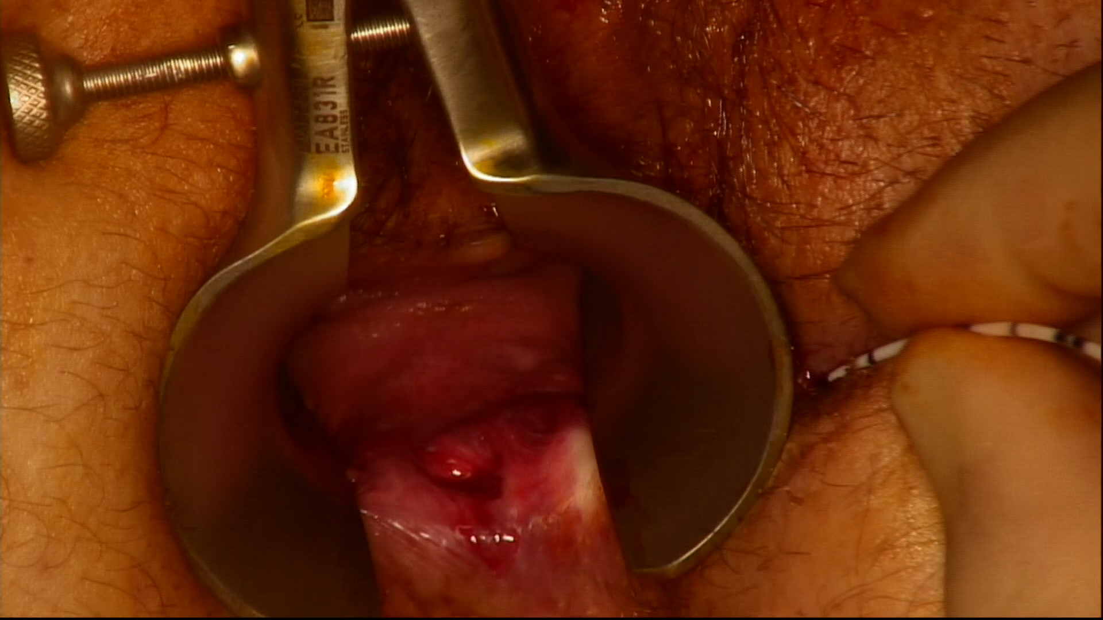

Fig:2 Laser treatment of haemorrhoids
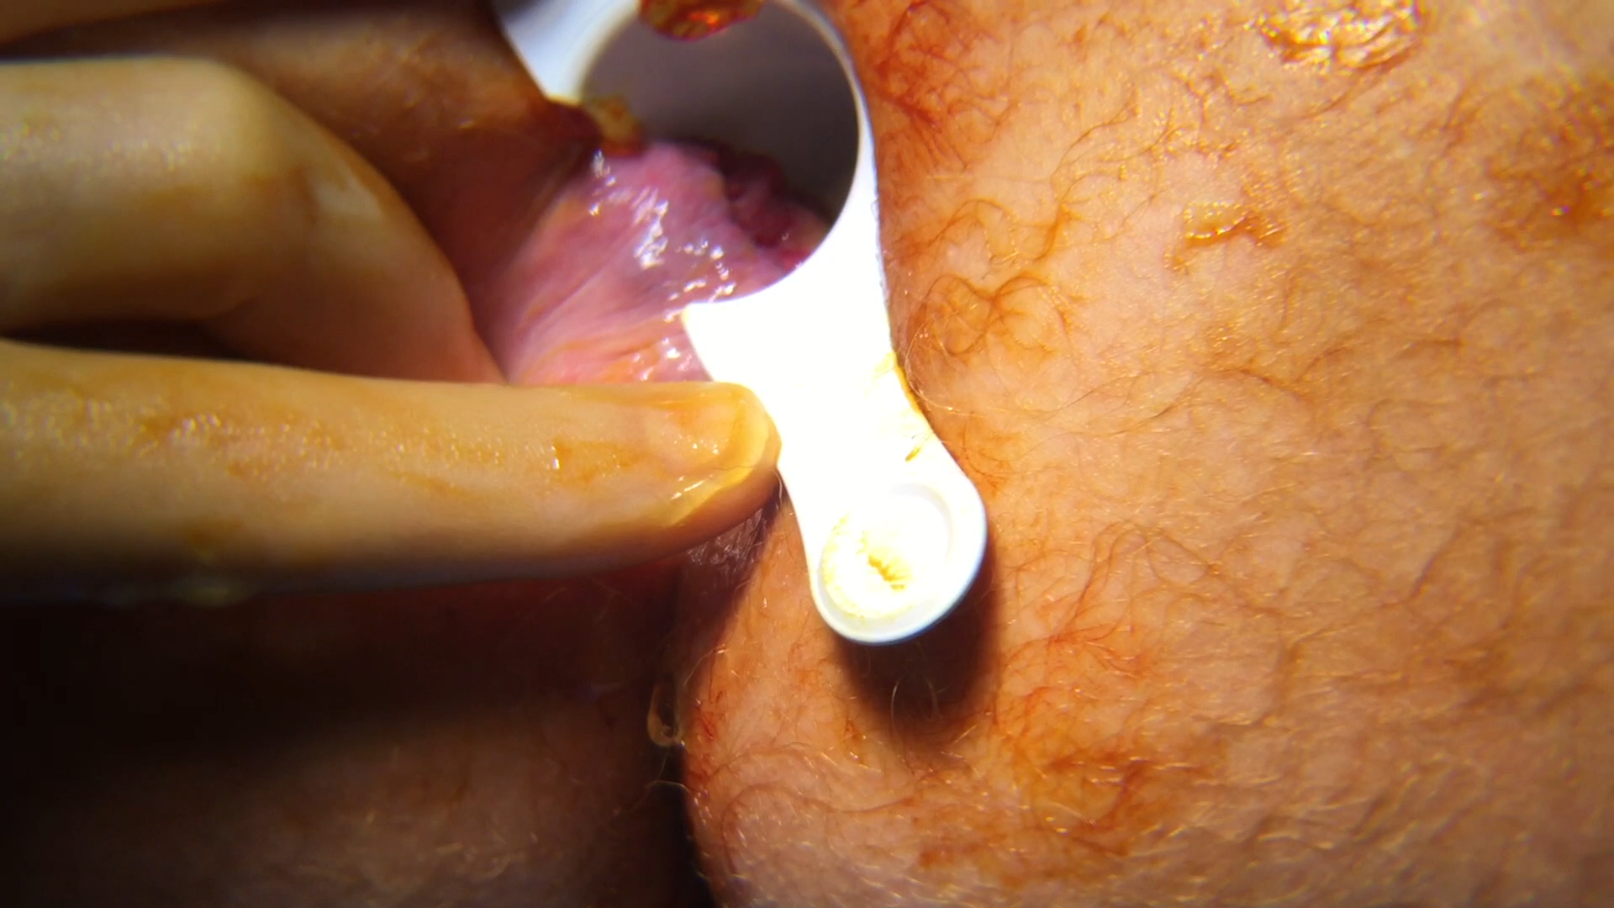
Fig:3 Laser treatment for pilonidal sinus
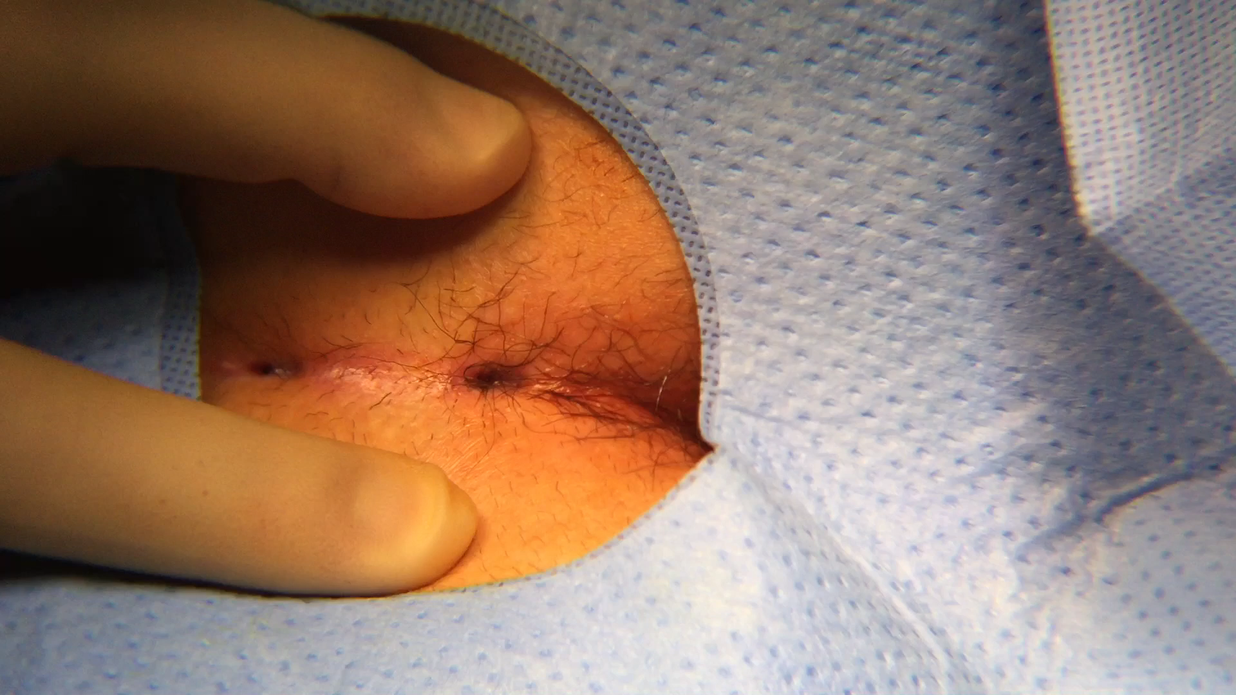
Questionnaire send to patient: 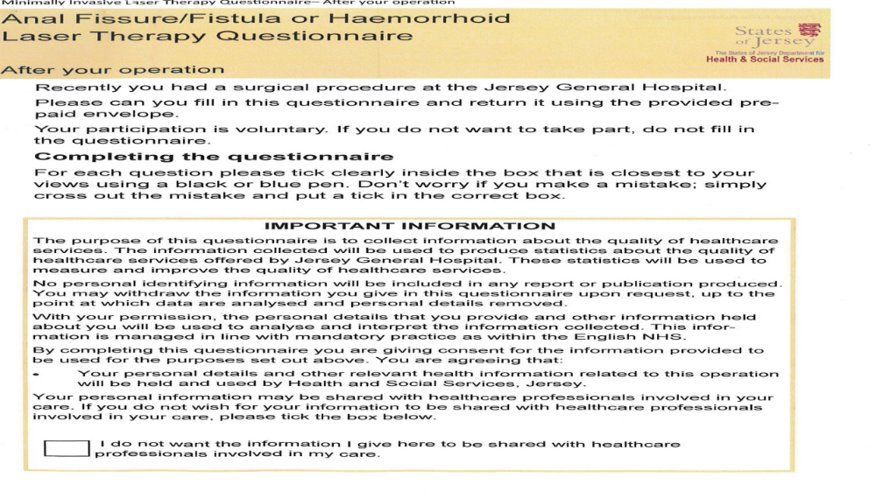

Twenty seven male and eighteen female were recruited for the study.

Forty four procedures on thirty eight patients between
September 2016 and December 2017:
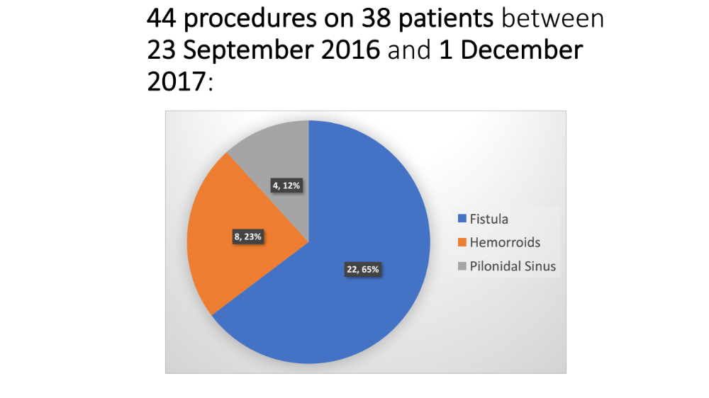
Pre operation questionnaire send to the patient about their quality of life
Thirty nine post-op questionnaires sent after first surgery with ten returns from first questionnaires
A further twenty seven post-op questionnaires re-sent with eight returns
Four post-op questionnaires sent after the second surgery

Patients response to preoperative and post operative questionnaire was:
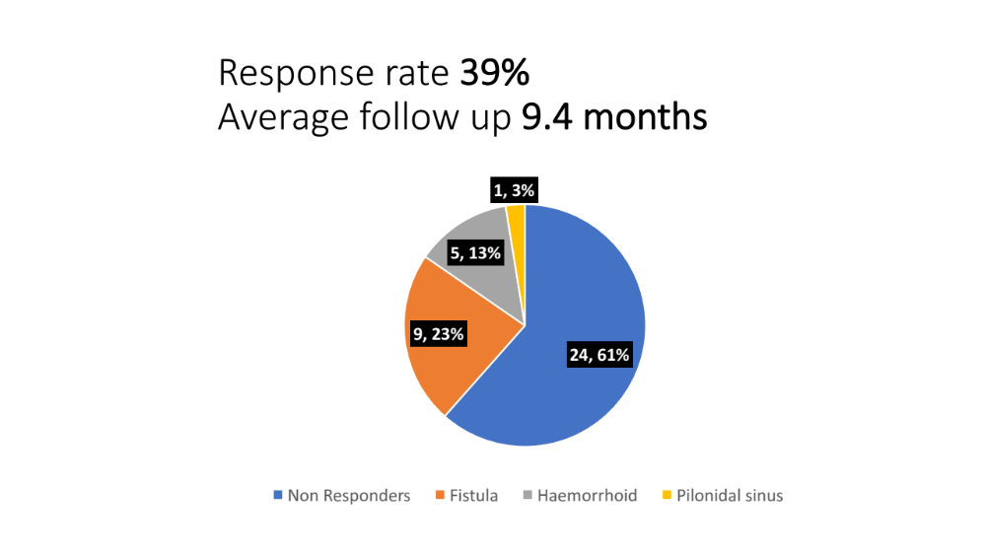

Twenty two patients had anal fistula repairs (FiLac)
Eight patients had haemorrhoids treatment with laser probe
Four patients had pilonidal sinus treatment with laser probe
Age range between twenty to seventy years old
Male to female ratio was sixty to forty
Pain score assess for each procedure using sensory component of VAS ,on the scale zero to ten.
Four patients describe experiencing no pain after laser treatment for fistula (FiLac).
Four patients describe experiencing moderate pain after laser treatment for fistula (FiLac).
One patient describe experiencing extreme pain after laser treatment for fistula (FiLac).
Two patients describe experiencing no pain after laser treatment for haemorrhoids.
Three patients describe experiencing moderate pain after laser treatment for haemorrhoids
One patient describe no pain after laser treatment for his pilonidal sinus.

Graphic presentation of postoperative pain assessment:
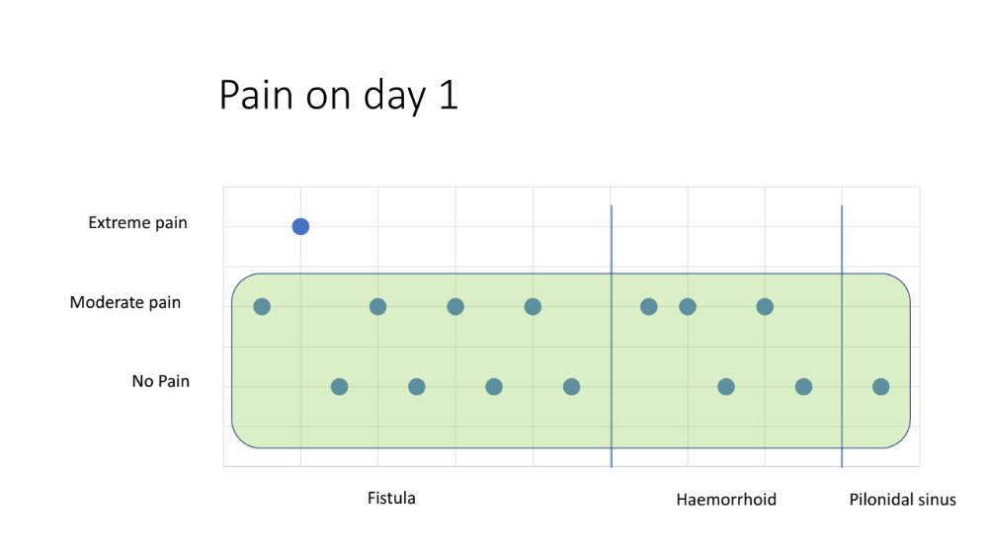

Results:
For laser treatment of fistula (FiLac), three patients describe very good results, four patients describe good results, and two patients describe poor results.
For haemorrhoids laser treatment, one patient describe excellent result, three patients describe good results and one patient describe poor result and for pilonidal sinus one patient describe excellent result.
Six patients describes symptoms much better after laser treatment of fistula(FiLac),One patient describe symptoms little better, one patient describe symptoms about the same and one patient describe symptoms little worse after treatment of fistula with laser(FiLac).
Three patients describe symptoms much better after laser treatment of haemorrhoids and one patient describe symptoms little better.
One patient describe symptoms much better after laser treatment of pilonidal sinus.

Graphic presentation of response(results) to treatment:
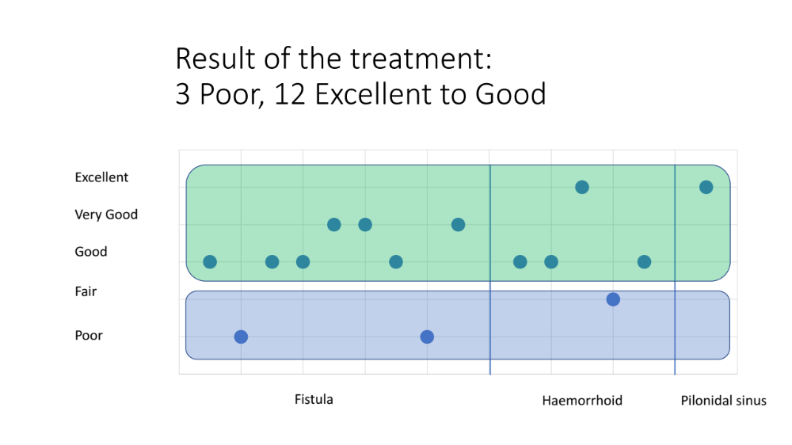

One patient had difficulty passing urine after laser treatment of haemorrhoids
Two patients visited emergency department within twenty four hours of their procedures for minor issue.
Four patient have pain and difficulty passing stool after the procedure.
Eleven patient notice small amount of bleeding after procedure which is expected due to the nature of procedures.

Days return to work:
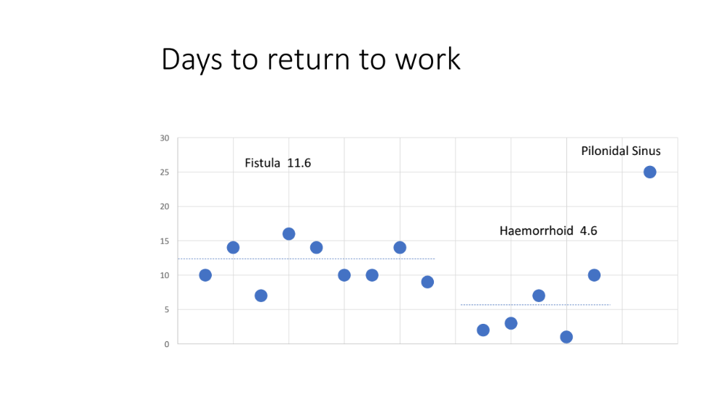
Conclusion:
Laser treatment is a minimal invasive novel treatment for minor ano rectal conditions such as laser treatment of fistula (FiLac), haemorrhoids and pilonidal sinus
Patients have much better outcome for these conditions.
Long term follow up required to assess the effectiveness of laser treatment for these minor ano rectal conditions.
Acknowledgments: This work is closely supported by quality improvement and audit department at Jersey general hospital and with close collaboration with Mr.Miklos Kassai Consultant colorectal surgeon at Jersey General Hospital who closely supervise me to prepare this valuable paper for publication
Author contributions:Mr.Muhammad Aleem designed the research, analysis and reviewed the manuscripts.MA ,participated in data interpretation, reviewed the manuscripts, and provided critical comments. All authors reviewed and approved the final report.
Disclosure: The author reports no conflict of interest in this work
References:
Dessily M, Charara F, Ralea S, Alle JL Acta Chir Belg 2017 June ;117:164-168.doi 1080/00015458.2016.1272285.Epub2017 Jan6.
Giamundo P, Geraci M. Tibaldi L,Valente M ; Colorectal Dis, 2014 Feb;16(2);110-5,doi;101111/codi.12440. Wiley online library
National Centre for Biotechnology Information(NCBI) at the U.S. National Library of Medicine(NLM)
Springer ;Techniques in Coloproctology 2017;21(4)268-276
https://www.ncbi.nlm.nih.gov/pubmed/28056720

Biography:

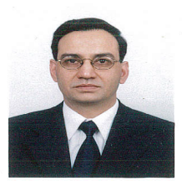
I have completed my fellowship in general surgery from Royal College of Surgeons Edinburgh and Dublin(Ireland)
I have completed my basic and higher surgical training in Republic of Ireland and England.
I have special interest in laparoscopic coloproctology.
Currently I am working at Jersey General Hospital Channel Island of U.K.

Publishing author details:
Muhammad Aleem
Contact Number: 00447797862735
Email address: M.Aleem@health.gov.je
Category: Publication

