Abstract Template
Abstract Title: Successful surgical treatment of thymic carcinoma by VATS
M.D. Sung Hwan Kim, M.D. Jae Jun Jung, M.D. Jong Woo Kim, M.D. Jung Hoon Byun

Department of thoracic and cardiovascular surgery
Gyeongsang National University Changwon Hospital,
Gyeongsang National University, College of Medicine

Abstract (not more than 300 words)

Thymoma is the most common tumor in the anterior mediastium, and it is often difficult to distinguish between invasive thymoma and encapsulated thymoma. The frequency of thymoma with calcification is 10 to 41% and in invasive thymoma up to 54%. Various forms of calcifications found in thymoma, most common type is small foci of calcification. We report of thymoma case with massive ringed calcification.

Keywords—Thymoma, Calcification, Ossification

Professional Biography (100-150 words)

Professor Kim has completed his PhD at the age of 38 years from Gyeongsang National University Hospital and postdoctoral studies from Samsung Medical Center in Seoul, South Korea. He is the chief professor of department of lung and esophageal surgery at Changwon Gyeongsang National University Hospital. He has published numerous papers in reputed journals.

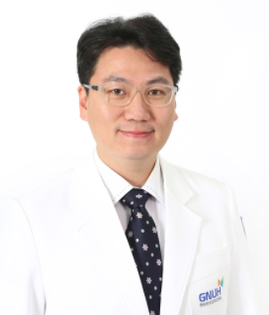
Paste your Photograph here

Email Id:

Any Comments: Thank you for inviting me here.

