Abstract Template

Pancreatic cancer – radical surgery as a part of multimodal treatment

Ryska M, Nikov A

Surgery department, 2.Faculty of Medicine, Charles University and Central Military Hospital, Prague

Abstract

Pancreatic cancer is solid malignant, chemoresistant tumour with unfavourable prognosis. Radical resection with adjuvant chemotherapy is only potential curable therapeutic modality enabling to prolong survival of 25 % patients. Borderline conception contents active approach to primary non-resectable patients to reach resectability by neoadjuvant chemo(radio)therapy. Palliative and symptomatic therapy is indicated in about 70 % patients.
In the case of suspicious of pancreatic cancer, patient should be referral to specialized centre. Effective diagnostic therapeutic approach only guarantees optimal quality of life of these patients.
Key words: pancreatic cancer – diagnosis – therapy – multidisciplinary approach – quality of life

Professional Biography
After Faculty of Medicine in 1978 he joined as an internal aspirant at the Surgical Clinic of the Faculty Hospital in Prague, in 1984 he worked for 4 months at the Surgical Clinic in Uppsala, Sweden, and from 1984 until 1992, a clinic assistant. In 1991 he graduated from a postgraduate surgical school at Hammersmith Hospital in London. In 1992 he habilitated from surgery (Friedly surgery in the treatment of choledocholithiasis) and until 1994 he worked as an assistant professor of surgery at the Surgical Clinic of the 3rd Medical Faculty of Charles University). In 1994 he joined the IKEM Cardiovascular and Transplantation Surgery Clinic and after completing a four-month internship at the Virchow University Surgical Clinic in Berlin under Prof. P. Neuhause started a liver transplant program at IKEM. In 1997 and 1998, he completed his monthly study stays in Mt. Sinai Hospital in New York and UCLA in Los Angeles. In 1998 he founded the IKEM Transplantation Surgery Clinic, where he worked as its head until 2004. Since 2004, when he was appointed Professor of Surgery, in 2005 he founded the Surgical Clinic of the 2nd Medical Faculty of the Charles University and the University Hospital Prague. For 4 months he was the Chief Medical Officer of the 6th Army Hospital of the Czech Army in Kabul (2008). Since 1 July 2010 he has served as Deputy Director of the Prague National Institute for Science and Education. From 12/2011 to 7/2014 he was a member of the Government Council for Science, Research and Innovation. From 1.4. 2014 is the chair of the newly established Agency for Health Research.

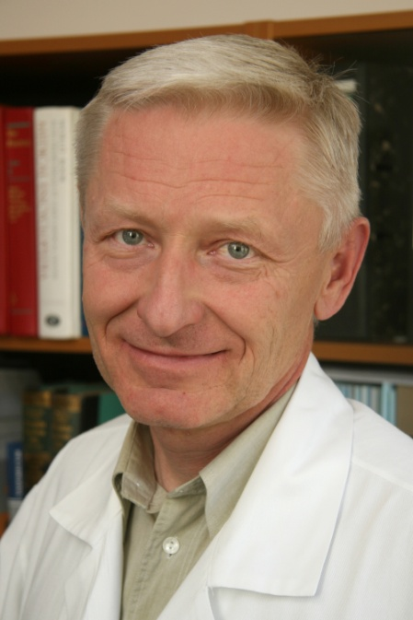
E- mail: miroslav.ryska@uvn.cz

z

