Laser Surface Sealing Processing for Thermal Barrier Coatings
(Fundamentals, Applications and Developments)

Prof. Dr. Adel K. Mahmoud

University of Diyala , Department of Materials Engineering, Diyala, Iraq &
Ankara Yildirim Beyazit University, Department of Metallurgical and Materials Engineering, 06100-Ankara, Turkey

*Corresponding author: adel_alkayali@yahoo.com

Abstract
The main objective of this research work is to investigate the effect of laser surface sealing processing of thermal barrier coatings produced by plasma spraying technique. The thermal barrier coatings produced by this technique suffer from many defects like porosity, voids, and high surface roughness. With these defects the performance of thermal barrier coating layers is degraded, therefore laser surface sealing processing must be introduced to enhance their properties and increase their resistance to the external effects. The previously published literatures are very little about the laser surface sealing processing of thermal barrier coatings using solid lasers. Detailed study has been carried out on the feasibility of using high power density laser beam in order to optimize the properties of plasma –sprayed thermal barrier coatings by decreasing the porosity and improving the surface finish, mechanical, thermal insulation properties, oxidation, hot corrosion and thermal shock resistance.

Keywords— Laser surface hardening processing, Al-Si alloy, wear mechanism

Professional Biography

Prof. Adel K. Mahmoud has completed his PhD at the age of 31 years from University of Technology – Baghdad – Iraq and award Professor Degree in 2015 from University of Diyala. He is a Visiting Professor now in Ankara Yildirim Beyzit University, Ankara – Turkey. He has published more than 30 papers in reputed journals and has been serving as an editorial board member of repute.

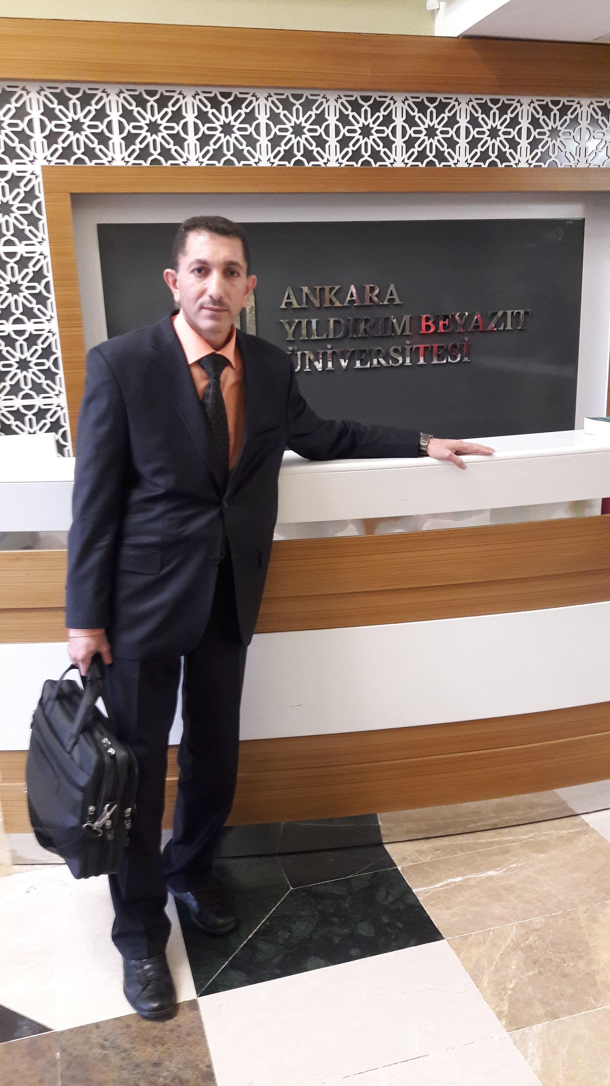

Email Id: adel_alkayali@yahoo.com
Contact Number: 00905536671691

