Performance analysis of integrated solar heating and radiative cooling system with spectral selective cover
Gang Pei¹, Xianze Ao¹, Bin Zhao¹, Mingke Hu¹

¹ Department of Thermal Science and Energy Engineering, University of Science and Technology of China
University of Science and Technology of China, No.96, JinZhai Road Baohe District,
Hefei, Anhui, 230026, P.R.China.
Tel.: 86-551-63601652

Abstract

A novel combined diurnal solar heating and nocturnal radiative cooling (SH-RC) system can offer multi-functionality and enhance time utilization ratio. For an idealized SH-RC system, it should have unity absorptivity (emissivity) in the solar radiation wavelength (i.e., 0.3–2.5 μm) and the atmospheric window (i.e., 8–13 μm) and unity reflectivity in other wavelength bands (i.e., 2.5–8 μm and 13–25 μm). To meet this spectral characteristics, previous studies have been focus on developing a spectral selectively collecting plate and using polyethylene as wind cover. Here a novel photonic selective structure is proposed to be used as wind cover of SH-RC system. The structure consists of alternating layers of zinc sulfide (ZnS) and ytterbium fluoride (YbF₃) of varying thickness, on front and back of a 500-μm-thick ZnS substrate. The cover has high transmissivity of approximately 0.85 in bands 0.4–2.5 μm and 8–13 μm, and high reflectivity of approximately 0.70 in band 3–7 μm. With the photonic selective cover, a vacuum SH-RC system would be possible, the energy loss caused by heat convection and heat conduction of the system would decrease and blackbody can be used as collecting plate to achieve high-performance integrated SH-RC system. Numerical analysis demonstrates that the blackbody-photonic cover SH-RC system can achieve a diurnal heating power of approximately 650 W/m² and nocturnal cooling power in excess of 100 W/m² at a typical ambient temperature (solar irradiance is 900 W/m², ambient temperature is 30 °C). This photonic selective cover provides an alternative choice for achieving high-performance diurnal solar heating and nocturnal radiative cooling.
Keywords—Atmospheric window, photonic crystal, Renewable energy, Spectral selectivity
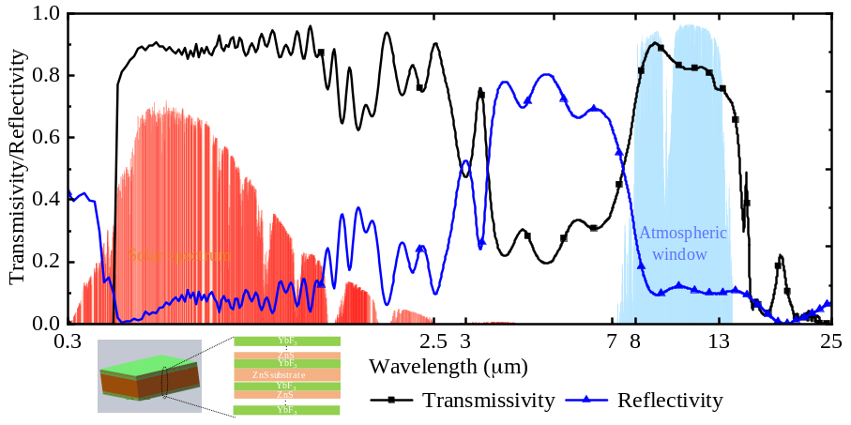

Professional Biography

Prof. Gang Pei is a Professor of University of Science and Technology of China and the dean of Department of Thermal Science and Energy Engineering. He received his doctorate in engineering thermal physics in 2006 from the University of Science and Technology of China. His researches mainly focus on solar energy, novel thermodynamic cycle, building energy and radiative cooling. He has published more than 140 papers in journal and conference proceedings, including 90 SCI papers, with non-self citation of 1467 times. He achieved rewards of Marie Curie International Incoming Fellowships, Fok Ying-Tong Education Foundation, Lu Jiaxi Young Talents Award from Chinese Academy of Sciences, New Century Excellent Talents Award from the Ministry of Education, Excellent Youth Science and Technology Fund Award from Anhui Province, and so on.
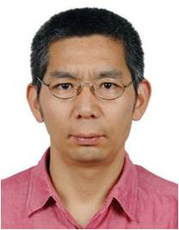
Email Id: peigang@ustc.edu.cn

Any Comments:

