Numerical modeling of high power Nd:YAG dual end pumped zigzag slab Amplifier
M.Najafi¹, A. Sepehr¹, E. Tanhaee¹, M.M. Majidof¹, F.Abedzade¹, S.H.Nabavi²

¹ Iranian National Centre for laser science and technology (INLC), Iran
²Department of photonics &physics, Tarbiat Modares University (TMU), Iran

Abstract
Abstract: In this study we present a precise numerical model to calculate laser parameters taking into account contra directional pumping architecture and saturation effects in solving rate equations. In order to compute the spatial distribution of the pump and laser intensities, a self-consistence algorithm is used. Corresponding absorbed pump energy from both direction as well as the amount of signal amplification after passing each element is evaluated after iterating considered algorithm through Nd:YAG slab crystal. Although Single-pass amplifier is modelled, multipass configuration could simply be generalized.
The simulation is carried out considering an Nd:YAG slab crystal (130×25×1.7mm) with 0.06% dopant concentration and 500W signal power. Fig.1a shows the simulation result of saturated absorption coefficient versus different pumping power for both ends of slab. As it is seen, absorption coefficient in entrance face of seed beam is significantly lower than exit face. It is expected from depleting the population inversion due to amplified signal and thus increasing tendency for pump absorption. As an advantage, gain coefficient along slab length is obtained, fig. 1b. Although pump configuration is symmetric, gain graph is noticeably asymmetric owing to one-pass amplification. At last, output power is computed from presented method and compared to commonly analytical solution of rate equation without considering reciprocal pumping and saturated features, fig.1c [4]. As it is illustrated the variation between two modes is about ∆=20%.
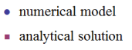
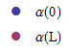
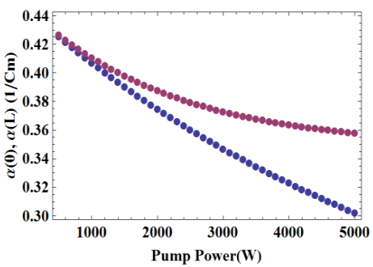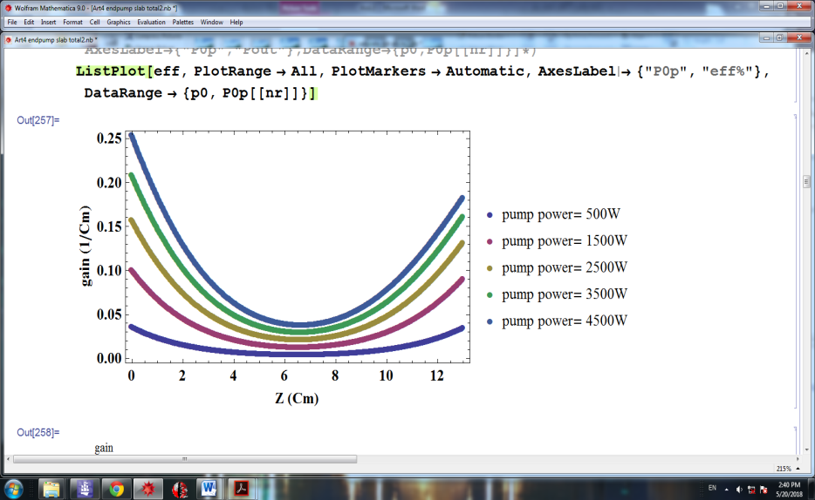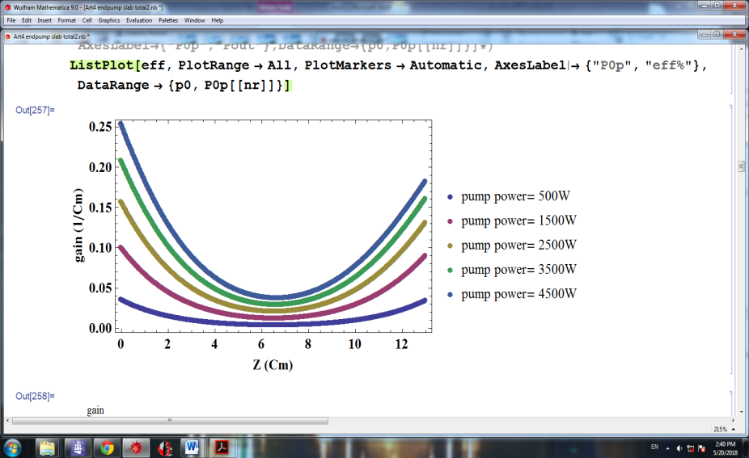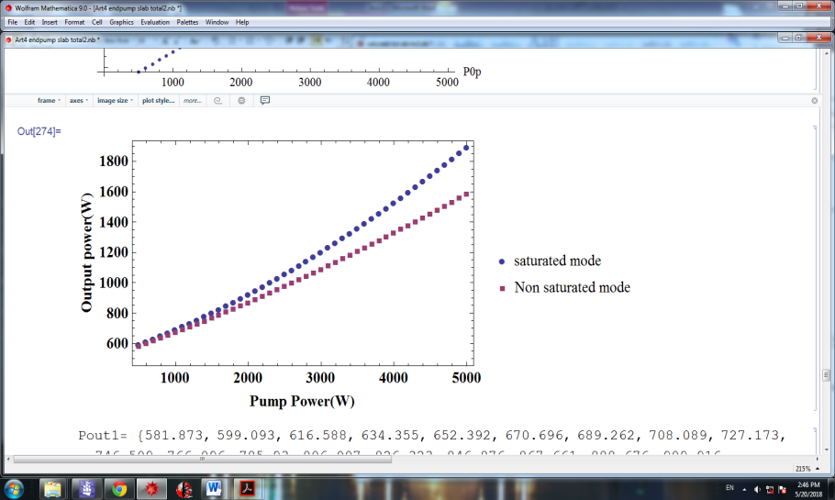
$$∆$$
(a) | (b) | (c)
Fig.1. (a) saturated absorption coefficient versus different pumping in signal entrance face (blue balls) and exit face (red balls).(b) saturated gain coefficient along slab length in different pump power.(c) comparison between output power of presented method (blue circles) and analytical solution of rate equations (red squares).

Keywords— Slab amplifier, Rate equation, saturation effect, iterative method

Professional Biography
Mohanna Najafi has complicated her education on atomic and molecular physics in Shahid Beheshti University (SBU), Iran. She joined the Iranian National Centre for laser science and technology (INLC) in 2008. She has been working on solid state lasers theoretically and experimentally. She conducts numerical simulation of propagation of electromagnetic waves in non-linear media. Her recent activity is focused on zigzag slab laser development.
Email Id: Mohana.Najafii@gmail.com

