Spherical Approximation for combination of Mechanical Deformation & Optical Path Difference thermal lenses in Nd: YAG slab amplifier
E. Tanhaee , M.M.Majidof, M.Najafy, F.Abedzade, S.H.Nabavi
^{1,2,3,4}Iranian National Center for Laser Science and Technology (INLC), Iran
⁵Department of photonics& physics,Tarbiat Modares University (TMU),Iran
Abstract
In this study, we pave the way for preconception of thermal lens by amalgamation of Mechanical Deformation (MD) and Thermal Optical Path Difference (TOPD) via Spherical-fitting Approximation (SFA) with analytical and experimental results at Nd:YAG slab amplifier (Nd:YAG slab was 0.6%-Nd⁺³doped, with 2 mm in thickness, 20mm in width, 100mm in length and refractive index 1.8179 which is made By Czochralski technique In INLC) up to 420W pump power. Wavelength and maximum output power of Diode source was 808nm and 480 W. Fig.1.a, shows schematic of our experimental setup (Fluid temperature is set to 21⁰C). According to Fig.1, Fig.2.a and b, the analytical simulation of combination MD & TOPD have a good agreement with experimental results in terms of focal points and curvatures.
Keywords—Slab amplifier, Spherical-fitting Approximation (SFA), Thermal Optical Path Difference (TOPD), Mechanical Deformation (MD)
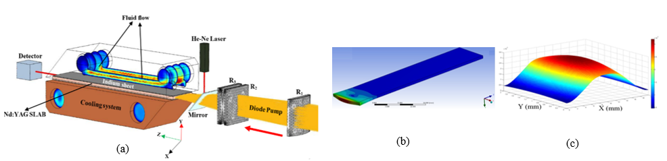

Fig.1: (a) experimental optical design for beam shaping (R₁, R₂ and R₃are radius of lenses) and cooling condition for Nd: YAG slab
(b) Mechanical Deformation (MD) of slab 0.6%-Nd⁺³ doped (c) TOPD act of slab Nd: YAG
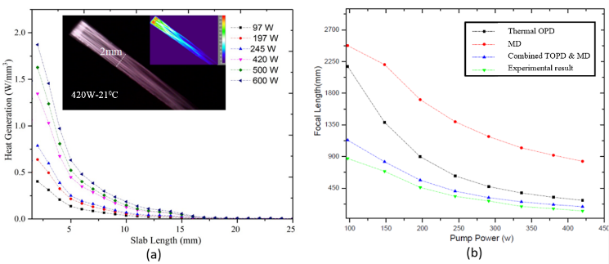
Fig.2: (a) Numerical calculation of Heat generation for different pump powers (b) comparison the numerical focal length performance of thermal OPD (■), MD (●) and combination of them (▲) with experimental results (▼)at width of Nd: YAG slab
Professional Biography
I'm chairman in slab laser and researcher in nanophotonics and fiber laser. I Wrote several book about physics in IRAN and my master science was nanophysics at Tehran university,Iran.


Email Id: e.tanhaee.ns.technics@gmail.com
Contact Number:+98-09353238602

