Sol-gel Materials for Optical Applications
E. Castellón¹, M. Zayat² and D. Levy²*

¹Escuela de Química and Centro de Investigación en Ciencia e Ingeniería de Materiales, Universidad Costa Rica, 11501-2060 San José, Costa Rica (Universidad de Costa Rica, CR)

²Instituto de Ciencia de Materiales de Madrid, ICMM-CSIC, 28049 Madrid, Spain. email: David.Levy@icmm.csic.es (ICMM-CSIC, SP)

Abstract

One of the main research activities of the Sol-Gel Group@Madrid (GSG-ICMM) is based on a new approach of "incorporating electroactive organic molecules in glasses". In other words, the possibility of manipulating the optical properties of molecules encapsulated in thin-films glasses by means of application of an external electric field. Due to their interesting optical properties, these new materials can be used in a very wide range of applications. This development consists on the microencapsulation of liquid crystal (LC) droplets dispersed in Sol-Gel glasses. The prototypes of optical switches have been developed as GDLC® (Gel-glass Dispersed Liquid Crystal).
As an interesting alternative, the structure of biological templates has been also explored as a novel route for the preparation of an electrooptical device from a biofilm structure created by bacterial activity. Biofilms created by live microorganisms can provide specific structures. The novel usage of the tridimensional architecture and optical properties of a biofilm created by the bacterium Pseudomonas putida mt-2 for the fabrication of a variable light-transmission device will be described. The bacterial cell factory is a promising non-chemical route for the generation of tridimensional structures oriented to the design of new.
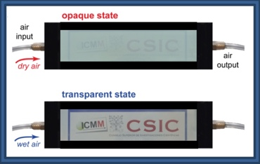
A new concept of an optical thin-film material that exhibits reversible humidity-responsive light-transmittance properties is presented. The novel reversible humidity-responsive light transmission thin-film material consists on a dispersive porous structure, with embedded hygroscopic and deliquescent compounds, that is able to scavenge water molecules from humid air to fill-up the pores and become transparent to the incident light.
Upon exposure to dry air, water is released from the structure and the material recovers its original light scattering properties. The developed thin-films can change their transparency when exposed to air with different relative humidity (RH), adjusting the light throughput.
Therefore, this material concept can be used to design new optical windows, having the advantage that they do not require liquid crystal, transparent conductive glass substrates or complex layer-by-layer architectures for operation as in conventional smart windows.
The general design of the humidity-driven light-scattering device concept will be presented.

Keywords— deliquescent, electrooptical, hygroscopic, smart-window, thin-film.

Professional Biography (100-150 words)

David Levy started (1982-89) at The Hebrew University of Jerusalem, with the pioneering first application of the Sol-Gel process to the preparation of organically doped silica gel-glasses and reached the ICMM-CSIC in 1989. He was awarded the “First Ulrich Prize” for the most innovative work and was nominated to the “Juan Carlos I Rey” research award. He has authored over 133 papers (> 6800 citations; h=40, G-Scholar), reviews, book chapters, Co-Editor of The Sol-Gel Handbook, and several patents, and was PI for 27 Industry Projects. He is member of the International Advisory Board of the “Sol-Gel Optics” and “Optoelectronics and Optical Science and Technology” of the SPIE (USA), and member of the Experts Panel of the FP7 and H2020 Materials and Space Programs. He Chaired the XVII Sol-Gel International Conference in Madrid, 2013. DL is Professor at ICMM-CSIC heading the Sol-Gel Group (SGG) and his research interests are optical materials and their applications, and also headed the LINES of the INTA, where developed space materials for space optical instruments, able to be implemented on the board of a satellite.

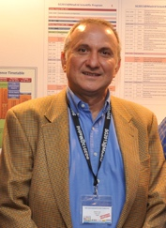

Email Id: David.Levy@icmm.csic.es
Contact Number:+34913349076

Any Comments:

