Femtosecond laser direct writing of crystal-in-glass LaBGeO₅ waveguides
Sergey V. Lotarev, Alexey S. Lipatiev, Tatiana O. Lipateva, Vladimir N. Sigaev

Mendeleev University of Chemical Technology of Russia, Russia

Abstract (not more than 300 words)
Femtosecond lasers have become a powerful tool for three-dimensional precision micromachining of dielectrics. One of its promising applications is space-selective laser-induced crystallization of glasses providing growth of continuous crystalline architectures with functional properties such as second-order optical nonlinearity. Though laser-induced precipitation of different crystalline phases was demonstrated in a wide set of glasses, writing single-crystal tracks which could operate as channel waveguides was a challenge which required optimization of laser treatment parameters and beam profiling. Such crystalline channel waveguides consisting of ferroelectric stillwellite LaBGeO₅ phase have been recently obtained in lanthanum borogermanate glass. In particular, we reported laser writing of oriented LaBGeO₅ tracks with improved homogeneity providing waveguide effect by applying the femtosecond beam with elliptical waist cross-section and demonstrated second harmonic generation in this waveguide.
In the present study, we revealed possibility and investigated conditions of laser direct writing of oriented LaBGeO₅ crystal tracks at various pulse duration from 300 fs to 5 ps and various pulse repetition rate from 25 kHz to 500 kHz. It is shown that there is a constant minimal value of peak pulse intensity about 1,6·10¹² W/cm² in the pulse repetition rate range of 100-500 kHz, while at lower repetition rates this value rapidly grows with repetition rate decrease.
We also suggest a method of fast laser-induced growth of a seed microcrystal which is necessary as a starting point for writing a crystalline track and is formed in glass by the stationary beam. Exposure of glass to the beam with gradually increasing pulse energy is shown to greatly reduce and stabilize time required to grow a seed crystal as compared to the beam with constant pulse energy.
The obtained data will be useful for further improvement and feasibility of crystal-in-glass waveguides writing method.
This study was supported by the Russian Science Foundation (grant 17-73-20324).

Keywords— laser direct writing, stillwellite, channel waveguide, space-selective crystallization

Professional Biography (100-150 words)

Sergey Lotarev has graduated from Physical faculty of Lomonosov Moscow State University in 2003 having obtained a specialization in laser physics and nonlinear optics and completed his PhD in Mendeleev University of Chemical Technology of Russia in 2006 in the field of glass nanostructuring with nonlinear optical crystalline phases. During last decade, his research is focused on the laser-induced modification of glasses including space-selective crystallization of glasses and laser direct writing of nanocrystallized and crystal-in-glass waveguides, space-selective precipitation of plasmonic nanoparticles in glasses, inscription of birefringent nanogratings in multicomponent glasses and ultrastable optical data storage with multilevel recording of information by the femtosecond laser beam. He has published more than 40 papers in peer-reviewed journals.

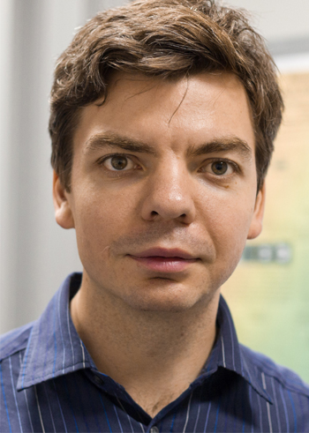

Email Id: sergey_lot@mail.ru, slotarev@muctr.ru
Contact Number: +79104229675

