Abstract Template
Supraorbital angiolymphoid hyperplasia with eosinophilia.
Chitgopekar RP 1, Bangal SV1 Gupta AK3, Karle R4

1. Consultant, Prakash Netralaya, Ahmednagar.
2. Professor and Head of Department,
3. Assistant Professor, Department Of Anaesthesiology,
4. Professor, Department Of Pathology, RMC, Loni.

Abstract

Angiolymphoid hyperplasia with eosinophilia (ALHE) is a rare clinicopathologic entity that shares both clinical and histopathological features with Kimura disease. Although they were once considered as different stages of the same disease, they are now known to represent separate entities. ALHE is a condition that causes swellings in the head and neck region affecting muscular arteries and is benign in nature.¹ Orbital involvement is unusual. Diagnosis of ALHE is frequently confused with malignant tumour until biopsy is done.⁴ We present here a young female with unilateral, painless and slowly progressive swelling on the inner and upper aspect of her left orbit, who was diagnosed as a case of ALHE with orbital involvement on the basis of CT scan and excisional biopsy. Regular follow up was performed and no evidence of recurrence was found.
Key Words: Orbit, angiolymphoid hyperplasia, eosinophilia.
Professional Biography (100-150 words)

Dr.Rajeev Prakash Chitgopekar has completed his graduation from Maharashtra University of health sciences, Nasik, Maharashtra and Diploma in ophthalmic medicine and surgery from PIMS Ahmednagar. He has done his DNB training from Sankara Netralaya, Chennai. Has presented papers in numerous state conferences in India and has won Best paper award for the same. He is in the field of ophthalmology since 2011. Presently working as a consultant in Prakash Netralaya, Ahmednagar and is specialized in Cataract and Glaucoma.

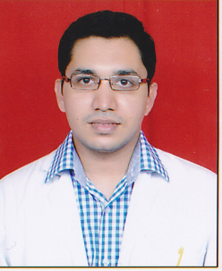
Email Id: prakashnetralaya@yahoo.com

Any Comments: Can have this article as an ORAL OR as an e-POSTER.

