Orbital extension of supraorbital angiolymphoid hyperplasia with eosinophilia

Bangal SV1, Chitgopekar RP2, Gupta AK3, Karle R4

  - Professor and Head of Department, 2. Resident, Department Of Ophthalmology, RMC, Loni

- Assistant Professor, Department Of Anaesthesiology, 4. Professor, Department Of Pathology, RMC, Loni

CASE REPORT

Bangal S.V. et.al: Case report: Orbital extension of supraorbital angiolymphoid hyperplasia with eosinophilia. AMJ 2011, 4, 3, 111-3 Doi: http://doi.org/10.21767/AMJ.2011.548

Corresponding Author:

Rajeev P. Chitgopekar
207, Department Of Ophthalmology, Rural Medical College

of Pravara Institute of Medical Sciences, Loni, Rahata,
Ahmednagar, Maharashtra, India.

Email: rajuchitgopekar@yahoo.co.in

Abstract

Angiolymphoid hyperplasia with eosinophilia (ALHE) is a rare clinicopathologic entity that shares both clinical and histopathological features with Kimura disease. Although they were once considered as different stages of the same disease, they are now known to represent separate entities. ALHE is a condition that causes swellings in the head and neck region affecting muscular arteries and is benign in nature.¹ Orbital involvement is unusual. Diagnosis of ALHE is frequently confused with malignant tumour until biopsy is done.⁴ We present here a young female with unilateral, painless and slowly progressive swelling on the inner and upper aspect of her left orbit, who was diagnosed as a case of ALHE with orbital involvement on the basis of CT scan and excisional biopsy. Regular follow up was performed and no evidence of recurrence was found.

Key Words: Orbit, angiolymphoid hyperplasia, eosinophilia.

Introduction

Angiolymphoid Hyperplasia with Eosinophilia (ALHE) is a rare clinical entity characterised by the presence of a variable number of papules, plaques or nodules of the dermis and

subcutaneous tissues.² ALHE shows a predilection for the head and neck area, affecting muscular arteries.¹ Orbital involvement is unusual. The aetiology of ALHE is obscure, however it has been reported to occur in pregnancy and also following trauma in some cases. Literature favours an underlying reactive process, and describes a tendency for recurrence and neoplastic transformation, thus, ALHE is frequently confused with a malignant tumour until biopsy is done. ALHE also shares both clinical and histopathological features with Kimura disease, and although they were once considered different stages of the same disease, they are now known to represent separate entities. In contrast to Kimura disease which develops mainly in patients from Asia, ALHE has no racial predilection and is typically seen in westerners.² There is a slight female predominance in the third to fifth decade of life. We hereby report an Indian patient with orbital ALHE. To the best of our knowledge, this is the first case report of this type from India.

Background

- twenty-five year old Asian housewife presented with a one year history of a slowly progressive swelling at the upper lid of left eye. On examination, a painless swelling was noted which followed the contour of the superomedial aspect of the left orbital margin. It measured 3x3cm and was round to oval in shape. A few violaceous, darkbrown papules were found on the forehead over the swollen region (see figure 1). Lid position and extraocular movements were normal, with examination of anterior and posterior segment of both eyes revealing no abnormality. Both eyes had visual acuity 20/20 with intraocular pressure 17.3mm of Hg.

Figure 1: Supraorbital ALHE with violaceous papules on forehead
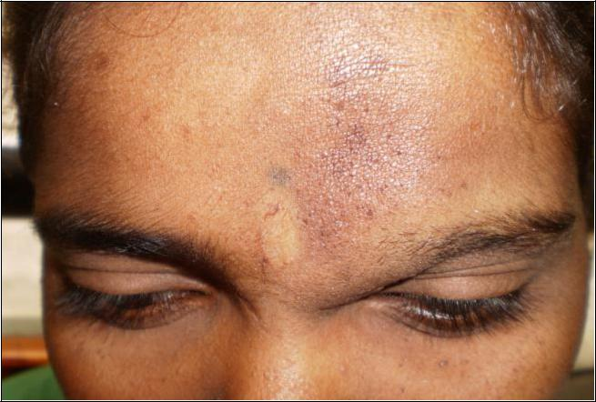

A full blood count was normal except for a mild eosinophilia (7%). A CT scan of the head, orbit and paranasal sinuses was performed (see figure 2).

Figure 2: CT scan showing Superomedial orbital extension of supraorbital ALHE
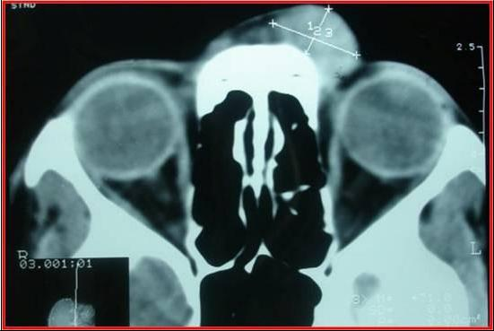

Contiguous 3mm coronal/ axial sections were taken, which showed a well defined soft tissue density lesion measuring 2 x 1.2 cm with CT attenuation value of 45-80 HU. The lesion was extraocular, preseptal and anteromedial to the medial rectus muscle and anterolateral to nasal bone. The lesion appeared to cause contour bulge along the superomedial margin of the orbit. The nasal septum was central and the paranasal sinuses were normal.

Surgery was performed to remove the mass. A 3cm incision was taken superomedially near the orbital margin, the mass was identified, and the fibrovascular attachments were dissected. A irregular, greyishblack soft tissue mass measuring 2x2 cm was then excised.

Histological analysis showed aggregates of lymphocytes forming lymphoid follicles surrounded by fibrofatty tissues

(see figure 3A), nerves and skeletal muscle. Lymphoid follicles showed proliferation of blood vessels lined with plump endothelial cells and vessels in the intervening stroma, with intense infiltration by eosinophils (see figure 3B).

Figure 3 A: 10X microscopic view, haematoxylin and eosin (H&E) stained section revealing lymphoid follicles surrounded by fibrofatty tissue.
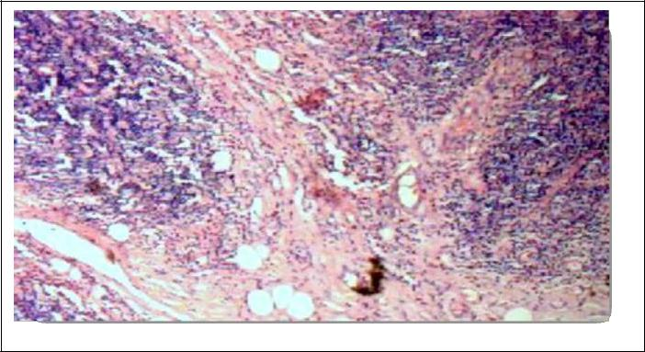

Figure 3 B: 40X microscopic view, H & E stained section showing blood vessels lined with plump endothelial cells and infiltration by eosinophils.
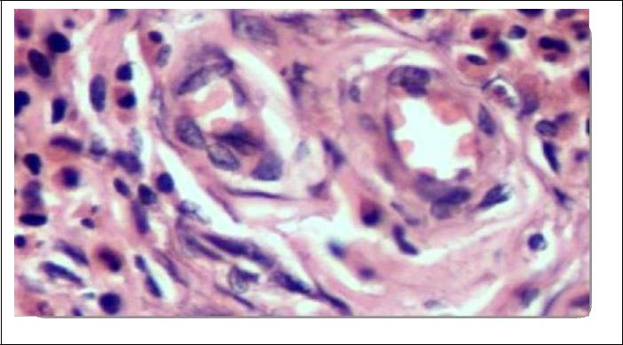

On the basis of the clinical features, and the supportive radiological and histopathological findings, the diagnosis of supraorbital ALHE with orbital extension was made. The patient is undergoing regular follow-up and there has been no evidence of recurrence of the condition.

Discussion

Wells and Whimster were the first to describe ALHE in 1969.⁵ It has been reported from many parts of the world and can occur in all races. This condition is characterised by abnormal proliferation of endothelial cells with infiltrates of lymphocytes and eosinophils, as demonstrated by this case. ALHE is also known as

eosinophilic lymphofolliculitis or Histiocytoid hemangioma.^{6, 7} ALHE should be distinguished from a variety of benign and malignant vascular proliferations including pyogenic granuloma, epithelioid hemangioendothelioma and Kaposi’s sarcoma – all of which lack a noticeable eosinophil infiltrate. ALHE usually presents as benign nodules with erythematous papules mostly in the head and neck region, however the orbital involvement seen in this case is unusual. Features of orbital involvement may include proptosis, watering, pruritus around the eyes and blurring of peripheral vision.³ Our patient was successfully treated surgically before she developed any such symptoms.

Surgical excision may be beneficial in the case of a solitary small tumour but there is a risk of recurrence at the surgical site.² Systemic and intralesional steroid administration, interferon therapy, cryotherapy, laser therapy and topical application of Tacrolimus have been used with success.²

In conclusion, ALHE with orbital involvement is a rare clinical entity, and further work is required to accurately describe its incidence, aetiology and presentation.

References

- Gonzalez-Cuyar LF, Tavora F, Zhao XF, Wang G, Auerbach A, Aguilera N, et al. Angiolymphoid hyperplasia with eosinophilia developing in a patient with history of peripheral T-cell lymphoma: evidence for multicentric T-cell lymphoproliferative process. Diagn Pathol,2008,-; 29-;( -3): -22

- Wolff K, Goldsmith L, Katz S,Gilchrest B,Paller A, Lafell D. Fitzpatricks textbook of dermatology in general medicine, 2008,-; 7th ed. 313-15.

- McEachren TM, Brownstein S, Jordan DR, Montpetit VA, Font RL. Epithelioid hemangioma of the orbit. Ophthalmology. 2000,-; 107(4): 806-10.

- Ingrams DR, Stafford ND, Creagh TM. Angiolymphoid hyperplasia with eosinophilia. J Laryngol Otol.1995,-; 109(3): 262-64 .

- Kempf W, Haeffner AC, Zepter K, Sander CA, Flaig MJ, Mueller B, et al. Angiolymphoid hyperplasia with

eosinophilia:evidenceforaT-cell

lymphoproliferative origin. Hum Pathol. 2002,-; 33(10):-1023-29.

- Jacob J, George S, Roy RB ,Dildeepa S. Angiolymphoid hyperplasia with eosinophilia - A case report. Indian Jl of Otolaryngol Head Neck Surg.2006,-; 58(3):- 285-87.

- Weiss SW, Enzinger FM. Epithelioid hemangioendothelioma: a vascular tumor often mistaken for a carcinoma. Cancer.1982,-;50:970– 81.

ACKNOWLEDGEMENTS

We express our sincere gratitude to Department of Ophthalmology, Department of Anaesthesia, Department of Pathology, Department of Radiology and the staff at the Pravara Rural Hospital for their cooperation and support.

PEER REVIEW
Not commissioned externally peer reviewed.

CONSENT
The authors declare that

- They have obtained informed consent for the publication of the details relating to the patient(s) in this report.

- All possible steps have been taken to safeguard the identity of the patient(s).

- This submission is compliant with the requirements of local research ethics committees.

CONFLICTS OF INTEREST
Nil

