Iris localisation of type 1 neurofibromatosis :
2 clinical cases report
J. Laayoun , s. Iferkhas , a. Bouzidi ,a. alami , m. Elmellaoui ,a. bouassel , n. Elhalouate
a. Elwafi, k. Zaoui , a. Laktawi

5th hospital guelmim –MOROCCO-

ABSTRACT
Introduction
type 1 neurofibromatosis (NF-1) is a rare multisystemic disorder .
In our study we report two cases of Iris localisation of type 1 neurofibromatosis .
Case N : 1
It’s about a 36-year-old woman .The disease started in childhood with the appearance of multiple hyperpigmented skin macules.

ophtalmic examination reveales more than two iris hamartomas (Lisch nodules) in both eyes
Case N : 2
a female , 25 y.o. had multiple Small clumps of pigment on the iris of both eyes (Lisch nodules) .MRI of the brain reveales Sphenoid dysplasia .

Discussion
Neurofibromatosis type 1 (NF1) consists on the development of multiple benign neurofibromas and areas of abnormally hypo- or hyperpigmentation of the skin.

Summary
clinical trials for drugs to treat neurofibromas are beginning.

Introduction
type 1 neurofibromatosis (NF-1) is a rare multisystemic disorder . it has a dominant autosomal transmission mode , and it’s due to a mutation concerning chromosome 17 .
the diagnosis is based on a multitude of cutaneous , nervous , ocular and squeletal manifestations . the most frequent are cutaneous café-au-lait spots and neurofibromas . Lisch nodules are the most common type of ocular involvement in NF-1.
In our study we report two cases of Iris localisation of type 1 neurofibromatosis .
Case N : 1
It’s about a 36-year-old woman .The disease started in childhood with the appearance of multiple hyperpigmented skin macules. Actually , she presents more than six café-au-lait spots on her skin (Fig.1).

Fig.1
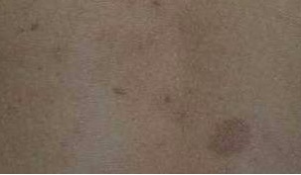

she has no visual loss , and ophtalmic examination reveales more than two iris hamartomas (Lisch nodules) in both eyes (Fig.2 a,b).

Fig 2a (right eye)
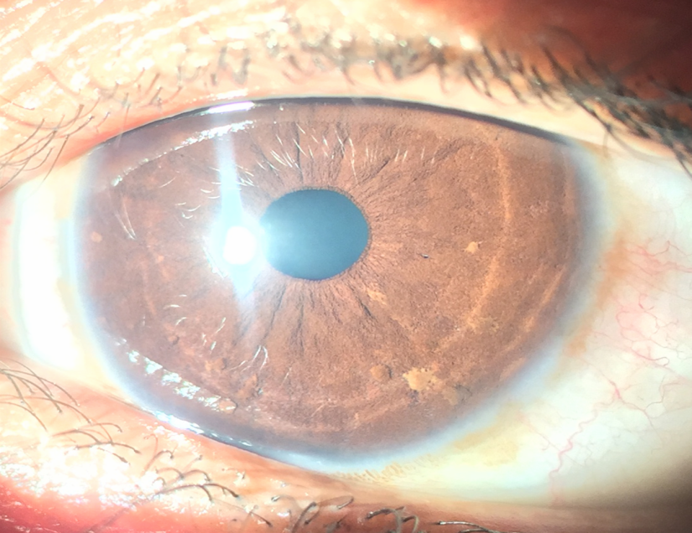

Fig 2b (left eye)

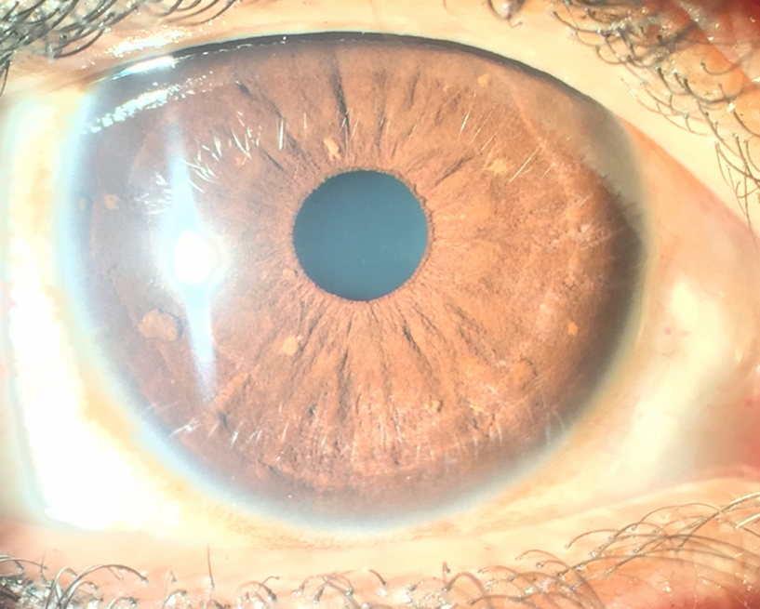

The diagnosis NF-1 was made according to the presence of two of the seven diagnostic criterias of the National Institute of Health Consensus Development Conference .
fundus examination was normal . and there was no orbital abnormalities on MRI.
Case N : 2
The second patient , also a female , 25 y.o. had a history of learning disabilities and speech difficulties . At physical examination we found no skin, brain or squeletal abnormalities . Visual acuity was normal , and slit lamp examination revealed multiple Small clumps of pigment on the iris of both eyes (Lisch nodules) (Fig.3a,b) .
Fig.3a (right eye)
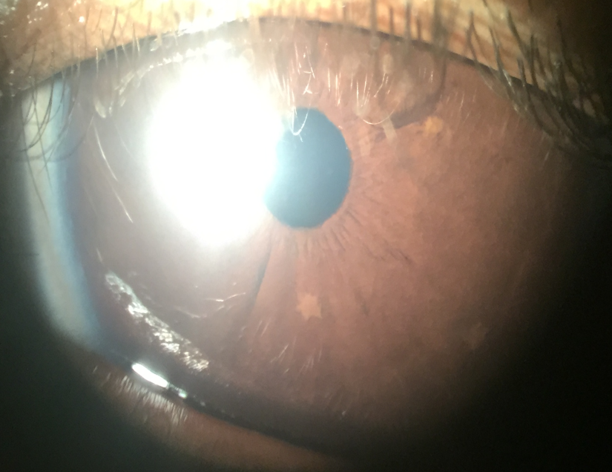
Fig.3b (left eye)
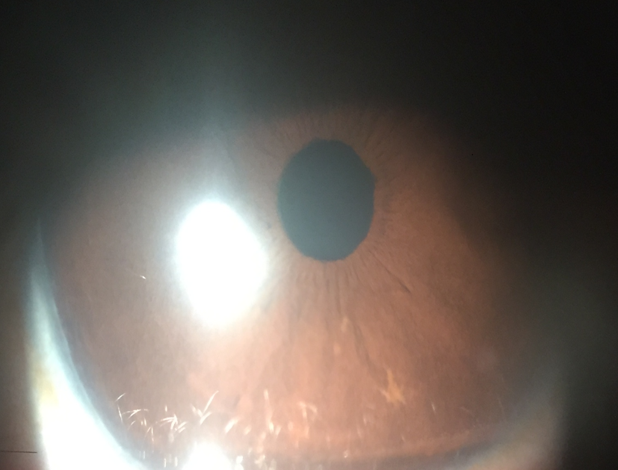

MRI of the brain reveales Sphenoid dysplasia (Fig.4).
Fig.4 :
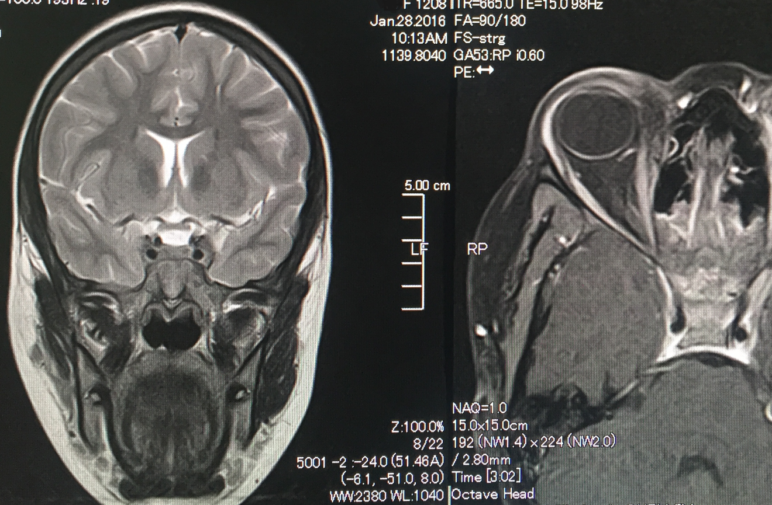

Those two criterias were essentials To asset the diagnosis NF-1 .

Discussion
One of the most rare genetic disorders, Neurofibromatosis type 1 (NF1), also called von Recklinghausen's disease, consists on the development of multiple benign neurofibromas and areas of abnormally hypo- or hyperpigmentation of the skin. It affects 3 from 10.000 newbirths worldwide (1). Neurofibromatosis type
1 is currently diagnosed by using a set of clinical criteria
(Table 1) (2). Two or more criteria are needed for definitive diagnosis.

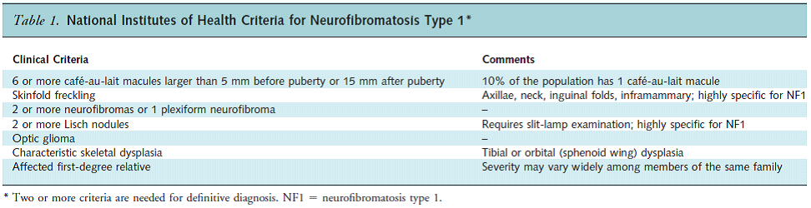

Areas of abnormal pigmentation include cafe-au-lait spots on the skin of the trunk and other regions as axillary and inguinal area as we see in the case N:1 in our study.
Also , Small clumps of pigment develop on the iris of the eyes (Lisch nodules). These nodules are melanocytic hamartomas, Their presence is highly indicative of NF1 as they occur in 97 percent of affected individuals. In individuals with NF1, associated symptoms and findings may vary greatly in range and severity from case to case. Most people with NF1 have normal intelligence but Specific learning problems have been observed in 30– 60% of NF1 children.(3); and that was the case of the patient N : 2 in our study .
NF1 is caused by mutations of a relatively large gene on the long arm (q) of chromosome 17 (17q11.2). those Pathogenic mutations in the NF1 gene have been found in most of the 60 exons. They comprise a wide diversity of mutation types (4).
Once the diagnosis is considered, referral should be made to any clinician skilled in the diagnosis of NF1, including geneticists, paediatricians, neurologists , ophthalmologists or dermatologists.
Cafe´ au lait patches and skin-fold freckling do not usually cause complications , a recent follow-up study did not reveal any haematological malignancies in 14 children with NF1 (5) . However, some patients are distressed by the appearance of this pigmentation and may be helped by skin camouflage advice. There is no evidence to support the routine use of laser treatment for cafe´ au lait patches. Also , Lisch nodules are not thought to cause any ophthalmologic complication and do not need any specfific treatment .

Summary
Since the year 1990, when NF1 gene was identified , much has been learned about the pathophysiology of the disorder . This has resulted in the availability of molecular diagnostic testing, and clinical trials for drugs to treat neurofibromas are beginning.

References

1- Williams VC Lucas J, Babcock MA, et al.— Neurofibromatosis type 1 revisited. Pediatrics, 2009, 123, 124- 133.

2- Neurofibromatosis. Conference statement. National Institutes of Health
Consensus Development Conference. Arch Neurol. 1988;45:575-8. [PMID:
3128965]
3- Hyman SL, Shores A, North KN. The nature and frequency of cognitive deficits in children with neurofibromatosis type 1. Neurology 2005;11:1037–44.
4- Messiaen LM, Callens T, Mortier G, Beysen D, Vandenbroucke I, Van Roy N, et al. Exhaustive mutation analysis of the NF1 gene .Hum Mutat. 2000;15:541-55. [PMID: 10862084]
5 - Cambiaghi S, Restano L, Caputo R. Juvenile xanthogranuloma associated with neurofibromatosis 1: 14 patients without evidence of haematologic malignancies. Paediatr Dermatol 2004;21:97–101.

