THE STRESS LEVEL AND STRESS RELATED FACTORS AMONG AMBULANCE DRIVERS OF RUAMKATANYU AND POH TECK TUNG FOUNDATION AND THE EFFECT OF THE PROGRESSIVE MUSCLE RELAXATION INTERVENTION TOWARD STRESS
Miss Pinalin Penthong

Abstract (300 word limit)
This study aimed to study the relationship among general characteristics, work-related factors and the stress level in ambulance drivers at Ruamkatanyu and Poh teck tung foundation. Eighty-three self-administered questionnaires were included in the analysis. The Progressive muscle relaxation was introduced to reduce the stress level in 20 subjects, compared with another 23 subjects in the control group.
The most stress level was mild stress (43.4%). The results showed that stress was significantly associated with marital status (p-value = 0.000), monthly income (p-value = 0.000), household monthly income (p-value = 0.000), income sufficiency (p-value = 0.000), type of shift work per day (p-value = 0.001), number of the patient or injured person per day (p-value = 0.035), emergency severity index (ESI) in resuscitation (red) (p-value = 0.000), neck pain (p-value = 0.022), shoulder pain (p-value = 0.020), waist pain (p-value = 0.016) and pressure from patient and the family members (p-value = 0.000).
The study showed the difference in mean stress scores after the intervention program between experimental and control groups were significant (p-value < 0.05). The reaction time before and after the progressive muscle relaxation practice in experimental group were significantly difference (p-value < 0.001).
The conclusion this study revealed that the stress level in ambulance drivers was average in mild level. The general characteristics factors, work-related factors, ergonomics factors, and social psychology factors have related the stress. The progressive muscle relaxation was implemented, and the result showed the stress score was decreased by the post evaluated.

Image
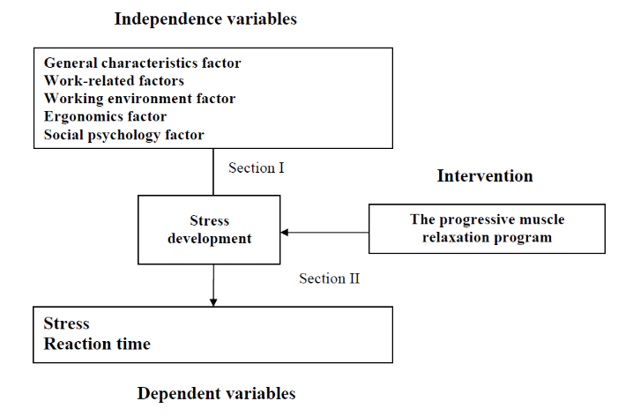

Figure 1: Conceptual framework

Recent Publications (minimum 5)
- Pinalin p (2021) Nursing Journal Volume 48:93-106.

Photograph



Biography (150 word limit)
Her study about stressors and intervention in decreasing the stress among ambulance drivers. She has developed and learned about Progressive muscle relaxation training that has the effect of reducing anxiety and mental stress. The program applies the principle of a general relaxation of the body and the mind and aims to make the driver more relaxing and comfortable, both physically and mentally. The author aims to improve and implement this program as a preventive and corrective measure against stress-related problems and mental health problems in the future.
Email: pinalin.penthong@hotmail.com

Notes/Comments:

This presentation received a grant to present
the work from the Faculty of Graduate studies,
Mahidol University

