Novel Virus-like Mesoporous Silica-ZnO-Ag Nanoparticles and Quercetin Synergize with NIR Laser for Covid-19 Infectious Diseases Treatment
Fadi Ibrahim*
Department of Chemistry, Al_Shujaa_bin_Al _Aslam School, Kuwait
A B S T R A C T
This work shows that novel virus-like mesopore silica-zinc oxide/Ag nanoparticles (SZnOAg) synthesized and professionally collected on NIR laser irradiation with quercetin to improve their effectively eliminates the virus as a biomedical application. The properties of the nanoparticles can be tuned with respect to their core diameter, tubular length, and outer diameter. Due to their biomimetic appearance, they can rapidly transform living cells into virus-like particles, this SZnOAg nanomaterials has specific elimination effect on bacteriophage and covid-19. Using epitaxial growth, we can construct virus-like structures that can be used for biomedicine applications. These nanomaterials and NIR laser could open the way to a new range of antiviral materials, due to the low-efficiency cellular uptake of current nanoparticles, their applications in the biomedical field are limited. Herein, it clearly shown that novel mesoporous silica nanoparticles can be easily exhibited superior cellular uptake property.
KEYWORDS: Infectious Diseases; Biomedical Applications; Covid-19; Virus-like mesopore; Epitaxial growth Zinc/Silica/Silver nanoparticles; NIR Laser; SEM/TEM; Photothermal; Bacteriophage.
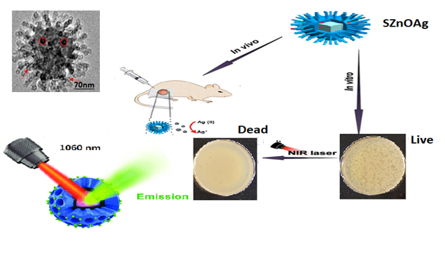
Figure 1: Schematic description photothermal effect of the quercetin and SZnOAg under NIR laser irradiation (1060 nm) and its synergistic antiviral effects.
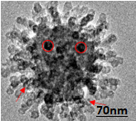
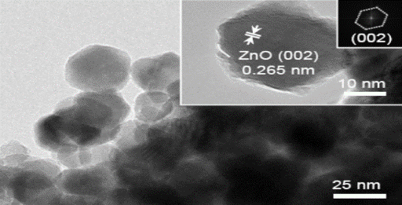
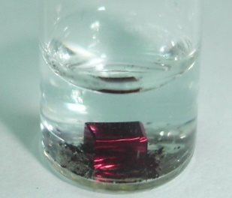
Figure 2: FE-TEM images with crystallinity and electron diffraction.
(1) Abian O, Ortega-Alarcon D, Jimenez-Alesanco A, Ceballos-Laita L, Vega S, Hugh T, et al. Structural stability of SARS-CoV-2 3CLpro and identification of quercetin as an inhibitor by experimental screening. Int J Biol Macromol. (2020) 164:1693–703.
(2) Wenxing Wang, Peiyuan Wang, Xueting Tang, Ahmed A. Elzatahry, Shuwen Wang, Daifallah Al-Dahyan, Mengyao Zhao, Chi Yao, Facile Synthesis of Uniform Virus-like Mesoporous Silica Nanoparticles for Enhanced Cellular Internalization. ACS Cent. Sci. (2017) 3: 839−846.

