Exploring community nurses views on the implementation of a local Weight Management Pathway
Mrs Sophie Hinks, BSc (Hons), PGDip SPQ, MSc, University College Isle of Man

Abstract (300 word limit)
Overweight and obesity is a major cause of non-communicable diseases globally, nationally and locally. It also has a significant cost to both the individual and society.
Weight management pathways (WMP) are a recognised tool used to reduce levels of overweight and obesity and are recommended by both the World Health Organization (WHO) and the National Institute for Health and Care Excellence (NICE). Yet locally there is no WMP in place. A WMP, to best meet the local population’s needs, along with a guidance document was designed based on current WMP’s in the UK. This was then shown to participants of the focus group.
This research focuses on community nursing staffs views on the implementation of a local WMP through the use of interpretative phenomenology. A focus group was conducted which sought the views of adult community nursing staff on current weight management procedures and their views on the implementation of a WMP. The data was then thematically analysed with the use of the Theoretical Domains Framework (TDF).
The findings acknowledge the lack of a current WMP as well as the limitations of the Malnutrition Universal Screening Tool (MUST) assessment, which is what is currently utilised in practice, as it does not trigger interventions for overweight or obesity. The need for and benefits of a local WMP were recognised by participants, however the need for training in the use of the tool was also recognised.
Potential barriers to its implementation were deemed to be the sensitive subject, a lack of staff knowledge and patients willingness to change. The recognition of these barriers reflected background literature and could aid in the implementation of a WMP by ensuring that they have been considered and potentially prevented. Further barriers including cost and communications systems were discovered that weren’t recognised in previous research.

Image
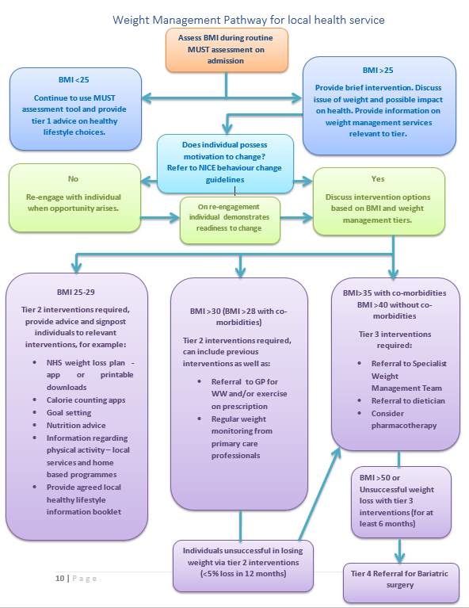
Figure 1. Weight Management Pathway for local health service (authors own).
Recent Publications (minimum 5)
- Brown, I., Stride, C., Psarou, A., Brewins, L., & Thompson, J. (2007). Management of obesity in primary care: nurses’ practices, beliefs and attitudes. Journal of advanced nursing, 59(4), 329-341. http://dx.doi.org/10.1111/j.1365-2648.2007.04297.x
- Brumbaugh, H. (2019). Motivational Interviewing for Weight Loss in Primary Care. Capstones & Scholarly Projects, 64. Retrieved from https://digscholarship.unco.edu/capstones/64
- Corrigan, L. (2016). Lifestyle Assessment – Best Practice Guidelines. Retrieved from https://www.dudleyformulary.nhs.uk/download/392/lifestyle-assessment-best-practice-guidelines.
- Department of Health and Social Care. (2020). Tackling obesity: empowering adults and children to live healthier lives. Retrieved from Tackling obesity: empowering adults and children to live healthier lives - GOV.UK (www.gov.uk)
- East and North Hertfordshire Clinical Commissioning Group. (2019). The Management of Overweight & Obese Adults Pathway. Retrieved from https://clinical-pathways.org.uk/sites/default/files/guidance/Obesity%20and%20Management%20of%20Overweight%20Patients/management-overweight-and-obese-adults-v3.pdf
365: 519-530.

- Hampshire County Council. (2018). Weight management services for Hampshire residents - Primary care pathway 2018. Retrieved from https://documents.hants.gov.uk/public-health/prevention-pathways/Weightmanagementprimarycarepathway.pdf

- Hansson, L., Rasmussen, F., & Ahlstrom, G.I. (2011). General Practitioners’ and district nurses’ conceptions of the encounter with obese patients in primary health care. BMC Family Practice, 12(1). https://doi.org/10.1186/1471-2296-12-7

- Hazlehurst, J.M., Logue, J., Parretti, H.M., Abbott, S., Brown, A., Pournaras, D.J., & Tahrani, A.A. (2020). Developing Integrated Clinical Pathways for the Management of Severe Adult Obesity: a Critique of NHS England Policy. Current Obesity Reports, 9, 530-543. https://doi.org/10.1007/s13679-020-00416-8

- Holmgren, M., Sandberg, M., & Ahlstrom, G. (2019). To initiate the conversation – Public health nurses’ experiences of working with obesity in persons with mobility disability. Journal of Advanced Nursing, 75(10), 2156-2166. http://dx.doi.org/10.1111/jan.14081

- JCN. (2018). Can community nurses take on obesity? Journal of Community Nursing, 32(2), 8-11. Retrieved from http://web.a.ebscohost.com/ehost/pdfviewer/pdfviewer?vid=11&sid=df47da2e-c6dc-4254-9ec8-c1a4f59b28a8%40sdc-v-sessmgr03

- Laidlaw, A., Napier, C., Neville, F., Collinson, A. & Cecil, J.E. (2019). Talking about weight talk: primary care practitioner knowledge, attitudes and practice. Journal of Communication in Healthcare, 12(3-4), 145-153. doi:10.1080/17538068.2019.1646061

- Lundberg, K., Jong, M., Jong, M.C. & Kristiansen, L.P. (2020). Patients’ experiences of the caring encounter in health promotion practice: a qualitative study in Swedish primary health care. BMC Family Practice, 21, 232. https://doi.org/10.1186/s12875-020-01296-6

- McClinchy, J., Dickinson, A., Barron, D., & Thomas, H. (2013). Practitioner and patient experiences of giving and receiving healthy eating advice. British Journal of Community Nursing, 18(10), 498-503. http://dx.doi.org/10.12968/bjcn.2013.18.10.498

- McFarlane, G. (2008). Adult Weight Management Pathway (>16years) – Version 12. Retrieved from https://www.nhstaysideadtc.scot.nhs.uk/approved/bulletin/taypres/2010/Weight%20Management%20Pathway.pdf

- National Institute for Health and Care Excellence. (2016a). Obesity: clinical assessment and management. Retrieved from https://www.nice.org.uk/guidance/qs127/resources/obesity-clinical-assessment-and-management-pdf-75545363615173

- National Institute for Health and Care Excellence. (2016b). Obesity in adults: prevention and lifestyle weight management programmes. Retrieved from https://www.nice.org.uk/guidance/qs111/resources/obesity-in-adults-prevention-and-lifestyle-weight-management-programmes-pdf-75545293071301

- National Institute for Health and Care Excellence. (2021). Obesity management in adults. Retrieved from obesity-obesity-management-in-adults.pdf

- Reddy, S. (2006). Care pathway for the management of overweight and obesity. Retrieved from http://www.htmc.co.uk/resource/data/htmc1/docs/Care%20pathway%20for%20the%20management%20of%20overweight%20and%20obesity.pdf

- Sellwood, L. (2013). Public health and obesity: the role of the district nurse. British Journal of Community Nursing, 18(1), 26-33. doi: 10.12968/bjcn.2013.18.Sup6.S26

- Semlitsch, T., Stigler, F.L., Jeitler, K., Horvath, K., & Siebenhofer, A. (2019). Management of overweight and obesity in primary care – A systematic overview of international evidence-based guidelines. Obesity Reviews, 20, 1218-1230. DOI: 10.1111/obr.12889

- Tahrani, A., Parretti, H., O’Kane, M., Chowhan, H., Ratcliffe, D., & Le Brocq, S. (2020). Managing obesity in primary care. Retrieved from https://d3j7puhwqgd8ts.cloudfront.net/Uploads/r/y/q/finalobesityalgorithmwithreferences_771631.pdf

- World Health Organization. (2020b). WHO Guidelines on Physical Activity and Sedentary Behaviour. Retrieved from https://apps.who.int/iris/rest/bitstreams/1315866/retrieve

- World Health Organization. (2021). Obesity and overweight. Retrieved June 30, 2021 from https://www.who.int/news-room/fact-sheets/detail/obesity-and-overweight

Photograph

 Biography (150 word limit)
Sophie has her expertise in community nursing having worked in community nursing for over 10 years and being a qualified District Nurse for almost 6 years, she is now a lecturer in Health and Social Care. Her work on Weight Management stems from a passion for improving patient health outcomes based on both personal and professional experiences with the aim of introducing a WMP within the local healthcare service. The qualitative approach used for this research meets both the research aim to explore views as well as underpinning the epistemological viewpoint in nursing to understand people’s views and experiences. This is Sophie’s first research project but she has a desire to further her research into other aspects of weight management that will benefit her local community including both staff and patients.
Email: sophie.hinks@ucm.ac.im
Notes/Comments:

