Proximal Humerus Fracture
Paola Arapi, Msc, University of Medicine, Faculty of Medicine, Tirana, Albania

Abstract
Statement of the Problem: In the aging population, the proximal humerus fracture is one of the most common osteoporotic fracture type. More than 75% of the patients that present with proximal humerus fracture are over 51 years old of age and 55% are woman. In 90% of the cases the causes are low-energy injuries with the mechanism of falling from standard height and in 10% of the cases the causes are high-energy injuries such as road accidents. The study purpose was to assess the prevalence of proximal humerus fracture during the study period and the method of its treatment. Methodology & Theoretical Orientation: the study was caring out from January 2018-March 2019 in Tirana, Albania. The data were provided in “Orthopedics and Traumatology Clinique”. There were 119 patients in total hospitalized due to proximal humerus fracture. Findings: Approximately 32% of patients with a proximal humerus fracture are treated conservatively and will regain shoulder function without surgery. More than 38% of patients are treated with metal plates and screws technique. Only 6% of the cases are treated with screw technique. Other 4% of the cases are treated with k-wire technique and the other 4% are treated with CRPF technique. Even though patients who are treated with surgical way seems to have better results, it is not recommended too. Conclusion & Significance: A new approach is therefore needed to prevent the causes of this kind of fractures by previously treating the concomitant diseases, osteoporosis and improve the safety in the home and in the workplace. Based on the current evidence surgery should not be considered the gold standard when treating proximal humerus fractures. Patients should be advised of the high rate of complications that are associated with choosing surgical treatment. Nevertheless because the superiority of single treatment has not been confirmed, the final decision should be made with the patient.

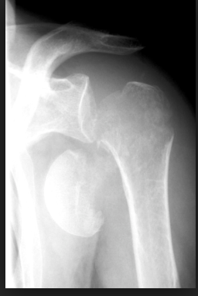
Figure 1. Proximal humerus fracture
Recent Publications
- Schumaier, A., & Grawe, B. (2018). Proximal Humerus Fractures: Evaluation and Management in the Elderly Patient. Geriatric orthopaedic surgery & rehabilitation, 9, 2151458517750516.
- Lowry, Véronique et al. (2017). Acute proximal humeral fractures in adults. Journal of Hand Therapy, Volume 30, Issue 2, 158 – 166
- Chen L, Xing F, Xiang Z (2016) Effectiveness and Safety of Interventions for Treating Adults with Displaced Proximal Humeral Fracture: A Network Meta-Analysis and Systematic Review. PLoS ONE 11(11): e0166801.
- Bell, John-Erik et al. (2016). Mortality after proximal humerus fractures. Journal of Shoulder and Elbow Surgery, Volume 25, Issue 6, e174
- Slobogean, G. P., Johal, H., Lefaivre, K. A., MacIntyre, N. J., Sprague, S., Scott, T., … Bhandari, M. (2015). A scoping review of the proximal humerus fracture literature. BMC musculoskeletal disorders, 16, 112. doi:10.1186/s12891-015-0564-8

 Biography
Msc. Paola Arapi in 2019 has completed her studies for General Medicine in the University of Medicine, Faculty of Medicine in Tirana, Albania. She currently is an independent researcher. She has participated in scientific activities both within the country and abroad. Her primary research interests are focused on preventive medicine.
Email: arapipaola@gmail.com

